Relational Database(RDBMS via ODBC) Interface

Version 3.20.6.x
Revision A
OSIsoft, LLC
777 Davis St., Suite 250
San Leandro, CA 94577 USA
Tel: (01) 510-297-5800
Fax: (01) 510-357-8136
Web: http://www.osisoft.com

OSIsoft Australia • Perth, Australia
OSIsoft Europe GmbH • Frankfurt, Germany
OSIsoft Asia Pte Ltd. • Singapore
OSIsoft Canada ULC • Montreal & Calgary, Canada
OSIsoft, LLC Representative Office • Shanghai, People’s Republic of China
OSIsoft Japan KK • Tokyo, Japan
OSIsoft Mexico S. De R.L. De C.V. • Mexico City, Mexico
OSIsoft do Brasil Sistemas Ltda. • Sao Paulo, Brazil

Relational Database(RDBMS via ODBC) Interface
Copyright: © 2006-2012 OSIsoft, LLC. All rights reserved.
No part of this publication may be reproduced, stored in a retrieval system, or transmitted, in any form or by any means, mechanical, photocopying, recording, or otherwise, without the prior written permission of OSIsoft, LLC.

OSIsoft, the OSIsoft logo and logotype, PI Analytics, PI ProcessBook, PI DataLink, ProcessPoint, PI Asset Framework(PI-AF), IT Monitor, MCN Health Monitor, PI System, PI ActiveView, PI ACE, PI AlarmView, PI BatchView, PI Data Services, PI Manual Logger, PI ProfileView, PI WebParts, ProTRAQ, RLINK, RtAnalytics, RtBaseline, RtPortal, RtPM, RtReports and RtWebParts are all trademarks of OSIsoft, LLC. All other trademarks or trade names used herein are the property of their respective owners.

U.S. GOVERNMENT RIGHTS
Use, duplication or disclosure by the U.S. Government is subject to restrictions set forth in the OSIsoft, LLC license agreement and as provided in DFARS 227.7202, DFARS 252.227-7013, FAR 12.212, FAR 52.227, as applicable. OSIsoft, LLC.

Published: 06/2012

Table of Contents
Terminology ix
Chapter 1. Introduction 1
Reference Manuals 2
Supported Features 2
Configuration Diagram 7
Chapter 2. Principles of Operation 9
Concept of Data Input from Relational Database to PI 10
Query for Single Tag – One Value per Scan 10
Query for Single Tag – Time-Series per Scan 10
Tag Groups 11
Tag Distribution 11
RxC Distribution (combination of Group and Distribution) 12
Concept of Data Output from PI to Relational Database 12
Use of PI SDK 14
Chapter 3. Installation Checklist 15
Data Collection Steps 15
Interface Diagnostics 17
Advanced Interface Features 17
Chapter 4. Interface Installation 19
Interface on PI Interface Nodes 19
Naming Conventions and Requirements 19
Interface Directories 20
PIHOME Directory Tree 20
Interface Installation Directory 20
Interface Installation Procedure 20
Installing Interface as a Windows Service 20
Installing Interface Service with PI Interface Configuration Utility 21
Service Configuration 21
Installing Interface Service Manually 24
What is Meant by "Running an ODBC Application as Windows Service"? 25
Chapter 5. Digital States 27
Chapter 6. PointSource 29
Chapter 7. PI Point Configuration 31
Point Attributes 31
Tag 31
PointSource 31
PointType 32
Location1 32
Location2 32
Location3 33
Location4 33
Location5 34
InstrumentTag 35
ExDesc (ExtendedDescriptor) 35
Scan 38
Shutdown 39
Source Tag 39
Unused Attributes 40
Chapter 8. SQL Statements 41
Prepared Execution 42
Direct Execution 42
Language Requirements, ODBC API Conformance 42
SQL Placeholders 43
Timestamp Format 49
Inputs to PI via SELECT Clause – Detailed Description 53
NULL Columns 53
Bulk Data Input – Time-Series 54
Data Acquisition Strategies 54
SQL SELECT Statement for Single PI Tag 54
SQL SELECT Statement for Tag Groups 55
SQL SELECT Statement for Tag Distribution 56
Option 2: Arbitrary Position of Fields in SELECT Statement – Aliases 59
SQL SELECT Statement for RxC Distribution 59
Event based Input 60
Mapping of Value and Status – Data Input 62
Mapping of SQL (ODBC) Data Types to PI Point Types – Data Input 62
Output from PI 66
Global Variables 68
Chapter 9. Recording PI Point Database Changes 69
Short Form Configuration 69
Long Form Configuration 70
Chapter 10. PI Batch Database Output 71
PI Batch Database Replication without Module Database (old batches) 71
PI Batch Database Replication with Module Database (new batches) 72
PI Batch Database Replication Details 73
Chapter 11. RDBMSPI – Input Recovery Modes 75
Chapter 12. RDBMSPI – Output Recovery Modes (Only Applicable to Output Points) 79
Recovery TS 79
Out-Of-Order Recovery 79
Out-Of-Order Handling in On-Line Mode (RDBMSPI Interface Runs) 81
Recovery SHUTDOWN 83
Interface in Pure Replication Mode 83
Input Recovery 83
Output Recovery 83
Chapter 13. Automatic Reconnection 85
ODBC Connection Loss 85
PI Connection Loss 86
Chapter 14. Result Variables 87
Send Data to PI 87
Result of ODBC Query Execution 88
Chapter 15. RDBMSPI – Redundancy Considerations 89
Chapter 16. RDBMSPI and Server-Level Failover 91
Chapter 17. Startup Command File 93
Configuring the Interface with PI ICU 93
RDBODBC Interface page 96
Command-line Parameters 105
Sample RDBMSPI.bat File 121
Chapter 18. UniInt Failover Configuration 123
Introduction 123
Quick Overview 124
Synchronization through a Shared File (Phase 2) 125
Configuring Synchronization through a Shared File (Phase 2) 126
Configuring UniInt Failover through a Shared File (Phase 2) 129
Start-Up Parameters 129
Failover Control Points 131
PI Tags 132
Detailed Explanation of Synchronization through a Shared File (Phase 2) 136
Steady State Operation 137
Failover Configuration Using PI ICU 139
Create the Interface Instance with PI ICU 139
Configuring the UniInt Failover Startup Parameters with PI ICU 140
Creating the Failover State Digital State Set 140
Using the PI ICU Utility to create Digital State Set 141
Using the PI SMT 3 Utility to create Digital State Set 141
Creating the UniInt Failover Control and Failover State Tags (Phase 2) 144
Chapter 19. Database Specifics 145
Oracle 7.0; Oracle 8.x, 9i, 10g, 11g; Oracle RDB 145
Open Statements Limitation 145
TOP 10 146
How to Construct Stored Procedure that Returns Result-Set: 146
dBase III, dBase IV 147
Date and Time Data Type 147
Login 147
Multi-User Access 147
Microsoft Access 147
Login 147
Slowdown in statement preparation for more than 50 tags 148
Microsoft SQL Server 6.5, 7.0, 2000, 2005, 2008 148
DATETIME Data Type 148
TOP 10 148
SET NOCOUNT ON 148
CA Ingres II 149
Software Development Kit 149
IBM DB2 (NT) 149
Statement Limitation 149
Informix (NT) 150
Error while ODBC Re-Connection 150
Paradox 150
Error when ALIASES used in WHERE Clause 150
Chapter 20. Interface Node Clock 151
Time Synchronization with PI Server 152
Time Zone and Daylight Saving 152
Chapter 21. Security 153
Windows 153
Chapter 22. Starting / Stopping the Interface 155
Starting Interface as a Service 155
Stopping Interface Running as a Service 155
Chapter 23. Buffering 157
Which Buffering Application to Use 157
How Buffering Works 158
Buffering and PI Server Security 159
Enabling Buffering on an Interface Node with the ICU 159
Choose Buffer Type 160
Buffering Settings 160
Buffered Servers 163
Installing Buffering as a Service 166
Chapter 24. Interface Diagnostics Configuration 169
Scan Class Performance Points 169
Performance Counters Points 172
Performance Counters 173
Performance Counters for both (_Total) and (Scan Class x) 174
Performance Counters for (_Total) only 175
Performance Counters for (Scan Class x) only 177
Interface Health Monitoring Points 179
I/O Rate Point 184
Interface Status Point 186
Appendix A. Error and Informational Messages 189
Interface-specific Output File 189
Messages 190
System Errors and PI Errors 190
UniInt Failover Specific Error Messages 190
Informational 190
Errors (Phase 1 & 2) 191
Errors (Phase 2) 192
Appendix B. PI SDK Options 193
Appendix C. Examples 195
Example 1.1 – single tag query 195
Example 1.2 – query data array for a single tag 196
Example 1.3 – three PI points forming a GROUP 197
Example 1.4 – Tag Distribution 198
Example 1.5 – RxC Distribution 199
Example 1.6 – Single Input with PI Annotations 200
Example 2.1a – insert sinusoid values into table (event based) 201
Example 2.1b – insert sinusoid values into table (scan based) 202
Example 2.1c – insert 2 different sinusoid values into table (event based) 203
Example 2.1d – insert sinusoid values with (string) annotations into RDB table (event based) 204
Example 3.1 – Field Name Aliases 205
Example 3.2 – Tag Group, Fixed Column Positions 206
Example 3.3 – Tag Group, Arbitrary Column Position – Aliases 207
Example 3.4a – Tag Distribution, Search According to Real Tag Name 208
Example 3.4b – Tag Distribution, Search According to Tag's ALIAS Name 209
Example 3.4c – Tag Distribution with Auxiliary Column – rowRead 210
Example 3.4d – Tag Distribution with Auxiliary Table Keeping Latest Snapshot 211
Example 3.4e – Tag Distribution in Combination with /RBO and 'Time-Window' 212
Example 3.5 – Tag Distribution with Aliases in Column Names 213
Example 3.6 – RxC Distribution 214
Example 3.6b – RxC Distribution Using PI_TIMESTAMP Keyword 214
Example 3.7 – Event Based Input 215
Example 3.8 – Multi Statement Query 216
Example 3.9 – Stored Procedure Call 217
Example 3.10 – Event Based Output 218
Example 3.11 – Output Triggered by 'Sinusoid', Values Taken from 'TagDig' 219
Example 3.12 – Global Variables 220
Example 4.1 – PI Point Database Changes – Short Form Configuration 221
Example 4.2 – PI Point Database Changes – Long Form Configuration (only changedate and tag name recorded) 222
Example 5.1 – Batch Export (not requiring Module Database) 223
Example 5.2a – Batch Export (Module Database required) 224
Example 5.2b – UnitBatch Export (Module Database required) 225
Example 5.2c – SubBatch Export (Module Database required) 226
Example 6.1 – Last One Hour of 'Sinusoid' 227
Appendix D. Hints and Checklist 229
Hints for the PI System Manager 229
ORDER BY TIMESTAMP 229
Suppress I/O Timeout 229
Checklist and Trouble-Shooting 229
No Data (Input) 229
Appendix E. For Users of Previous Interface Versions 231
Read Before Update 231
Upgrading the Interface from a Previous Version 231
Appendix F. Interface Test Environment 235
Interface Version 1.28 235
Interface Version 2.x 235
Interface Version 3.x 236
Tested RDBMSs 237
Appendix G. Technical Support and Resources 239
Before You Call or Write for Help 239
Help Desk and Telephone Support 239
Search Support 240
Email-based Technical Support 240
Online Technical Support 240
Remote Access 241
On-site Service 241
Knowledge Center 241
Upgrades 241
OSIsoft Virtual Campus (vCampus) 241
Appendix H. Revision History 243

Terminology
To understand this interface manual, you should be familiar with the terminology used in this document.

Buffering
Buffering refers to an Interface Node’s ability to store temporarily the data that interfaces collect and to forward these data to the appropriate PI Servers.

N-Way Buffering
If you have PI Servers that are part of a PI Collective, PIBufss supports n-way buffering. N-way buffering refers to the ability of a buffering application to send the same data to each of the PI Servers in a PI Collective. (Bufserv also supports n-way buffering to multiple PI Servers however it does not guarantee identical archive records since point compressions attributes could be different between PI Servers. With this in mind, OSIsoft recommends that you run PIBufss instead.)

ICU
ICU refers to the PI Interface Configuration Utility. The ICU is the primary application that you use to configure PI interface programs. You must install the ICU on the same computer on which an interface runs. A single copy of the ICU manages all of the interfaces on a particular computer.
You can configure an interface by editing a startup command file. However, OSIsoft discourages this approach. Instead, OSIsoft strongly recommends that you use the ICU for interface management tasks.

ICU Control
An ICU Control is a plug-in to the ICU. Whereas the ICU handles functionality common to all interfaces, an ICU Control implements interface-specific behavior. Most PI interfaces have an associated ICU Control.

Interface Node

An Interface Node is a computer on which
- the PI API and/or PI SDK are installed, and
- PI Server programs are not installed.

PI API
The PI API is a library of functions that allow applications to communicate and exchange data with the PI Server. All PI interfaces use the PI API.

PI Collective
A PI Collective is two or more replicated PI Servers that collect data concurrently. Collectives are part of the High Availability environment. When the primary PI Server in a collective becomes unavailable, a secondary collective member node seamlessly continues to collect and provide data access to your PI clients.

PIHOME
PIHOME refers to the directory that is the common location for PI 32-bit client applications.
A typical PIHOME on a 32-bit operating system is C:\Program Files\PIPC.
A typical PIHOME on a 64-bit operating system is C:\Program Files (x86)\PIPC.
PI 32-bit interfaces reside in a subdirectory of the Interfaces directory under PIHOME.

For example, files for the 32-bit Modbus Ethernet Interface are in
[PIHOME]\PIPC\Interfaces\ModbusE.
This document uses [PIHOME] as an abbreviation for the complete PIHOME or PIHOME64 directory path. For example, ICU files in [PIHOME]\ICU.

PIHOME64
PIHOME64 is found only on a 64-bit operating system and refers to the directory that is the common location for PI 64-bit client applications.
A typical PIHOME64 is C:\Program Files\PIPC.
PI 64-bit interfaces reside in a subdirectory of the Interfaces directory under PIHOME64.

For example, files for a 64-bit Modbus Ethernet Interface would be found in
C:\Program Files\PIPC\Interfaces\ModbusE.
This document uses [PIHOME] as an abbreviation for the complete PIHOME or PIHOME64 directory path. For example, ICU files in [PIHOME]\ICU.

PI Message Log
The PI message Log is the file to which OSIsoft interfaces based on UniInt 4.5.0.x and later writes informational, debug and error message. When a PI interface runs, it writes to the local PI message log. This message file can only be viewed using the PIGetMsg utility. See the UniInt Interface Message Logging.docx file for more information on how to access these messages.

PI SDK
The PI SDK is a library of functions that allow applications to communicate and exchange data with the PI Server. Some PI interfaces, in addition to using the PI API, require the use of the PI SDK.

PI Server Node
A PI Server Node is a computer on which PI Server programs are installed. The PI Server runs on the PI Server Node.

PI SMT
PI SMT refers to PI System Management Tools. PI SMT is the program that you use for configuring PI Servers. A single copy of PI SMT manages multiple PI Servers. PI SMT runs on either a PI Server Node or a PI Interface Node.

Pipc.log
The pipc.log file is the file to which OSIsoft applications write informational and error messages. When a PI interface runs, it writes to the pipc.log file. The ICU allows easy access to the pipc.log.

Point
The PI point is the basic building block for controlling data flow to and from the PI Server. For a given timestamp, a PI point holds a single value.
A PI point does not necessarily correspond to a “point” on the foreign device. For example, a single “point” on the foreign device can consist of a set point, a process value, an alarm limit, and a discrete value. These four pieces of information require four separate PI points.

Service
A Service is a Windows program that runs without user interaction. A Service continues to run after you have logged off from Windows. It has the ability to start up when the computer itself starts up.
The ICU allows you to configure a PI interface to run as a Service.

Tag (Input Tag and Output Tag)
The tag attribute of a PI point is the name of the PI point. There is a one-to-one correspondence between the name of a point and the point itself. Because of this relationship, PI System documentation uses the terms “tag” and “point” interchangeably.
Interfaces read values from a device and write these values to an Input Tag. Interfaces use an Output Tag to write a value to the device.

Introduction
The interface allows bi-directional transfer of data between the PI System and any Relational Database Management System (RDBMS) that supports Open DataBase Connectivity (ODBC) drivers. The interface runs on Microsoft Windows operating systems, and is able to connect to any PI Server node available on the network. This version only supports one ODBC connection per running copy but multiple interface instances are possible.
SQL statements are generated by the end user, either in the form of ordinary ASCII files, or are directly defined in the ExtendedDescriptor of a PI Tag. These SQL statements are the source of data for one or more PI Tags – data input; and, similarly, PI tags can provide values for RDB – data output.
The interface makes internal use of the PI API and PI SDK in order to keep a standard way of interfacing from a client node to the PI Server node.
Note: Databases and ODBC drivers not yet tested with the interface may require additional onsite testing, which will translate to additional charges. Refer to Appendix G: Interface Test Environment for a list of databases and ODBC drivers that the interface is known to work with. Even if the customer’s database and/or ODBC driver is not shown, the interface will likely work with it. Please contact the OSIsoft technical support, or the local sales rep. for additional guidance.

Note: Version 3.x of the RDBMSPI Interface is a major revision (as the version 2.x was for version 1.x) and many enhancements have been made that did not fit into the design of the previous version. Refer to Appendix F: For Users of Previous Interface Versions prior to upgrading an older version of the interface.
The interface runs on Intel computers with Microsoft Windows operating systems and the Interface Node may be either a PI home or PI API node – see section Configuration Diagram.
This document contains the following topics:
- Brief design overview
- Installation and operation details
- PI Points configuration details (points that will receive data via this interface)
- Supported command line parameters
- Commented examples
Note: The value of [PIHOME] variable for the 32-bit interface will depend on whether the interface is being installed on a 32-bit operating system (C:\Program Files\PIPC) or a 64-bit operating system (C:\Program Files (x86)\PIPC).
The value of [PIHOME64] variable for a 64-bit interface will be C:\Program Files\PIPC on the 64-bit Operating system.
In this documentation [PIHOME] will be used to represent the value for either [PIHOME] or [PIHOME64]. The value of [PIHOME] is the directory which is the common location for PI client applications.

Note: Throughout this manual, there are references to where messages are written by the interface, which is the PIPC.log. Since the interface version 3.20.6.x the interface has been built against a UniInt version 4.5.5.22, which now writes all its messages to the local PI Message log.
Please note that any place in this manual where it references PIPC.log should now refer to the local PI message log. Please see the document UniInt Interface Message Logging.docx in the %PIHOME%\Interfaces\UniInt directory for more details on how to access these messages.

Reference Manuals

OSIsoft
- PI Server Manuals
- PI API and PI SDK Manual
- UniInt Interface User Manual
- Examples_readme.doc

Vendor
- Vendor specific ODBC Driver Manual
- Microsoft ODBC Programmer's Reference

Supported Features
Feature | Support
Part Number | PI-IN-OS-RELDB-NTI
* Platforms | 32-bit Interface | 64-bit Interface
Windows XP
32-bit OS | Yes | No
64-bit OS | Yes (Emulation Mode) | No
Windows 2003 Server
32-bit OS | Yes | No
64-bit OS | Yes (Emulation Mode) | No
Windows Vista
32-bit OS | Yes | No
64-bit OS | Yes (Emulation Mode) | No
Windows 2008
32-bit OS | Yes | No
Windows 2008 R2
64-bit OS | Yes (Emulation Mode) | No
Windows 7
32-bit OS | Yes/No | No
64-bit OS | Yes (Emulation Mode) | No
Auto Creates PI Points | No
Point Builder Utility | No
ICU Control | Yes
PI Point Types | Float16 / Float32 / Float64 / Int16 / Int32 / Digital / String / Timestamp
Sub-second Timestamps | Yes
Sub-second Scan Classes | Yes
Automatically Incorporates PI Point Attribute Changes | Yes
Exception Reporting | Yes
Outputs from PI | Yes (Event-based, Scan-based)
Inputs to PI: | Scan-based / unsolicited / Event Tags
Supports Questionable Bit | No
*Support for reading/writing to PI Annotations | Yes
Supports Multi-character PointSource | Yes
Maximum Point Count | Unlimited
Required PI API Version | 1.6.0+
* Uses PI SDK | Yes
PINet String Support | No
* Source of Timestamps | RDBMS or PI Server
History Recovery | Yes
* UniInt-based  * Disconnected Startup  * SetDeviceStatus | Yes  No  Yes
* Failover | UniInt Phase 2 Failover (cold); Server-level failover
* Vendor Software Required on PI Interface Node / PINet Node | Yes
Vendor Software Required on Foreign Device | Yes
Vendor Hardware Required | No
Additional PI Software Included with Interface | No
Device Point Types | See note below.
Serial-Based Interface | No
* See paragraphs below for further explanation.

Platforms
The Interface is designed to run on the above mentioned Microsoft Windows operating systems and their associated service packs.
Please contact OSIsoft Technical Support for more information.
Support for reading/writing to PI Annotations
Next to the timestamp, value and status, the RDBMSPI interface can write/read also to PI annotations (see section Data Acquisition Strategies and take a look at the PI_ANNOTATION keyword).

Uses PI SDK
The PI SDK and the PI API are bundled together and must be installed on each PI Interface node. This Interface specifically makes PI SDK calls to access the PI Batch Database and read some PI Point Attributes. Since interface version 3.15, PI SDK is used to write and read to/from PI Annotations.

Source of Timestamps
The interface can accept timestamps from the RDBMS or it can provide PI Server synchronized timestamps.

History Recovery
For output tags, the interface goes back in time and uses values stored in the PI Archive for outputting them through a suitable SQL statement (mostly INSERTs or UPDATEs). See section RDBMSPI – Output Recovery Modes, for more on this topic.
For input tags, history recovery often depends on the WHERE condition of a SELECT query. Moreover, since version 3.17, the interface implemented enhanced support for the input history recovery; for more detailed description, see section RDBMSPI – Input Recovery Modes

UniInt-based
UniInt stands for Universal Interface. UniInt is not a separate product or file; it is an OSIsoft-developed template used by developers and is integrated into many interfaces, including this interface. The purpose of UniInt is to keep a consistent feature set and behavior across as many of OSIsoft’s interfaces as possible. It also allows for the very rapid development of new interfaces. In any UniInt-based interface, the interface uses some of the UniInt-supplied configuration parameters and some interface-specific parameters. UniInt is constantly being upgraded with new options and features.
The UniInt Interface User Manual is a supplement to this manual.

SetDeviceStatus
The RDBMSPI Interface 3.15+ is built with UniInt 4.3+, where the new functionality has been added to support health tags – the health tag with the point attribute
Exdesc = [UI_DEVSTAT] is used to represent the status of the source device.
The following events will be written into the tag:
- "0 | Good | " the interface is properly communicating and gets data from/to the RDBMS system via the given ODBC driver
- "3 | 1 device(s) in error | " ODBC data source communication failure
- "4 | Intf Shutdown | "the interface was shut down
Refer to the UniInt Interface User Manual.doc file for more information on how to configure health points.

Failover
- Server-Level Failover
The interface supports the FAILOVER_PARTNER keyword in the connection string when used with the Microsoft SQL Server 2005 (and above) and the Native Client ODBC driver. In other words, in case the interface connects to the mirrored Microsoft SQL Servers and the connection gets broken, the interface will attempt to reconnect the second SQL Server.
- UniInt Failover Support
UniInt Phase 2 Failover provides support for cold, warm, or hot failover configurations. The Phase 2 hot failover results in a no data loss solution for bi-directional data transfer between the PI Server and the Data Source given a single point of failure in the system architecture similar to Phase 1. However, in warm and cold failover configurations, you can expect a small period of data loss during a single point of failure transition. This failover solution requires that two copies of the interface be installed on different interface nodes collecting data simultaneously from a single data source. Phase 2 Failover requires each interface have access to a shared data file. Failover operation is automatic and operates with no user interaction. Each interface participating in failover has the ability to monitor and determine liveliness and failover status. To assist in administering system operations, the ability to manually trigger failover to a desired interface is also supported by the failover scheme.
The failover scheme is described in detail in the UniInt Interface User Manual, which is a supplement to this manual. Details for configuring this Interface to use failover are described in the UniInt Failover Configuration section of this manual.
This interface supports UniInt Phase 2, cold failover.

Vendor Software Required
The ODBC Driver Manager comes with Microsoft Data Access Components (MDAC). It is recommended to use the latest MDAC available at: http://msdn.microsoft.com (and search for the MDAC keyword).In addition, the given (RDBMS specific) ODBC driver must be installed and configured on the interface node.

Device Point Types
For full description of the ODBC supported data types see the ODBC Programmer's Reference available on http://msdn.microsoft.com/en-us/library/ms714177.aspx.
The interface does some internal consideration in terms of mapping the RDBMS data types to PI data types and vice versa. For more information on this topic see sections:
Mapping of SQL (ODBC) Data Types to PI Point Types – Data Input
and Mapping of Value and Status – Data Input.

Configuration Diagram
In the following figures there is the basic configuration of the hardware and software components in a typical scenario used with the RDBMSPI Interface.
Configuration Diagram – PI Home Node with PI Interface Node and RDBMS Node
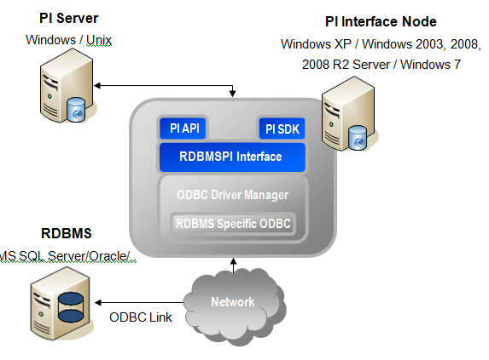
Configuration Diagram – All PI Software and RDBMS Installed on one Node
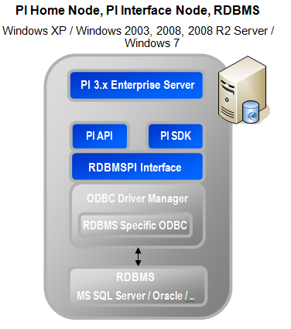
Note: For both of the configuration options depicted above - the communication between the RDBMPI interface and a PI Server is established via PI API and, optionally, through PI SDK. PI API is used for the actual transfer of time series, PI SDK is used for replication of the PI Batch Database and for reading from and writing to PI Annotations. To activate the PI SDK link, the /PISDK=1 start-up parameter must be defined.
The communication between the RDBMSPI interface and a relational database happens through the ODBC library. The interface can thus connect a relational database, which runs either on an interface node, or can be remote. This remote database node does not have to be the Windows platform.

Principles of Operation
The PI Relational Database Interface runs on Windows operating systems as a console application or as a Windows NT service. As already stated, it uses the extended PI API and/or PI SDK to connect to the PI Server node and the specified ODBC driver for connection to the Relational DataBase (RDB). For the ODBC connection, the Data Source Name (DSN) must be created via the ODBC Administrator (the Data Sources ODBC icon in Windows Control Panel). This DSN name is then passed within the start-up parameters of the interface; example: /DSN=OracleX.
SQL queries are provided by the user in the form of either ASCII files, or via direct definition in the PI point's ExtendedDescriptor. Queries are executed according to the scan class type (cyclic or event driven) of a PI point holding the query definition.
In the direction from a relational database to PI - input, the appropriate SELECT, or a Stored Procedure returning a result-set, must be specified. The interface then converts the result-set into the PI time-series concept of: timestamp, value, status, annotation.
The opposite direction - writing data out of PI to RDB - uses the concept of run-time placeholders and a different set of SQL statements (INSERT, UPDATE, Stored Procedure call,..).

General Features Supported by the Current Version if the RDBMSPI interface:
- Query timestamp, value, status and/or annotation in RDB tables
- Scan or Event based (input)
- SELECT queries or Stored Procedures calls
- Query data (input) for: Single tags, Multiple tags (Tag Group), Multiple tags via TagName Key (Tag Distribution and RxC Strategy).
- Event or Scan based (output): INSERT, UPDATE and DELETE statements and Stored Procedure calls
- Support of multiple SQL statements – multiple statements per PI tag (multiple statements can be one single transaction - /TRANSACT keyword or auto-committed)
- Millisecond and sub-millisecond timestamp resolution
- Support of runtime placeholders: timestamp (scan time, snapshot time,…), value, status and/or annotation, including the foreign tags (tags outside the interface point-source)
- Access to all PI point attributes (classic point class) through placeholders AT.x
- History recovery for input and output points
- Old PI Batch Database replication to RDB through BA.x placeholders
- New PI Batch Database replication (batches, unit-batches, sub-batches)
- Recording of the PI point attribute changes into RDB
- Support for different Timezone/DST settings than PI Server
- RDB timestamps as well as timestamps taken from PI (through placeholders) can optionally be in UTC (/UTC start-up parameter)
- And many others.
The two sections, which follow - Concept of Data Input from Relational Database to PI and Concept of Data Output from PI to Relational Database, briefly explain the basics how the time-series data is transferred from RDB to PI and vice versa (from PI to RDB). The more detailed description of SQL statements, placeholders, retrieval strategies, hints to individual RDBs, etc. follows in section SQL Statements later on in this manual.

Concept of Data Input from Relational Database to PI
The SELECT query is generally expected to provide a result-set consisting of the following columns: timestamp, value, status [,annotation]. The interface then internally transforms such a result-set according to the specified distribution strategy. The following paragraphs outline the principles of the individual data collection approaches; from a simple approach - per-tag-query-definitions to more complex ones, where the result-set contains time-series for multiple tags.
Note: The sole purpose for supporting several distribution strategies is to minimize the number of queries the interface executes. As stated in the beginning of this manual – an execution of fewer queries, which retrieve data for more PI tags, is less expensive and faster than per-tag query execution.

Query for Single Tag – One Value per Scan
There are Distributed Control Systems (DCS) that keep only current values in relational database tables. Through the scan-based, per-tag defined SELECT, the interface can read such data in a timely (periodical) manner. In fact, RDBMSPI then simply emulates the behavior of a standard DCS interface - the corresponding SELECT is expected to return exactly one row, which represents a snapshot of the given value. The obvious disadvantage of this kind of data retrieval is low performance and accuracy limited to the scan frequency. Needless to say that relational databases are not designed for this kind querying on a massive scale, like hundreds or thousands of queries executed in a loop.
A typical low throughput query can be similar to:
SELECT TOP 1 Timestamp,Value,Status FROM Table WHERE Name=?;

Query for Single Tag – Time-Series per Scan
A better strategy (compared to the one described in the previous paragraph) is to define lower scan rates (e.g. 1+ minute) instead of executing the “one-row-delivering” SELECT every second. In other words, getting the same amount of data in one call is faster and less expensive than getting it in many calls. This approach, however, assumes that RDB tables get populated by INSERTs (not UPDATEs); the interface then retrieves “true time-series”, even if still for one tag. The mandatory timestamp column serves as a book-mark, because the ultimate goal is to read only the newly arrived rows since the last scan.
An example of a query delivering a per-tag-time-series can be like:
SELECT Timestamp,Value,Status FROM Table WHERE Name=? AND Timestamp>? ORDER BY Timestamp ASC;
As a result, the interface obtains a succession of time-ordered rows representing only those, which have been INSERTed since the last scan. This is achieved by asking for rows bigger than the timestamp question-mark. Moreover, the interface can also do the PI exception reporting, because the result-set is ordered.
For more detailed description of the per-tag reads, see section SQL SELECT Statement for Single PI Tag. Concrete examples are in:
Appendix C: Examples Example 1.1 – single tag query.
Appendix C: Examples Example 1.2 – query data array for a single tag.

Tag Groups
Another way of improving performance (compared to reading time-series for a single tag) is grouping tags together. For Tag Groups - an RDB table should be structured in a way that multiple events are stored in the same row in more columns. Hence, the result-set for Tag Groups must be of the following form:
Timestamp,Value1,Status1,Value2,Status2,…
Timestamp,Value1,Status1,Value2,Status2,…
…
or, in case there is a timestamp column for every value/status pair:
Timestamp1,Value1,Status1,Timestamp2,Value2,Status2,…
Timestamp1,Value1,Status1,Timestamp2,Value2,Status2,…
…
An example of the “Tag Group” SELECT statement can be like:
SELECT Timestamp,Value1,Status1,Value2,Status2,… FROM Table WHERE Timestamp>? ORDER BY Timestamp ASC;
Obviously, querying such a table is more efficient than having a SELECT statement defined per a single tag. For detailed description of this distribution strategy, see section SQL SELECT Statement for Tag Groups. The concrete example: Appendix C: Examples Example 1.3 – three PI points forming a GROUP.

Tag Distribution
Compared to Tag Groups, where grouping happens in the form of multiple ValueN, StatusN pairs in the SELECT list, the Tag Distribution approach requires “named rows”. That means, an additional field must be provided in the result-set; the Name column then tells the interface to which target point a particular row will be distributed. The result set for Tag Distribution should have the following form:
Timestamp,Name,Value,Status
Timestamp,Name,Value,Status
…
An example of a “Tag Distribution” SELECT can be like:
SELECT Timestamp,Name,Value,Status FROM Table WHERE Timestamp > ?;
Again, a SELECT query delivering time-series for multiple tags allows for more efficient data retrieval. For a detailed description of this distribution strategy, see section SQL SELECT Statement for Tag Distribution. A concrete example can be found in Appendix C: Examples Example 1.4 – Tag Distribution.

RxC Distribution (combination of Group and Distribution)
Some laboratory data in RDB tables have a common structure that looks like:
SAMPLETIME,TANK_NAME,TANK_LEVEL,TANK_LEVEL_STATUS,TEMPERATURE_NAME,TEMPERATURE_VALUE,TEMPERATURE_STATUS,DENSITY_NAME, DENSITY_VALUE, DENSITY_STATUS, …
…
To efficiently transform and forward this kind of result-set to PI, the interface implements a strategy that accepts data being structured as follows:
Timestamp,Name1,Value1,Status1,Name2,Value2,Status2,…
Timestamp,Name1,Value1,Status1,Name2,Value2,Status2,…
…
or, in case there is a timestamp column for every name/value/status set:
Timestamp1,Name1,Value1,Status1,Timestamp2,Name2,Value2,Status2,…
Timestamp1,Name1,Value1,Status1,Timestamp2,Name2,Value2,Status2,…
…
The RxC approach is actually a combination of the Tag Group and Tag Distribution retrievals. For a more detailed description of this distribution strategy, see section SQL SELECT Statement for RxC Distribution and a concrete example can be found in Appendix C: Examples Example 1.5 – RxC Distribution.

Concept of Data Output from PI to Relational Database
Transferring data from PI to a relational database works similarly to RDB reading; that is, an appropriate SQL statement (usually INSERT) needs to be defined. Statements are executed either event driven (sign-up for snapshot), or on a periodical basis. For copying data from PI to a relational database, the event based approach is used most often. To achieve this, an output tag (a tag that actually executes an SQL statement) must have a reference to its SourceTag. The SourceTag triggers the execution and the output tag itself then gets a copy of the exported data to signal the success or failure of the output operation.
For periodical output, the corresponding output PI point configuration should look like those for input points; the difference is that the SQL statements used are those which modify the relational database; INSERT, UPDATE, DELETE, or the Stored Procedure call. More detailed description can be found in section Output from PI.
See examples in these sections:
- Example 2.1a – insert sinusoid values into table (event based).
- Example 2.1b – insert sinusoid values into table (scan based).
- Example 2.1c – insert 2 different sinusoid values into table (event based).
- Example 2.1d – insert sinusoid values with (string) annotations into RDB table (event based).

Use of PI SDK
RDBMSPI features implemented through PI SDK are the following:
- Writing to and reading from PI annotations
Next to the timestamp, value and status, RDBMSPI interface can write/read also to PI annotations (see section Data Acquisition Strategies and see the PI_ANNOTATION keyword).
- Replication of PI Batch Database
See chapter PI Batch Database Output.
All the above mentioned features are optional. However, users have to be aware that when these features are configured on nodes with buffering, the PI SDK buffering must be enabled in order the PI SDK calls are buffered properly; the PI SDK buffering ships with PI SDK version 1.4 and above.
Note: In order to activate the PI SDK link, enable PI SDK through PI ICU,
or manually specify the /PISDK=1 start-up parameter.
CAUTION!
When RDBMSPI interface runs against High Availability PI Servers, SQL queries containing the annotation column on nodes NOT supporting the PI SDK buffering,
will NOT deliver events to other collective members, but the primary.
Events with annotations will always bypass exception reporting.
Use of PI SDK requires the PI Known Server’s Table contains the PI Server name the interface connects to.

UniInt Failover
This interface supports UniInt failover. Refer to the UniInt Failover Configuration section of this document for configuring the interface for failover.

Installation Checklist
If you are familiar with running PI data collection interface programs, this checklist helps you get the Interface running. If you are not familiar with PI interfaces, return to this section after reading the rest of the manual in detail.
This checklist summarizes the steps for installing this Interface. You need not perform a given task if you have already done so as part of the installation of another interface. For example, you only have to configure one instance of buffering for every Interface Node regardless of how many interfaces run on that node.
The Data Collection Steps below are required. Interface Diagnostics and Advanced Interface Features are optional.
Note: The steps below should be followed in the order presented.

Data Collection Steps
- Confirm that you can use PI SMT to configure the PI Server. You need not run PI SMT on the same computer on which you run this interface.
- If you are running the interface on an interface node, edit the PI Server’s trust table to allow the Interface to write data.
- Run the installation kit for the PI Interface Configuration Utility (ICU) on the interface node if the ICU will be used to configure the interface. This kit runs the PI SDK installation kit, which installs both the PI API and the PI SDK.
- Run the installation kit for this Interface. This kit also runs the PI SDK installation kit which installs both the PI API and the PI SDK if necessary.
- If you are running the interface on an interface node, check the computer’s time zone properties. An improper time zone configuration can cause the PI Server to reject the data that this interface writes.
- Run the ICU and configure a new instance of this interface. Essential startup parameters for this interface are:

Point Source (/PS=x)

Interface ID (/ID=#)

PI Server (/Host=host:port)
Scan Class (/F=##:##:##,offset)

Data Source Name (/dsn)

Interface log file (/output)
- If you will use digital points, define the appropriate digital state sets.
- Build input tags and, if desired, output tags for this interface. Important point attributes and their purposes are:
Location1 specifies the interface instance ID.
Location2 specifies bulk vs. non-bulk reading.
Location3 defines the reading strategy.
Location4 specifies the scan class.
Location5 specifies how the data is sent to PI (snapshot, archive write,..).
ExtendedDescriptor stores the various keywords.
InstrumentTag specifies name of the file that stores the SQL file.
SourceTag for output points.
- Configure the interface using the PI ICU utility or edit startup command file manual. It is recommended to use PI ICU whenever possible.
- Configure performance points.
- Configure the I/O Rate tag.
- It is recommended to test the connection between the interface node and the RDB using any third-party ODBC based application. For example the ODBC Tester app. from Microsoft or any other tool that works with ODBC data sources. Verify that the SQL query(ies) are syntactically correct and they deliver data from/to the above mentioned third-party ODBC based applications.
- Take one, (ideally) simple SQL statement, which has been tested in the third party tool and configure an interface tag, which will use it.
- Set or check the interface node clock.
- Start the interface interactively and confirm its successful connection to the PI Server without buffering.
- Confirm that the interface collects data successfully for one tag. If OK, add more.
- Stop the interface and configure a buffering application (either Bufserv or PIBufss). When configuring buffering use the ICU menu item Tools Buffering… Buffering Settings to make a change to the default value (32678) for the Primary and Secondary Memory Buffer Size (Bytes) to 2000000. This will optimize the throughput for buffering and is recommended by OSIsoft.
- Start the buffering application and the interface. Confirm that the interface works together with the buffering application by either physically removing the connection between the Interface Node and the PI Server Node or by stopping the PI Server.
- Configure the Interface to run as the Windows Service. Confirm that the interface runs properly as a Service.
- Restart the interface node and confirm that the interface and the buffering application restart.

Interface Diagnostics
- Configure Scan Class Performance points.
- Install the PI Performance Monitor Interface (Full Version only) on the Interface Node.
- Configure Performance Counter points.
- Configure UniInt Health Monitoring points
- Configure the I/O Rate point.
- Install and configure the Interface Status Utility on the PI Server Node.
- Configure the Interface Status point.

Advanced Interface Features
Configure UniInt Failover; see that section in this document for details related to configuring the interface for failover.

Interface Installation

Interface on PI Interface Nodes
OSIsoft recommends that interfaces be installed on PI interface nodes instead of directly on the PI Server node. A PI interface node is any node other than the PI Server node where the PI Application Programming Interface (PI API) is installed (see the PI API manual). With this approach, the PI Server need not compete with interfaces for the machine’s resources. The primary function of the PI Server is to archive data and to service clients that request data.
On the PI API nodes, OSIsoft’s interfaces are usually installed along with the buffering service. For more information about Buffering see the Buffering section of this manual.
In most cases, interfaces on PI interface nodes should be installed as automatic services. Services keep running after the user logs off. Automatic services automatically restart when the computer is restarted, which is useful in the event of a power failure.
The guidelines are different if an interface is installed on the PI Server node. In this case, the typical procedure is to install the PI Server as an automatic service and install the interface as an automatic service that depends on the PI Update Manager and PI Network Manager services. This typical scenario assumes that Buffering is not enabled on the PI Server node. Bufserv can be enabled on the PI Server node so that interfaces on the PI Server node do not need to be started and stopped in conjunction with PI, but it is not standard practice to enable buffering on the PI Server node. The PI Buffer Subsystem can also be installed on the PI Server. See the UniInt Interface User Manual for special procedural information.
More considerations about NT Services and ODBC applications are described in section What is Meant by "Running an ODBC Application as Windows Service"?

Naming Conventions and Requirements
In the installation procedure below, it is assumed that the name of the interface executable is rdbmspi.exe and that the startup command file is called rdbmspi.bat.

When Configuring the Interface Manually
It is customary for the user to rename the executable and the startup command file when multiple copies of the interface are run. For example, rdbmspi1.exe and rdbmspi1.bat would typically be used for interface number 1, rdbmspi2.exe and rdbmspi2.bat for interface number 2, and so on. When an interface is run as a service, the executable and the command file must have the same root name because the service looks for its command-line parameters in a file that has the same root name.
Note: The interface is installed along with the .pdb file (file containing the debug information). This file can be found in the same directory as the executable file or in %windir%\Symbols\exe. If you rename the rdbmspi.exe to rdbmspi1.exe, you also have to create/rename the corresponding .pdb file. That is, rdbmspi.pdb to rdbmspi1.pdb.

Interface Directories

PIHOME Directory Tree

32-bit Interfaces
The [PIHOME] directory tree is defined by the PIHOME entry in the pipc.ini configuration file. This pipc.ini file is an ASCII text file, which is located in the %windir% directory.
For 32-bit operating systems, a typical pipc.ini file contains the following lines:
[PIPC]
PIHOME=C:\Program Files\PIPC
For 64-bit operating systems, a typical pipc.ini file contains the following lines:
[PIPC]
PIHOME=C:\Program Files (X86)\PIPC
The above lines define the root of the PIHOME directory on the C: drive. The PIHOME directory does not need to be on the C: drive. OSIsoft recommends using the paths shown above as the root PIHOME directory name.

Interface Installation Directory
The interface install kit will automatically install the interface to:
PIHOME\Interfaces\RDBMSPI\
PIHOME is defined in the pipc.ini file.

Interface Installation Procedure
The RDBMSPI interface setup program uses the services of the Microsoft Windows Installer. Windows Installer is a standard part of Windows 2000 and later operating systems. To install, run the appropriate installation kit.
RDBMSPI_#.#.#.#_.exe

Installing Interface as a Windows Service
The PI RDBMS Interface service can be created, preferably, with the PI Interface Configuration Utility, or it can be created manually.

Installing Interface Service with PI Interface Configuration Utility
The PI Interface Configuration Utility provides a user interface for creating, editing, and deleting the interface service:
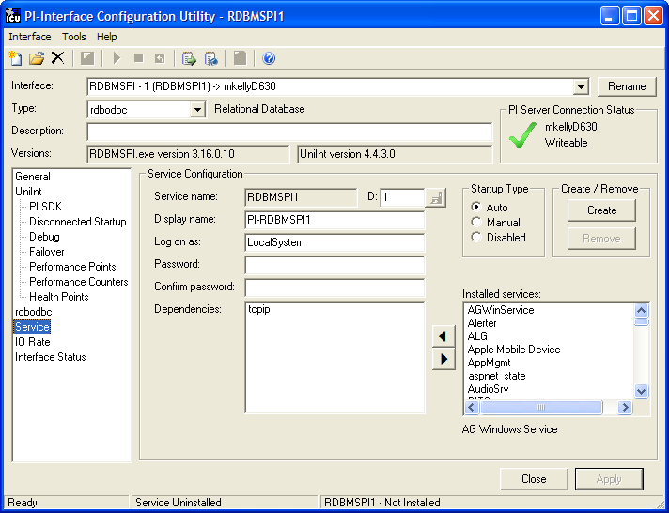

Service Configuration

Service name
The Service name box shows the name of the current interface service. This service name is obtained from the interface executable.

ID
This is the service id used to distinguish multiple instances of the same interface using the same executable.

Display name
The Display Name text box shows the current Display Name of the interface service. If there is currently no service for the selected interface, the default Display Name is the service name with a “PI-” prefix. Users may specify a different Display Name. OSIsoft suggests that the prefix “PI-” be appended to the beginning of the interface to indicate that the service is part of the OSIsoft suite of products.

Log on as
The Log on as text box shows the current “Log on as” Windows User Account of the interface service. If the service is configured to use the Local System account, the Log on as text box will show “LocalSystem”. Users may specify a different Windows User account for the service to use.

Password
If a Windows User account is entered in the Log on as text box, then a password must be provided in the Password text box, unless the account requires no password.

Confirm password
If a password is entered in the Password text box, then it must be confirmed in the Confirm Password text box.

Dependencies
The Installed services list is a list of the services currently installed on this machine. Services upon which this interface is dependent should be moved into the Dependencies list using the button. For example, if API Buffering is running, then “bufserv” should be selected from the list at the right and added to the list on the left. To remove a service from the list of dependencies, use the button, and the service name will be removed from the Dependencies list.
When the interface is started (as a service), the services listed in the dependency list will be verified as running (or an attempt will be made to start them). If the dependent service(s) cannot be started for any reason, then the interface service will not run.
Note: Please see the PI Log and Windows Event Logger for messages that may indicate the cause for any service not running as expected.

- Add Button
To add a dependency from the list of Installed services, select the dependency name, and click the Add button.

- Remove Button
To remove a selected dependency, highlight the service name in the Dependencies list, and click the Remove button.
The full name of the service selected in the Installed services list is displayed below the Installed services list box.

Startup Type
The Startup Type indicates whether the interface service will start automatically or needs to be started manually on reboot.
- If the Auto option is selected, the service will be installed to start automatically when the machine reboots.
- If the Manual option is selected, the interface service will not start on reboot, but will require someone to manually start the service.
- If the Disabled option is selected, the service will not start at all.
Generally, interface services are set to start automatically.

Create
The Create button adds the displayed service with the specified Dependencies and with the specified Startup Type.

Remove
The Remove button removes the displayed service. If the service is not currently installed, or if the service is currently running, this button will be grayed out.

Start or Stop Service
The toolbar contains a Start button and a Stop button . If this interface service is not currently installed, these buttons will remain grayed out until the service is added. If this interface service is running, the Stop button is available. If this service is not running, the Start button is available.
The status of the Interface service is indicated in the lower portion of the PI ICU dialog.
Status of the Interface Service
Service installed or uninstalled

Status of the ICU

Installing Interface Service Manually
Help for installing the interface as a service is available at any time with the command:
RDBMSPI.exe –help
Open a Windows command prompt window and change to the directory where the rdbmspi1.exe executable is located. Then, consult the following table to determine the appropriate service installation command.
Windows Service Installation Commands on a PI Interface Node or a PI Server Node with Bufserv implemented
Manual service | RDBMSPI.exe –install –depend "tcpip bufserv"
Automatic service | RDBMSPI.exe –install –auto –depend "tcpip bufserv"
*Automatic service with service id | RDBMSPI.exe –serviceid X –install –auto –depend "tcpip bufserv"
Windows Service Installation Commands on a PI Interface Node or a PI Server Node without Bufserv implemented
Manual service | RDBMSPI.exe –install –depend tcpip
Automatic service | RDBMSPI.exe –install –auto –depend tcpip
*Automatic service with service id | RDBMSPI.exe –serviceid X –install –auto –depend tcpip
*When specifying service id, the user must include an id number. It is suggested that this number correspond to the interface id (/id) parameter found in the interface .bat file.
Check the Microsoft Windows Services control panel to verify that the service was added successfully. The services control panel can be used at any time to change the interface from an automatic service to a manual service or vice versa.

What is Meant by "Running an ODBC Application as Windows Service"?
Consider the following guidelines carefully before configuring the interface:
The interface MUST be capable of connecting to RDB as a console application before you attempt to run it as a Windows service.
Including this step is vitally important, because running an application as Windows service adds another level of complexity that can mask other issues that have nothing to do with the fact that the application is running as a Windows service. Once it has been verified that the application can run successfully as a stand-alone application, it can be assumed that any problems that arise when running the application as Windows service have something to do with the system’s configuration.
The ODBC driver/client and any necessary database client software MUST be on the system PATH.
On Windows machines, there is a distinction made between system environment variables and user environment variables. System environment variables are used whenever the operating system is in use, no matter whether there is a particular user-id logged in or not. This is important, because if the ODBC driver/client (and database client software, if needed) is listed on the PATH environment variable as user environment variables, these values will only be valid as long as the particular user-id for whom they are set is logged in, and not at system boot-up.
If you are using an ODBC data source to establish the connection, the data source MUST be a System DSN.
The reasons for this are similar to the first situation – user DSNs can only be accessed by someone logged into the machine with a particular user-id, and not at system boot-up. System DSNs are available at boot-up and by any application running under any account.
To check this, open the ODBC Data Source Administrator and make sure that the data source in question appears on the list on the "System DSN" tab. If it is not there, create one and add it to this list, and ensure the application points to it.

The latest version of MDAC MUST be on the interface node.
There has been at least one occasion where a customer was able to resolve his issue running his application as a service with his database by installing the latest MDAC. As of the authoring of this document, MDAC 2.8 SP1 is the latest version.

Digital States
For more information regarding Digital States, refer to the PI Server documentation.

Digital State Sets
PI digital states are discrete values represented by strings. These strings are organized in PI as digital state sets. Each digital state set is a user-defined list of strings, enumerated from 0 to n to represent different values of discrete data. For more information about PI digital tags and editing digital state sets, see the PI Server manuals.
An interface point that contains discrete data can be stored in PI as a digital point. A digital point associates discrete data with a digital state set, as specified by the user.

System Digital State Set
Similar to digital state sets is the system digital state set. This set is used for all points, regardless of type, to indicate the state of a point at a particular time. For example, if the interface receives bad data from the data source, it writes the system digital state Bad Input to PI instead of a value. The system digital state set has many unused states that can be used by the interface and other PI clients. Digital States 193-320 are reserved for OSIsoft applications.

PointSource
The PointSource is a unique, single or multi-character string that is used to identify the PI point as a point that belongs to a particular interface. For example, the string Boiler1 may be used to identify points that belong to the MyInt Interface. To implement this, the PointSource attribute would be set to Boiler1 for every PI point that is configured for the MyInt Interface. Then, if /ps=Boiler1 is used on the startup command-line of the MyInt Interface, the Interface will search the PI Point Database upon startup for every PI point that is configured with a PointSource of Boiler1. Before an interface loads a point, the interface usually performs further checks by examining additional PI point attributes to determine whether a particular point is valid for the interface. For additional information, see the /ps parameter. If the PI API version being used is prior to 1.6.x or the PI Server version is prior to 3.4.370.x, the PointSource is limited to a single character unless the SDK is being used.

Case-sensitivity for PointSource Attribute
The PointSource character that is supplied with the /ps command-line parameter is not case sensitive. That is, /ps=P and /ps=p are equivalent.

Reserved Point Sources
Several subsystems and applications that ship with PI are associated with default PointSource characters. The Totalizer Subsystem uses the PointSource character T, the Alarm Subsystem uses G and @, Random uses R, RampSoak uses 9, and the Performance Equations Subsystem uses C. Do not use these Point Source characters or change the default point source characters for these applications. Also, if a PointSource character is not explicitly defined when creating a PI point; the point is assigned a default PointSource character of Lab (PI 3). Therefore, it would be confusing to use Lab as the PointSource character for an interface.
Note: Do not use a PointSource character that is already associated with another interface program. However it is acceptable to use the same point source for multiple instances of an interface.

PI Point Configuration
The PI point is the basic building block for controlling data flow to and from the PI Server. A single point is configured for each measurement value that needs to be archived.

Point Attributes
Use the point attributes below to define the PI point configuration for the Interface, including specifically what data to transfer.

Tag
The Tag attribute (or tagname) is the name for a point. There is a one-to-one correspondence between the name of a point and the point itself. Because of this relationship, PI documentation uses the terms “tag” and “point” interchangeably.
Follow these rules for naming PI points:
- The name must be unique on the PI Server.
- The first character must be alphanumeric, the underscore (_), or the percent sign (%).
- Control characters such as linefeeds or tabs are illegal.
- The following characters also are illegal: * ’ ? ; { } [ ] | \ ` ' "

Length
Depending on the version of the PI API and the PI Server, this Interface supports tags whose length is at most 255 or 1023 characters. The following table indicates the maximum length of this attribute for all the different combinations of PI API and PI Server versions.
PI API | PI Server | Maximum Length
1.6.0.2 or higher | 3.4.370.x or higher | 1023
1.6.0.2 or higher | Below 3.4.370.x | 255
Below 1.6.0.2 | 3.4.370.x or higher | 255
Below 1.6.0.2 | Below 3.4.370.x | 255

PointSource
The PointSource attribute contains a unique, single or multi-character string that is used to identify the PI point as a point that belongs to a particular interface. For additional information, see the /ps command-line parameter and the PointSource section.
Note: See in addition the Location1 parameter – interface instance number.

PointType
Typically, device point types do not need to correspond to PI point types. For example, integer values from a device can be sent to floating point or digital PI tags. Similarly, a floating-point value from the device can be sent to integer or digital PI tags, although the values will be truncated.
PointType | How It Is Used
Digital | Used for points whose value can only be one of several discrete states. These states are predefined in a particular state set (PI 3.x).
Int16 | 15-bit unsigned integers (0-32767)
Int32 | 32-bit signed integers (-2147450880 – 2147483647)
Float16 | Scaled floating-point values. The accuracy is one part in 32767
Float32 | Single-precision floating point values.
Float64 | Double-precision floating point values.
String | Stores string data of up to 977 characters.
Timestamp | The Timestamp point type for any time/date in the range  01-Jan-1970 to 01-Jan-2038 Universal Time (UTC).
For more information about the individual point types, see PI Server Manual.

Location1
This is the number of the interface process that collects data for this tag. The interface can run multiple times on one node (PC) and therefore distribute the CPU power evenly. In other words Location1 allows further division of points within one Point Source. The Location1 parameter should match the parameter /id (or /in) found in the startup file.
Note: It is possible to start multiple interface processes on different PI API nodes. But then a separate software license for the interface is required. One API node can run an unlimited number of instances.

Location2
The second location parameter specifies if all rows of data returned by a SELECT statement should be written into the PI database, or if just the first one is taken (and the rest skipped).
Note: For Tag Groups, the master tag will define this option for all tags in a group. It is not possible to read only the first record for one group member and all records for another one.
For Tag Distribution, the interface ALWAYS takes the whole result-set regardless of the Location2 setting.
Location2 | Data Acquisition Strategy
0 | Only the first record is valid  (except for the Tag Distribution Strategy and the RxC Strategy)
1 | The interface fetches and sends all data in the result-set to PI
Note: If there is no timestamp column in the SELECTed result-set and Location2=1; that is, the interface automatically provides the execution time, all the rows will get the same timestamp!

Location3
The third location parameter specifies the Distribution Strategy – how the selected data will be interpreted and sent to PI.
Location3 | Data Acquisition Strategy
0 | SQL query populates a Single Tag
> 0 | Location3 represents the column number of a multiple field query Tag Groups
-1 | Tag Distribution  (Tag name or Tag Alias name must be part of the result set)
-2 | RxC Distribution  (Multiple tag names or tag aliases name must be part of the result set)

Location4

Scan-based Inputs
For interfaces that support scan-based collection of data, Location4 defines the scan class for the PI point. The scan class determines the frequency at which input points are scanned for new values. For more information, see the description of the /f parameter in the Startup Command File section.

Trigger-based Inputs, Unsolicited Inputs, and Output Points
Location4 should be set to zero for these points.
Location4 | Type of Evaluation
Positive number | Index to the position of /f= startup parameter keyword (scan class number)
0 | Event based output and event based input, unsolicited points
-1 | Specifies the Managing Tag for recording of Pipoint Database changes in the short form. See section Recording of PI Point Database Changes for more details.
-2 | Specifies the Managing Tag for recording of Pipoint Database changes in the full form. See section Recording of PI Point Database Changes for more details.

Location5

Input Tags
If Location5=1 the interface bypasses the exception reporting (for sending data to PI it then uses the pisn_putsnapshot() function; see the PI API manual for more about this function call). Out-of-order data always goes directly to the archive through the function piar_putarcvaluex(ARCREPLACE).
Note: Out-of-order data means newvalue.timestamp < prevvalue.timestamp
Location5 | Behavior
0 | The interface does the exception reporting in the standard way. Out-of-order data is supported, but existing archive values cannot be replaced; there will be the -109 error in the pimessagelog.
1 | In-order data – the interface gives up the exception reporting – each retrieved value is sent to PI.  For out-of-order data – the existing archive values (same timestamps) will be replaced and the new events will be added (piar_putarcvaluex(ARCREPLACE)).  For PI3.3+ servers the existing snapshot data (the current value of a tag) is replaced. For PI2 and PI3.2 (or earlier) systems the snapshot values cannot be replaced. In this case the new value is added and the old value remains.  Note: When there are more events in the archive at the same timestamp, and the piar_putarcvaluex(ARCREPLACE) is used (out-of-order-data), only one event is overwritten – the first one!
2 | If the data comes in-order – the behavior is the same as with Location5=1  For out-of-order data – values are always added; that is, multiple values at the same timestamp can occur (piar_putarcvaluex(ARCAPPENDX)).

Output Tags
Location5 | Behavior
-1 | In-order data is processed normally.  Out-of-order data does not trigger the query execution.
0 | In-order as well as out-of-order data is processed normally.  Note: No out-of-order data handling in the recovery mode. See chapter RDBMSPI – Output Recovery Modes (Only Applicable to Output Points)
1 | In-order data is processed normally.  Enhanced out-of-order data management.  Note: special parameters that can be evaluated in the SQL query are available; see the section Out-Of-Order Recovery.
Note: If the query (for input points) contains the annotation column, the exception reporting will NOT be applied!

InstrumentTag

Length
Depending on the version of the PI API and the PI Server, this Interface supports an InstrumentTag attribute whose length is at most 32 or 1023 characters. The following table indicates the maximum length of this attribute for all the different combinations of PI API and PI Server versions.
PI API | PI Server | Maximum Length
1.6.0.2 or higher | 3.4.370.x or higher | 1023
1.6.0.2 or higher | Below 3.4.370.x | 32
Below 1.6.0.2 | 3.4.370.x or higher | 32
Below 1.6.0.2 | Below 3.4.370.x | 32
If the PI Server version is earlier than 3.4.370.x or the PI API version is earlier than 1.6.0.2, and you want to use a maximum InstrumentTag length of 1023, you need to enable the PI SDK. See Appendix B for information.
The InstrumentTag attribute is the filename containing the SQL statement(s). The file location is defined in a start-up parameter by the /SQL=directory_path.
Note: The referenced file is only evaluated when the pertinent tag gets executed for the first time, and then, after each point attribute change event. If the SQL statement(s) needs to be changed (during the interface operation, without the interface restart), OSIsoft recommends editing any of the PI point attributes – this action forces the interface to re-evaluate the tag in terms of closing the opened SQL statement(s) and re-evaluating the new statement(s) again.

ExDesc (ExtendedDescriptor)

Length
Depending on the version of the PI API and the PI Server, this Interface supports an ExDesc attribute whose length is at most 80 or 1023 characters. The following table indicates the maximum length of this attribute for all the different combinations of PI API and PI Server versions.
PI API | PI Server | Maximum Length
1.6.0.2 or higher | 3.4.370.x or higher | 1023
1.6.0.2 or higher | Below 3.4.370.x | 80
Below 1.6.0.2 | 3.4.370.x or higher | 80
Below 1.6.0.2 | Below 3.4.370.x | 80
If the PI Server version is earlier than 3.4.370.x or the PI API version is earlier than 1.6.0.2, and you want to use a maximum ExDesc length of 1023, you need to enable the PI SDK. See Appendix B for information.
The following tables summarize all the RDBMSPI specific definitions that can be specified in ExtendedDescriptor.

Recognized Keywords in the ExtendedDescriptor
Keyword | Example | Remark
/ALIAS | /ALIAS=Level321_in  or  /ALIAS="Tag123 Alias"  (support for white spaces) | Used with the DISTRIBUTOR strategy. This allows having different point names in RDB and in PI.
/EXD | /EXD=C:\PIPC\...\PLCHLD1.DEF | Allows getting over the 80-character limit (PI2) of the ExtendedDescriptor. (Suitable for tags with many placeholders.)
/SQL | /SQL="SELECT Timestamp, Value, status FROM Table WHERE Timestamp >?;" P1=TS | Suitable for short SQL statements. Allows the on-line statement changes (sign-up-for-updates) to be immediately reflected. The actual statement should be double-quoted and the ending semicolon is mandatory.
/TRANSACT | /TRANSACT | Suitable for cases when there is more than one SQL statement specified for the given tag. The statements succession is considered as one transaction, which is either committed or rolled back (if a runtime error occurs).
/TRIG  or  /EVENT | /EVENT=sinusoid  /EVENT='tag name with spaces'  /EVENT=tagname, /SQL="SELECT…;"  special:  /EVENT=sinusoid condition | Used for event driven input points. Each time the particular event point changes, the actual point is processed (SQL query is executed). Comma is used to divide the /EVENT keyword and any possible definition that might follow.  An optional condition keyword can be specified in order to filter input events (trigger conditions see table 25. For details).

Placeholders in the Extended Descriptior
Keyword | Example | Remark
TS, ST, LST,LET,  VL, SS_I, SS_C,  ANN_TS, ANN_R, ANN_I,  ANN_C | P1=TS P2=VL P3=ANN_C | Placeholder definitions. Placeholders do not have to be divided by comma.

Batch Database Related Keywords in the ExtendedDescriptor
Keyword | Example | Remark
/BA.ID | /BA.ID="Batch1" | Wildcard string of PIBatchID to match; defaults to "*".
/BA.GUID | /BA.GUID="16-bytes GUID" | Exact Unique ID of PIBatch object
/BA.PRODID | /BA.PRODID="Product1" | Wildcard string of Product to match; defaults to "*".
/BA.RECID | /BA.RECID="Recipe1" | Wildcard string of Recipe name to match; defaults to "*".
/BA.START | /BA.START="*-3d" | Search start time in PI time format.
/BA.END | /BA.END="*" | Search end time in PI time format.
/UB.BAID | /UB.BAID="Batch1" | Wildcard string of PIBatchID (Unit Batches) to match. Defaults to "*".
/UB.GUID | /UB.GUID="16-bytes GUID" | Unique id of PIUnitBatch
/UB.MODID | /UB.MODID="Module1" | Wildcard string of a PIModule name to match. Defaults to "*".
/UB.MODGUID | /UB.MODGUID="16- bytes GUID" | Unique id of PIModule
/UB.PRODID | /UB.PRODID="Product1" | Wildcard string of Product to match. Defaults to "*".
/UB.PROCID | /UB.PROCID="Procedure1" | Wildcard string of ProcedureName to match. Defaults to "*".
/SB.ID | /SB.ID="SubBatch1" | Wildcard string of PISubBatch name to match. Defaults to "*".
/UB.START | /UB.START="*-10d" | Search start time in PI time format.
/UB.END | /UB.END="*" | Search end time in PI time format.
/SB_TAG | /SB_TAG="Tagname" | Control tag for PISubBatch INSERT
Note: ExtendedDescriptor size is limited to 1024 characters.

Note: The keyword evaluation is case sensitive. That is, the aforementioned keywords have to be in capital letters!

Performance Points
For UniInt-based interfaces, the ExtendedDescriptor is checked for the string “PERFORMANCE_POINT”. If this character string is found, UniInt treats this point as a Performance Point. See the section called Performance Counters Points.

Trigger-based Inputs
For trigger-based input points, a separate trigger point must be configured. An input point is associated with a trigger point by entering a case-insensitive string in the ExtendedDescriptor PI point attribute of the input point of the form:
keyword=trigger_tag_name
where keyword is replaced by “event” or “trig” and trigger_tag_name is replaced by the name of the trigger point. There should be no spaces in the string. UniInt automatically assumes that an input point is trigger-based instead of scan-based when the keyword=trigger_tag_name string is found in the ExtendedDescriptor attribute.
An input is triggered when a new value is sent to the snapshot of the trigger point. The new value does not need to be different than the previous Snapshot value to trigger an input, but the timestamp of the new value must be greater than (more recent than) or equal to the timestamp of the previous value. This is different than the trigger mechanism for output points. For output points, the timestamp of the trigger value must be greater than (not greater than or equal to) the timestamp of the previous value.
Conditions can be placed on trigger events. Event conditions are specified in the ExtendedDescriptor as follows:
Event='trigger_tag_name' event_condition
The trigger tag name must be in single quotes. For example,
Event='Sinusoid' Anychange
will trigger on any event to the PI Tag sinusoid as long as the next event is different than the last event. The initial event is read from the snapshot.
The keywords in the following table can be used to specify trigger conditions.
Event Condition | Description
Anychange | Trigger on any change as long as the value of the current event is different than the value of the previous event. System digital states also trigger events. For example, an event will be triggered on a value change from 0 to “Bad Input,” and an event will be triggered on a value change from “Bad Input” to 0.
Increment | Trigger on any increase in value. System digital states do not trigger events. For example, an event will be triggered on a value change from 0 to 1, but an event will not be triggered on a value change from “Pt Created” to 0. Likewise, an event will not be triggered on a value change from 0 to “Bad Input.”
Decrement | Trigger on any decrease in value. System digital states do not trigger events. For example, an event will be triggered on a value change from 1 to 0, but an event will not be triggered on a value change from “Pt Created” to 0. Likewise, an event will not be triggered on a value change from 0 to “Bad Input.”
Nonzero | Trigger on any non-zero value. Events are not triggered when a system digital state is written to the trigger tag. For example, an event is triggered on a value change from “Pt Created” to 1, but an event is not triggered on a value change from 1 to “Bad Input.”

Scan
By default, the Scan attribute has a value of 1, which means that scanning is turned on for the point. Setting the scan attribute to 0 turns scanning off. If the scan attribute is 0 when the Interface starts, a message is written to the pipc.log and the tag is not loaded by the Interface. There is one exception to the previous statement.
If any PI point is removed from the Interface while the Interface is running (including setting the scan attribute to 0), SCAN OFF will be written to the PI point regardless of the value of the Scan attribute. Two examples of actions that would remove a PI point from an interface are to change the point source or set the scan attribute to 0. If an interface specific attribute is changed that causes the tag to be rejected by the Interface, SCAN OFF will be written to the PI point.

Shutdown
The Shutdown attribute is 1 (true) by default. The default behavior of the PI Shutdown subsystem is to write the SHUTDOWN digital state to all PI points when PI is started. The timestamp that is used for the SHUTDOWN events is retrieved from a file that is updated by the Snapshot Subsystem. The timestamp is usually updated every 15 minutes, which means that the timestamp for the SHUTDOWN events will be accurate to within 15 minutes in the event of a power failure. For additional information on shutdown events, refer to PI Server manuals.
Note: The SHUTDOWN events that are written by the PI Shutdown subsystem are independent of the SHUTDOWN events that are written by the Interface when the /stopstat=Shutdown command-line parameter is specified.
SHUTDOWN events can be disabled from being written to PI when PI is restarted by setting the Shutdown attribute to 0 for each point. Alternatively, the default behavior of the PI Shutdown Subsystem can be changed to write SHUTDOWN events only for PI points that have their Shutdown attribute set to 0. To change the default behavior, edit the \PI\dat\Shutdown.dat file, as discussed in PI Server manuals.

Bufserv and PIBufss
It is undesirable to write shutdown events when buffering is being used. Bufserv and PIBufss are utility programs that provide the capability to store and forward events to a PI Server, allowing continuous data collection when the Server is down for maintenance, upgrades, backups, and unexpected failures. That is, when PI is shutdown, Bufserv or PIBufss will continue to collect data for the Interface, making it undesirable to write SHUTDOWN events to the PI points for this Interface. Disabling Shutdown is recommended when sending data to a Highly Available PI Server Collective. Refer to the Bufserv or PIBufss manuals for additional information.

Source Tag
Output points control the flow of data from the PI Data Archive to any outside destination, such as a PLC or a third-party database. The UniInt based interfaces (including RDBMSPI) do use an indirect method for outputting values. That is, there are always two points involved – the SourceTag and the output tag. The output tag is actually an intermediary through which the SourceTag's snapshot is sent out. The rule is that whenever a value of the SourceTag changes, the interface outputs the value and, consequently, the output tag receives a copy of this event.
That means that outputs are normally not scheduled via scan classes (executed periodically). Nevertheless, outputting data to RDB on a periodical basis is possible. The interface does not namely mandate that the SQL statements for input points must be SELECTs. Input points can execute INSERTs, UPDATEs, DELETEs – SQL statements that send values to RDB (see section Output from PI for examples).
For outputs triggered by the SourceTag, the trigger tag (SourceTag) can be associated with any point source, including the point source of the interface it works with (referenced through the /ps start-up parameter). Also, the point type of the trigger tag does not need to be the same as the point type of the output tag. The default data type transformation is implemented.
As mentioned in previous paragraphs, an output is triggered when a new value is sent to the snapshot of a SourceTag. If no error is indicated (during the interface's output operation) then this value is finally copied to the output point. If the output operation is unsuccessful (e.g. any ODBC run time error occurred), then an appropriate digital state (Bad Output) is written to the output point.
Note: In case of an ODBC call failure, the output tag will receive the status Bad Output.

Unused Attributes
The interface does not use the following tag attributes.
- Conversion factor
- Filter code
- Square root code
- Total code
- UserInt1, UserInt2
- UserReal1, UserReal2

SQL Statements
As outlined in the previous sections, SQL statements can be defined in ASCII files, or can be specified directly within the ExtendedDescriptor of a PI tag. Both options are equivalent. ASCII files are located in the directory pointed to by the /SQL=directory_path keyword (found among the interface start-up parameters). Names of these files are arbitrary (the recommended form is filename.SQL) and the ASCII SQL file is bound to a given point via the InstrumentTag attribute. In case the InstrumentTag field is empty, the interface looks for a SQL statement definition in the ExtendedDescriptor (searching for the keyword /SQL). If no statement definition is found, the point is accepted, but marked inactive. Such a tag would only receive data via Tag Distribution or Tag Group strategies. Example: SQL statement definition in ExtendedDescriptor:
/SQL="SELECT Timestamp,Value,0 FROM Table WHERE Timestamp > ? ORDER BY Timestamp;" P1=TS
Note: The entire statement(s) definition text in the ExtendedDescriptor has to be surrounded by double-quotes (" ") and the semicolon ';' marking the end of a particular query is mandatory.
The same SQL statement defined in an ASCII file: SQL_in_ASCII.SQL
SELECT Timestamp,Value,0 FROM Table WHERE Timestamp > ? ORDER BY Timestamp;
Instrument Tag: SQL_in_ASCII.SQL
Extended Descriptor: P1=TS
Note: Both, the ASCII file and ExtendedDescriptor definitions can contain a sequence of SQL commands separated by semicolons ';'. When the interface works in the ODBC AUTOCOMMIT mode (default setting), each SQL statement gets committed immediately after the execution. Transaction can be enforced by the /TRANSACT keyword in the ExtendedDescriptor of a given tag; see section Explicit Transactions for more details.

Prepared Execution
Once SQL statement(s) have been accepted by the interface (during the interface startup, or after a point creation/edit), the corresponding ODBC statement handles are internally allocated and prepared. The prepared statements are then executed whenever the related tag gets scanned/triggered. This setup is most efficient when statements are executed repeatedly with only different parameter values supplied. On the other hand, some ODBC drivers are limited on the number of concurrently prepared ODBC statements (see the section Database Specifics); therefore, the interface also allows for the direct execution mode as described in the next paragraph.
Note: Prepared execution is the default behavior. It was the only option in previous versions of this interface (prior to version 3.0.6)

Direct Execution
The interface will use the direct ODBC Execution (will call the SQLExecDirect() function) when the start-up parameter /EXECDIRECT is specified. In this mode, the interface allocates, binds, executes and frees the ODBC statement(s) each time the given tag is examined. Direct execution has the advantage of not running into the concurrently prepared statement limitation known for some ODBC drivers. Another situation where the direct execution is useful, are complex stored procedures, because the direct execution allows dynamic binding and effectively examining different result-sets these stored procedures can generate.

Language Requirements, ODBC API Conformance
The level of API conformance of the ODBC driver used is checked at the interface startup. The interface requires the ODBC driver to be at least of Level 1 API conformance (SQL_ODBC_API_CONFORMANCE) and SQL statements should comply with the MINIMUM Grammar (SQL_ODBC_SQL_CONFORMANCE). The information about the supported conformance level (both API and Grammar) is written into the interface specific log-file (in debug level 1, section ODBC General Info:) immediately after the interface starts.
The following SQL statements are supported:
- SELECT …
- INSERT …
- UPDATE …
- DELETE …
Additionally, the interface allows for calling stored procedures:
- {CALL StoredProcedureName( [parameter list])}
If the syntax of an SQL statement is invalid, or the semantics do not comply with any of the interface specific rules / data retrieval strategies (for instance, an appropriate SELECT statement construction is not recognized for an input point), the tag is refused immediately before the first statement execution. The related error message is written into the log-file and the SQL statement(s) (of the tag) are not processed.
Note: It is highly recommended to test a new query for the interface with third party tools like for instance - MS Query or ODBCTester.

SQL Placeholders
The concept of placeholders allows for passing runtime values onto places marked by question marks '?' within SQL queries. Question mark placeholders can be used in many situations, for example in the WHERE clause of the SELECT or UPDATE statements, in an argument list of a stored procedure etc. Placeholders are defined in the tag's ExtendedDescriptor attribute. The assignment of a placeholder definition to a given question mark is sequential. This means that the first placeholder definition (P1=…) in the ExtendedDescriptor refers to the first question mark found in the SQL statement, second question mark to the second definition and so on. The individual Pn definitions are separated by white chars. The syntax and a short description of the supported placeholder definitions is shown in the table below (the table is divided into several sections that correspond with the given placeholder types PI Snapshot and Archive placeholders, PI Point Database placeholders and PI Batch Database placeholders).

Timestamp, Value, status and Annotation Placeholders Definitions
Placeholder Keywords for Extended Descriptor | Meaning / Substitution in SQL Query | Remark
Snapshot Placeholders
Pn=TS | TimeStamp  Timestamp taken from  Interface Internal Snapshot  (see the explanation of the term Internal Interface Snapshot later on in this manual) | Detailed description:  see section  Timestamp Format
Pn=TE | TimestampEnd  Used for bulk data input. See chapter RDBMSPI – Input Recovery Modes. | Detailed description:  see section  Timestamp Format
Pn=LST | Last Scan Time | Detailed description:  see section  Timestamp Format
Pn=ST | Scan Time  Input: Start of new scan for a scan class  Output: Time of output event | Detailed description:  see section  Timestamp Format
Pn=LET | Last Execution Time  Execution Time = time when the query finished execution. Since queries can be time consuming, this time difference (LST vs. LET) should not be underestimated. | Detailed description:  see section  Timestamp Format
Pn=VL | Current value | For Digital tags the length of the string representation of the state can be max. 79 characters; for String tags it is 977 characters.
Pn=SS_I | Current status integer representation
Pn=SS_C | Current status digital code string | Max. 79 characters
Pn=ANN_TS | Annotation TimeStamp
Pn=ANN_R | Annotation (Float) Number
Pn=ANN_I | Annotation (Integer) Number
Pn=ANN_C | Annotation (VarChar) String | Max. 1023 characters
Pn='tagname'/TS | Timestamp taken from the PI Snapshot of the tag 'tagname' | Tag name can contain spaces
Pn='tagname'/VL | Current value of the tag 'tagname' | Tag name can contain spaces
Pn='tagname'/SS_I | Current status of the tag 'tagname' – integer representation
Pn='tagname'/SS_C | Current status of the tag 'tagname' – string representation | Max. 79 characters  Tag name can contain spaces
Pn='tagname'/ANN_TS  Pn='tagname'/ANN_R  Pn= tagname '/ANN_I  Pn= tagname '/ANN_C | PI Annotations taken from the PI Snapshot of the tag 'tagname' | Tag name can contain spaces
Archive Placeholders
Pn='tagname'/VL('*',  previous)  Pn='tagname'/VL('*',next)  Pn='tagname'/VL('*',  interpolated) | Note: See the more detailed description of the Pn='tagname'/VL('*',mode)  syntax at the end of this section. | The archive retrieval placeholders’ syntax ; that is, the:  ('*', mode) can also be used with statuses (SS_I, SS_C) as well as with annotations (ANN_R,..).

PI Point Database Placeholders Definitions
Placeholder Keywords for Extended Descriptor | Meaning / Substitution in SQL Query | Remark
PI Point Database Placeholders
Pn=AT.TAG | Tag name of the current tag |  | Max. 1023 characters
Pn=AT.DESCRIPTOR | Descriptor of the current tag |  | Max. 1023 characters
Pn=AT.EXDESC | Extended Descriptor of the current tag |  | Max. 1023 characters
Pn=AT.ENGUNITS | Engineering units for the current tag |  | Max. 13 characters
Pn=AT.ZERO | Zero of the current tag
Pn=AT.SPAN | Span of the current tag
Pn=AT.TYPICALVALUE | Typical value of the current tag
Pn=AT.DIGSTARTCODE | Digital start code of the current tag
Pn=AT.DIGNUMBER | Number of digital states of the current tag
Pn=AT.POINTTYPE | Point type of the current tag |  | Max. 1 character
Pn=AT.POINTSOURCE | Point source of the current tag |  | Max. 1023 characters
Pn=AT.LOCATION1 | Location1 of the current tag
Pn=AT.LOCATION2 | Location2 of the current tag
Pn=AT.LOCATION3 | Location3 of the current tag
Pn=AT.LOCATION4 | Location4 of the current tag
Pn=AT.LOCATION5 | Location5 of the current tag
Pn=AT.SQUAREROOT | Square root of the current tag
Pn=AT.SCAN | Scan flag of the current tag
Pn=AT.EXCDEV | Exception deviation of the current tag
Pn=AT.EXCMIN | Exception minimum time of the current tag
Pn=AT.EXCMAX | Exception maximum time of the current tag
Pn=AT.ARCHIVING | Archiving flag of the current tag
Pn=AT.COMPRESSING | Compression flag of the current tag
Pn=AT.FILTERCODE | Filter code of the current tag
Pn=AT.RES | Resolution code of the current tag |  | PI2
Pn=AT.COMPDEV | Compression deviation of the current tag
Pn=AT.COMPMIN | Compression minimum time of the current tag
Pn=AT.COMPMAX | Compression maximum of the current tag
Pn=AT.TOTALCODE | Total code of the current tag
Pn=AT.CONVERS | Conversion factor of the current tag
Pn=AT.CREATIONDATE | Creation date of the current tag
Pn=AT.CHANGEDATE | Change date of the current tag
Pn=AT.CREATOR | Creator of the current tag.  REM: A string containing a number. The number is associated with the PI user name internally on the PI Server. |  | Max. 8 characters
Pn=AT.CHANGER | Changer of the current tag.  REM: See also AT.CREATOR |  | Max. 8 characters
Pn=AT.RECORDTYPE | Record type of the current tag
Pn=AT.POINTNUMBER | Point ID of the current tag
Pn=AT.DISPLAYDIGITS | Display digits after decimal point of the current tag
Pn=AT.SOURCETAG | Source tag of the current tag |  | Max. 1023 characters
Pn=AT.INSTRUMENTTAG | Instrument tag of the current tag |  | Max. 1023 characters
Pn=AT.USERINT1,2 | Userint1,Userint2
Pn=AT.USERREAL1,2 | Userreal1,Userreal2
PI Point Database “Change Placeholders”
Pn=AT.ATTRIBUTE | Changed attribute |  | Max. 1023 characters
Pn=AT.NEWVALUE | New value |  | Max. 1023 characters
Pn=AT.OLDVALUE | Old value |  | Max. 1023 characters

PI Batch Database Placeholders Definitions
Placeholder Keywords for Extended Descriptor |  | Meaning / Substitution in SQL Query | Remark
PI Batch Database Placeholders
Useable only beginning with PI Server 3.3 and PI SDK 1.1+
Pn=BA.ID | Batch identification |  | Max. 1023 characters
Pn=BA.PRODID | Batch product identification |  | Max. 1023 characters
Pn=BA.RECID | Batch recipe identification |  | Max. 1023 characters
Pn=BA.GUID | Batch GUID |  | 16 characters
Pn=UB.BAID | PIUnitBatch identification |  | Max. 1023 characters
Pn=UB.MODID | PI Module identification |  | Max. 1023 characters
Pn=UB.PRODID | PIUnitBatch product identification |  | Max. 1023 characters
Pn=UB. PROCID | PIUnitBatch procedure identification |  | Max. 1023 characters
Pn=UB.GUID | PIUnitBatch GUID |  | 16 characters
Pn=UB.MODGUID | PI Module GUID (IsPIUnit = true) |  | 16 characters
Pn=UB. START | PIUnitBatch start time
Pn=UB. END | PIUnitBatch end time
Pn=SB.ID | PISubBatch identification |  | Max. 1023 characters
Pn=SB.GUID | PISubBatch GUID |  | 16 characters
Pn=SB.HEADID | PISubBatch Heading |  | Max. 1023 characters
Pn=SB.START | PISubBatch start time
Pn=SB.END | PISubBatch end time
Pn=BA.BAID | Batch unit identification |  | Max. 255 characters
Pn=BA.UNIT | Batch unit |  | Max. 255 characters
Pn=BA.PRID | Batch product identification |  | Max. 255 characters
Pn=BA.START | Batch start time
Pn=BA.END | Batch end time
Miscellaneous
Pn="any-string" | Double quoted string |  | Max. 1023 characters
Note: Pn denotes the placeholder number (n). These numbers must be consecutive and in ascending order. Example of an ExtendedDescriptor, referring to an SQL statement using 3 placeholders is:
P1=TS P2=SS_I P3=AT.TAG

Note: Placeholders defined in the global variable file (/GLOBAL=full_path start-up parameter) start with character 'G' . Example: P1=G1 … Pn=Gm See section Global Variables for details.

Note: If the same placeholder definition is used multiple times in a query, it is possible to shorten the definition string using a back-reference:
Example: P1=TS P2=VL P3="Temperature" P4=SS_I P5=P3

Note: For valid events, SS_C will be populated with the string “O.K.”

More Detailed Description of Pn='tagname'/VL('*',mode) Placeholder Construct
For output tags, the syntax with the reference tag placeholders is: 'tagname'/VL, which means the tagname’s snapshot value. However, the event times do not always have to correlate with the snapshot of the referenced tags. This situation can for example happen when the interface tries to re-establish the connection to a relational database. The problem is that during the re-connection process, the interface does not empty the event queue and after the ODBC link is re-established, the snapshot timestamps of the referenced tags can potentially be already newer than the source tags events taken from the snapshot queues.
The 'tagname'/VL construction was thus insufficient. To address this problem, in the interface version 3.15 a new placeholder syntax was implemented: 'tagname'/VL('*',mode).
Note: The asterisk '*' in Pn=’tagname’/VL('*',mode) syntax denotes the event time. For output tags, it is usually the SourceTag’s event-time.
'tagname'/VL('*',mode) Placeholder
Value at event time  exists  for the tagname  Pn='tagname'/VL('*',mode) | Mode | Result  (value of the referenced tag at the event time)
No | Previous | The first value before the event time.
Yes | Previous | Value at the event time.
No | Next | The first value after the event time.  Error, if the event time > referenced tag snapshot.
Yes | Next | Value at the event time.
No | Interpolated | Interpolated value at the event time.
Yes | Interpolated | Value at the event time.

Binding of Placeholders to SQL (ODBC) Data Types
Because RDBMSPI is an application supposed to run against many different databases, it is helpful to automatically support more than one data-type the given placeholder is bound to. For example, integer fields in dBase appear as data type SQL_DOUBLE while most of the databases use SQL_INTEGER. The interface therefore has a fallback data type (see the "If error" in the next table).

Mapping of Placeholders onto RDB Data Types
Placeholder and PI Data Type | RDB Data Type
Snapshot Placeholders
TS, ST, LET, LST ANN_TS for all PI point types | SQL_TIMESTAMP
VL for real tags  ANN_R for all PI point types | SQL_REAL  If error SQL_FLOAT
VL for integer tags | SQL_INTEGER  If error SQL_FLOAT
VL for digital tags | SQL_VARCHAR
VL for string tags | SQL_VARCHAR
SS_I, ANN_I for all PI point types | SQL_INTEGER  If error SQL_FLOAT
SS_C, ANN_C for all PI point types | SQL_VARCHAR
PI Point Database Placeholders
AT.TAG, AT.DESCRIPTOR, AT.EXDESC, AT.ENGUNITS, AT.POINTTYPE , AT.POINTSOURCE, AT.CREATOR , AT.CHANGER, AT.SOURCETAG, AT.INSTRUMENTTAG, AT.ATTRIBUTE, AT.NEWVALUE, AT.OLDVALUE, "any_string" | SQL_VARCHAR
AT.DIGSTARTCODE, AT.DIGNUMBER, AT.LOCATION1, AT.LOCATION2, AT.LOCATION3, AT_LOCATION4, AT.LOCATION5, AT.SQUAREROOT, AT.SCAN, AT.EXCMIN, AT.EXCMAX, AT.ARCHIVING, AT.COMPRESSING, AT.FILTERCODE, AT.RES, AT.COMPMIN, AT.COMPMAX, AT.TOTALCODE, AT.RECORDTYPE, AT.POINTNUMBER, AT.DISPLAYDIGITS, AT.USERINT1,AT.USERINT2 | SQL_INTEGER  If error SQL_FLOAT  If error SQL_DOUBLE
AT_TYPICALVALUE, AT_ZERO, AT_SPAN, AT_EXCDEV, AT_COMPDEV, AT_CONVERS AT.USERREAL1,AT.USERREAL2 | SQL_REAL  If error SQL_FLOAT
PI Batch Database Placeholders
BA.ID,BA. BAID, BA.UNIT, BA.PRODID, BA_GUID, BA_PRODID, BA_RECID, UB_BAID, UB_GUID, UB_MODID, UB_MODGUID, UB_PRODID, UB_PROCID, SB_ID, SB_GUID, SB_HEADID | SQL_VARCHAR
BA.START, BA.END, UB.START, UB.END, SB.START, SB.END | SQL_TIMESTAMP
Note: The If Error means – when the ODBC function SQLBindParameter() fails using one data type, the second one is used. In addition, if the ODBC driver complies to Level 2 ODBC API conformance, or more precisely, ODBC driver supports the 'Level 2' – SQLDescribeParam() function, the interface binds the relevant variables to the appropriate data types (based on the info returned by the SQLDescribeParam() function). Otherwise, the binding is hard-coded according to the above stated table.

Timestamp Format
Even though the timestamp data type implementation is not consistent among various RDB vendors, the ODBC specification nicely hides these inconsistencies. For an ODBC client, the timestamp data type is always unified (the ODBC data type marker for a timestamp column is SQL_TIMESTAMP). Thanks to this unification, the generic ODBC clients can easily work with many data sources without worrying about the data type implementation details.
The RDBMSPI interface recognizes two places where a timestamp data type can appear, depending on which kind of query it executes:
- Input timestamps - those used in the SELECT's column lists, which are, along with the value and status, sent to PI
- Timestamps used in query parameters (accessed through placeholders).
This chapter briefly describes both of them:

Timestamp in SELECT’s List as Numeric Data Type – Support for Sub-milliseconds
The interface expects that the input timestamps are the native timestamps -SQL_TIMESTAMP. However, since the RDBMSPI Interface version 3.14, it also allows for the numeric representation of a timestamp. For example, in an RDB table, the timestamp column can be in the numeric form: Double or Integer. It is assumed that such a numeric timestamps represent the number of seconds since 01-Jan-1970 UTC). One of the advantages/reasons why the numeric timestamps are implemented is that the double/integer timestamps can go behind the millisecond precision (while the ODBC's SQL_TIMESTAMP can only store milliseconds). An example of a SELECT with a numeric timestamp can be like:
SELECT timestamp-as-number AS PI_TIMESTAMP, value AS PI_VALUE, 0 AS PI_STATUS FROM table WHERE …;
The interface automatically detects that the timestamp-as-number column is not of SQL_TIMESTAMP data type and transforms the number to the PI timestamp accordingly.
Note: The timestamp-as-number can only be used in the aliased mode (see chapter Data Acquisition Strategies – Option 2: Arbitrary Position of Fields in a SELECT Statement – Aliases). That is, the numeric column needs to be aliased using the PI_TIMESTAMP keyword.
CAUTION! The numeric timestamps can also only be used in the SELECT lists and not as placeholders. The following query will therefore NOT be accepted:
SELECT Timestamp-as-number AS PI_TIMESTAMP, Value AS PI_VALUE, 0 AS PI_STATUS FROM Table WHERE Time-as-number > ?; P1=TS
To overcome this, the numeric timestamp must be converted to the appropriate timestamp data type explicitly. Following are two examples that show how to convert the timestamp-as-number column to the native timestamp. The first example uses the ODBC extension function TimestampAdd(), the second is an example that uses the Oracle’s built in function To_date().
SELECT Time-as-number AS PI_TIMESTAMP, Value AS PI_VALUE, 0 AS PI_STATUS FROM table WHERE {fn TIMESTAMPADD(SQL_TSI_SECOND,Time-as-number, '1970-01-01 00:00:00')} > ?; P1=TS
SELECT Time-as-number AS PI_TIMESTAMP, Value AS PI_VALUE, 0 AS PI_STATUS FROM Table WHERE (to_date('01-Jan-1970') + Time-as-number/(24*3600)) > ?; P1=TS
Both examples only convert numbers that represent whole seconds since 01-Jan-1970. That is, the millisecond part is truncated in the conversion!

Timestamps in Query Parameters – Placeholders
The following tables list all the time-related placeholders’ definitions supported by the interface. Because there are implementation differences between input and output points,
the first table describes keywords used with input points.

Timestamp Placeholders – Input Points
Keyword | Time Used
Input:
TS | TimeStamp (Internal Interface snapshot)  Example:  Interface scans the RDB table for only the newly INSERTed rows:  SELECT Timestamp,Value,0 WHERE Timestamp > ? ORDER BY Timestamp ASC; P1=TS  Note: due to the exception reporting mechanism, this placeholder does not always correspond with the visible PI snapshot. In reality, the placeholder represents the latest value of a timestamp arrived from a query and this timestamp is then kept in the interface internally; throughout this document we reference it as Internal Interface Snapshot. It is therefore highly recommended to ORDER the SELECTed time-series by the timestamp column!  With the above query, the snapshot and placeholder timestamps can be as follows:  Current PI Snapshot: 20-Oct-2008 08:00:00  Latest timestamp in the result set: 20-Oct-2008 08:01:10  Placeholder P1 is populated with: 20-Oct-2008 08:01:10  Since PI accepts only snapshot times that are no further than 10 min ahead of the PI Server current time, users should be aware of a situation that timestamps retrieved from RDB can violate this limitation. It is therefore recommended to construct a query with a safeguard, which out-filters the future data entries:  SELECT Timestamp,Value,0 FROM Table WHERE Timestamp > ? AND Timestamp < sysdate+10*60/86400 ORDER BY Timestamp; P1=TS  Note: In the above query – the sysdate is Oracle's current time and '10*60/86400' is an expression for 10 minutes. For other than Oracle RDBMSs the query will of course look different. Another prerequisite is having the PI Server and RDB times synchronized.
TE | TimeStamp End.  During input history recovery, this timestamp is automatically populated with TS + the recovery step - see chapter RDBMSPI – Input Recovery Modes for more details. In on-line mode, the TE is populated with current time.
LST | Last Scan Time  Can be used to limit the amount of data obtained by executing the SELECT query to only newly inserted rows since the last scan. The amount of selected rows is therefore DEPENDENT on the scan frequency (allows longer scan periods at the cost of potentially bigger result-sets).  Example:  SELECT Timestamp,Value,0 WHERE Timestamp > ? ORDER BY Timestamp ASC; P1=LST  Note: LST is always updated, even if the query fails.
ST | Scan Time.  Time when a given scan class is scheduled.  A good example is to use this time to avoid transfer of future data from a table  Example:  SELECT Timestamp,Value,0 WHERE Timestamp > ? AND Timestamp < ? ORDER BY Timestamp ASC; P1=TS P2=ST
LET | Last Execution Time  Timestamp when the previous tag execution has finished. Queries can take some time to execute and LET thus differs from LST.  When there are more statements defined (that is, a batch of SQL statements is executed), LET is the time when the last statement finished execution.  That also means that LET is different for each query.  Note: LET is not updated if a query fails. On multi-statement query files LET is updated until the first query fails (no further queries are executed in the batch).
ANN_TS | PI Annotation in the form of DateTime. If the tag’s snapshot does not have any annotation, the value is undefined (NULL).
The output points (points that do have the SourceTag attribute populated) direction interprets the placeholders as follows:

Timestamp Placeholders – Output Points
Keyword | Time Used
Output:
TS | Snapshot timestamp of a source tag (for an output tag), or any foreign tag pointed to by its name ('tag name'/TS)  Example:  INSERT INTO Table (Timestamp,Value) VALUES (?,?);  P1=TS P2=VL  Note: The first question mark will be populated by the Source Tag's snapshot. That is, it is not necessary to define P1 as P1='source_tag'/TS
ST | At interface startup: ST=Snapshot Time, from that time on: ST=event time
ANN_TS | PI Annotation in the form of DateTime. If the tag’s snapshot does not have any annotation, the value is undefined (NULL).

Important Considerations Related to Timestamps
- All timestamp placeholders are populated with the snapshot timestamp at interface start-up. It allows for the temporary stops of the interface in cases when the input query is for instance like:
SELECT Timestamp, Value,Status WHERE Timestamp > ? ORDER BY Timestamp; P1=TS
You can stop the interface for a while, let the data “be buffered” in RDB tables and the first query execution after the interface start will get all the rows since the last one retrieved; that is, since the snapshot of the given point.
- Internal Interface Snapshot.
For input tags – the TS will be taken from the Internal Interface Snapshot. See the table above for more details on this term.
- SELECT Statements without Timestamp Column.
The interface offers the execution time for the input points when the RDB table does not have the timestamp column available. If the interface runs on an API node, the employed execution time is synchronized with the PI Server.
An example of the timestamp-less query can be as follows:
SELECT Value,0 FROM Table WHERE …;
Another alternative is to use the timestamp provided by the RDB. Either use the ODBC function {Fn NOW()} or use the appropriate (database specific) built-in function. The second query uses the Oracle's sysdate function:
SELECT {Fn NOW()},Value,0 FROM Table WHERE …;
SELECT sysdate,Value,0 FROM Table WHERE …;
- Timestamps have to contain Both – Time and Date
The interface always expects the full timestamp (date+time). It does not implement any automatic date completion in case there is just the time column available in RDB.

Inputs to PI via SELECT Clause – Detailed Description
For passing values in the direction from RDB to PI, users have to configure PI tags that define either a SELECT query or a Stored Procedure call (which returns data in the form of a result-set). The retrieved data is then forwarded to the corresponding PI points according to the specified distribution strategy (see the Data Acquisition Strategies section). Before we dive into a detailed description of the individual data acquisition strategies, a short discussion about how the interface handles NULLs:

NULL Columns
As NULLs can come in any column of the SELECT list, the interface applies the following rule before it forwards such a row to PI:
- If the timestamp column is NULL, the execution time is used.
- If the status column is NULL and the value column IS NOT NULL, the value is valid.
- When both, the value and the status are NULLs (or just the value is NULL) the No Data digital state is used to indicate the fact that the expected value is absent.
- For Tag Groups and RxC strategies the /IGNORE_NULLS start-up parameter allows ignoring values, which are NULL.
For further details see section Evaluation of STATUS Field – Data Input.

Bulk Data Input – Time-Series
Location2 determines if the whole result-set of SELECTed rows will be forwarded to PI or whether the interface takes just the first row.
Location2 | Bulk Option
0 | Only the first row in the result-set is used.
1 | The interface sends all rows of the selected result-set to PI.
Note: Location2=0 should be used very rarely. In most cases this parameter must be set to one.

Data Acquisition Strategies
To optimize the data transfer from RDB to PI, different data acquisition strategies are implemented. An individual acquisition strategy is recognized according to the Location3 attribute of a given tag. The following table summarizes the Location3 options.
Location3 | Data Acquisition Strategy
0 | SQL query populates a single tag.
> 0 | Tag Group mode.
-1 | Tag Distribution mode.
-2 | RxC Distribution mode.

SQL SELECT Statement for Single PI Tag

Option1: Fixed Position of Fields in SELECT Statement
To properly recognize the meaning of values read from a relational database, the following (fixed) column sequence is expected:
SELECT [Timestamp,] Value, Status FROM Table …;
When the “not aliased” column list is used, the interface always expects the timestamp field being at the first position, followed by the value and the status columns. In addition, the interface verifies the timestamp field against the SQL_TIMESTAMP data type marker; therefore, if a timestamp is stored for instance in a string column, always use the CONVERT() or the CAST() functions to transform the timestamp column to the appropriate data type. See section Timestamp Format for more details.
Valid combinations of the “not aliased” timestamp, value and status columns in the SELECT list are:
- SELECT Timestamp, Value, Status FROM Table…
- SELECT Value, Status FROM Table…
Note: The status is mandatory in this case; hence, if there is no appropriate status in a table, status can be provided in the form of a constant expression (zero)
SELECT Value,0 FROM Table …

Option 2: Arbitrary Position of Fields in a SELECT Statement – Aliases
If the RDB supports aliasing, the interface recognizes keywords, which help to translate the columns to the concept of timestamp, value, status and/or annotation. By naming (aliasing) the columns, there is no need to stick to the fixed positions of columns like explained in previous section. The corresponding keywords are the following:
PI_TIMESTAMP, PI_VALUE, PI_STATUS, PI_ANNOTATION
Using the predefined keywords, the following query:
SELECT Timestamp AS PI_TIMESTAMP, Value AS PI_VALUE, Status AS PI_STATUS, Annotation AS PI_ANNOTATION FROM…
is equal to:
SELECT Value AS PI_VALUE, Status AS PI_STATUS, Timestamp AS PI_TIMESTAMP, Annotation AS PI_ANNOTATION FROM …
Note: When the columns in the SELECT list are aliased, the status column is not mandatory. Therefore, a s valid SELECT can be of the following form:
SELECT Value AS PI_VALUE FROM Table …;
See these examples in Appendix B Examples:
- Example 3.1 – Field Name Aliases
- Example 1.6 – Single Input with PI Annotations

SQL SELECT Statement for Tag Groups
One SELECT statement can be the source of data for multiple PI tags – a Tag Group.
The filename, which is stated in the InstrumentTag attribute is considered to be a marker that defines the group member tags. This means that each member of the group references the same SQL query file; nonetheless, only one tag executes it – the master tag. This tag has Location3 attribute set to 1 or 2 and, in addition, holds all the placeholder definitions (P1=… in the ExtendedDescriptor). It is not required that the other group members have the placeholders defined, but their Location3 must be greater than zero to mark the group-member-tag position (index).

Option 1: Fixed Position of Fields in SELECT Statement
All the tags in a group should be numbered/indexed through Location3 and the index references the position of a column in the SELECT list. Furthermore, the master tag has to have the Location3 parameter set to either 1 or 2 (depending on whether the optional timestamp field is available or not).
See this example available in Appendix B: Examples:
- Example 3.2 – Tag Group, Fixed Column Positions
Note: If the SELECT statement contains the optional timestamp field, Location3 sequence is 2, 4, 6 … otherwise it would be 1, 3, 5 …; Location3 of a group member tag therefore reflects the real column position in the SELECT column list.
Location2 and Location3 & Group Strategy
Tag | Instrument  Tag | Extended Descriptor | Location2 | Location3 | Comment
Master tag | Filename.  SQL | P1=… | 0  First row only  1  Bulk read | 1  If no timestamp field used  2  If the first field is timestamp
Group member(s) | Filename.  SQL |  | Not evaluated | Field number of the value field | All tags refer to same SQL statement
Note: PI points with SQL statements defined in the ExtendedDescriptor (InstrumentTag attribute is empty) cannot form a group.

Option 2: Arbitrary Position of Fields in SELECT Statement – Aliases
The real column names in the RDB tables can be re-named (aliased) to the interface known keywords PI_TIMESTAMP, PI_VALUEn, PI_STATUSn, PI_ANNOTATIONn:
See this example available in Appendix B: Examples:
- Example 3.3 – Tag Group, Arbitrary Column Position – Aliases
Numbers used in column names (PI_VALUE1, PI_STATUS1…) correspond with the numbers stated in Location3. The main difference to the numbering scheme used in the fixed position strategy is that value and status are equally numbered. This number therefore does not correspond to a position of a column in the SELECT statement. The master tag (point that actually gets executed) is then recognized by Location3=1.

SQL SELECT Statement for Tag Distribution

Option 1: Fixed Position of Fields in SELECT Statement
Second possibility (next to the Tag Groups) to get data for multiple PI points, is to have one field configured as a key (e.g. the name of a point). A SELECT statement:
SELECT [Timestamp,] Tagname, Value, Status FROM Table WHERE Timestamp > ? ORDER BY Timestamp;
will then produce a suitable result-set:
[timestamp1,] tagname1, value1, status1
…
[timestampX,] tagnameX, valueX, statusX
…
The query execution is again controlled by one PI tag; a tag that carries and executes the actual SQL command. In the “interface terminology” we name it - the distributor tag. It is recommended that the distributor tag and its target tags are in the same scan class (same Location4).
Note: When the distributor tag is event based, Location4 of the target tags must be zero.

Note: String comparison of data in the tag name column against the real PI tag names is case INSENSITIVE, while searching against the ALIASes is case SENSITIVE.

Distributor Tag and Target Tag Attributes
Tag | Instrument  Tag | Extended Descriptor | Location2 | Location3 | Location4
Distributor tag | Filename.  SQL | P1=… | Not evaluated | -1 | n
Target  tags |  |  | Not evaluated | Not evaluated | n
See this example available in Appendix B: Examples
- Example 3.4a – Tag Distribution, Search According to Real Tag Name
CAUTION! After each execution the Distributor Tag is timestamped with current time and gets the number of SELECTed and successfully distributed rows to individual target tags; for more information, see chapter Detailed Description of Information the Distributor Tags Store.

Because the distributor tag is timestamped with current time, be aware that you cannot use the TS placeholder in the same way as in queries providing data to single tags. Remember, that when scanning a table in a timely manner, the goal is to retrieve just those rows, which have been added to the table since the last scan. As a work-around, the following scenarios (for the distribution strategy) can be considered:
- Use/create an additional column in the queried table that will be UPDATEd after each scan. That is, the next statement (after the SELECT) will have to be an UPDATE that will mark each row that it has already been sent to PI. The WHERE condition of the SELECT query will then out-filter the marked-as-read rows.
See this example available in Appendix B: Examples
- Example 3.4c – Tag Distribution with Auxiliary Column – rowRead
- A variation of the above is to create an additional table in RDB consisting of two columns – TagName and Time. The interface will have to UPDATE this table after each scan with the most recent times of those TagNames that have been just sent to PI. This table will thus remember the most recent timestamps (snapshots) of the involved.
The actual SELECT will then have to be a JOIN between the real data table and this additional “snapshot table”. In other words, the join will deliver only rows (from the data table) that have the time column newer than is recorded in this helper table.

See this example available in Appendix B: Examples
- Example 3.4d – Tag Distribution with Auxiliary Table Keeping Latest Snapshot
- The number of returned rows can be limited via a WHERE clause, which will make sure only rows that have the time column falling into a “moving” time-window (e.g. some time back from now). In PI terminology one will use the following syntax: time > '*-1h'. In combination with the /RBO start-up parameter (see the description of this switch later on), the interface will only store those rows that have not been sent to PI yet. The moving time-window has to be wide enough to accommodate new entries (in RDB) that came into the data table between the interface's scans. On the other hand, the time-window mustn't be too wide so that the interface doesn't read the same rows many times.
See this example available in Appendix B: Examples
- Example 3.4e – Tag Distribution in Combination with /RBO and 'Time-Window'

/ALIAS
Since names in RDB do not have to exactly correspond to PI tag names, the optional keyword /ALIAS (in ExtendedDescriptor) is supported. This allows mapping of PI points to rows retrieved from the relational database where there is no direct match between the PI tag name and a value obtained from a table. Please note that this switch causes the case SENSITIVE comparison.
See this example available in Appendix B: Examples
- Example 3.4b – Tag Distribution, Search According to Tag's ALIAS Name
Note: String comparisons against the /ALIAS definition in the ExtendedDescriptor of a target tag is case SENSITIVE.

Note: In case the /ALIAS (in ExtendedDescriptor) are set, the target points do not have to be in the same scan class as the Distributor tag. This is different to the scenario when no /ALIAS is defined; then the target tags are expected to share the same scan class. See also the /DOP description for an option to distribute events outside the specified PointSource.

PI2 Tag Name Matching Rules
PI2 tag names are always upper case. If using PI2 short names, they are internally evaluated in their delimited form e.g. XX:YYYYYY.ZZ => spaces are preserved - 'XX:YYYY .ZZ'

PI3 Tag Name Matching Rules
PI3 tag names preserve the case.
Note: If the TagName column in RDB has a fixed length (the CHAR(n) data type), the interface tries to automatically strip the trailing and leading spaces for the comparison. Another way can be to convert the TagName column via the CONVERT() scalar function or CAST it to SQL_VARCHAR. SELECT Timestamp, {Fn CONVERT(PI_TagName, SQL_VARCHAR)},…

Option 2: Arbitrary Position of Fields in SELECT Statement – Aliases
The interface then recognizes the column meaning by the following known keywords: PI_TIMESTAMP, PI_TAGNAME, PI_VALUE, PI_STATUS, PI_ANNOTATION:
SELECT Timestamp AS PI_TIMESTAMP, Name AS PI_TAGNAME …
Note: Do not mismatch the column name aliases (SELECT original_name AS other_name) with the /ALIAS keyword used in the ExtendedDescriptor.
See this example available in Appendix B: Examples:
- Example 3.5 – Tag Distribution with Aliases in Column Names

Signaling that not all Rows were Successfully Distributed
Since RDBMSPI version 3.13, the interface informs about the fact that not all selected rows (in a scan) were successfully delivered to the corresponding target tags; the @rows_dropped variable is set to true. Its type is boolean and the following construction can be used:
SELECT Timestamp AS PI_TIMESTAMP, Name AS PI_TAGNAME … FROM Table1 WHERE Timestamp > getdate()-1 ORDER BY Timestamp,Name;
WHILE @ROWS_DROPPED INSERT INTO Table2 (Name,Time,Value) VALUES (?,?,?) LOOP; P1=AT.TAG P2=TS P3=VL
The aforementioned construction remembers which rows did not make it into the target tags. The interface keeps this info in an internal container and the next statement (after the SELECT) loops through this container and executes the INSERT statement, which stores the not-delivered rows into a dedicated table in RDB. The undelivered rows are thus preserved and can be processed later on.
Note: The @rows_dropped variable only works in the Tag Distribution strategy. That is, it is not implemented for the RxC Distribution (see below).

SQL SELECT Statement for RxC Distribution
The tag distribution strategy is further extended so that it can contain entries for multiple PI tags row-wise as well as column-wise, hence the name RxC. The information in such a matrix is logically structured; for example:
SAMPLETIME,TANK_NAME,TANK_LEVEL,TANK_LEVEL_STATUS,TEMPERATURE_NAME,
TEMPERATURE_VALUE,TEMPERATURE_STATUS,DENSITY_NAME, DENSITY_VALUE, DENSITY_STATUS, …
The RxC scenario is in fact the combination of Tag Group and Tag Distribution. There can be multiple columns in the SELECT list (which are assigned to various target tags) as well as the individual rows get distributed based on a Name column.
The following bullets list the main RxC features:
- Only the “aliased” column names are recognized:
PI_TIMESTAMPn, PI_TAGNAMEn, PI_VALUEn, PI_STATUSn, PI_ANNOTATIONn
- In case there is just one timestamp for all the entries in a row, the keyword PI_TIMESTAMP can be used (Example 3.6b – RxC Distribution Using PI_TIMESTAMP Keyword)
- Location3 = -2
- /ALIAS keyword in ExtendedDescriptor works the same way as in tag distribution.
See this example available in in Appendix B: Examples:
Example 3.6 – RxC Distribution

Detailed Description of Information the Distributor Tags Store
After each execution, the interface sends two events into the distributor tags (pure distribution as well as RxC):
#1 = number of successfully distributed events to target tags
#2 = number of selected rows in the result-set
both entries are timestamped with current time; that is, these events appear in the PI archive at the same timestamp. All that is mainly done for administration purposes in order to see how many rows have been retrieved and how many successfully distributed.
Note: It is recommended that the distributor tag is Numeric (Float16, Float32, Float64, Int16, Int32). In case of a String distributor the event is formatted as follows:
Events distributed: n.
Rows selected: n.
The timestamp is always current time.

Event based Input
Input points can be scan based as well as event based - whenever the snapshot value of a trigger tag changes, an event is generated and the SQL statement gets executed. To configure the event triggers, the keywords /EVENT=TagName or /TRIG=TagName have to be specified in the input tag's ExtendedDescriptor.
See this example available in Appendix B: Examples:
- Example 3.7 – Event Based Input
Note: The /EVENT=TagName keyword should be separated from the next keyword definition by the comma ',' like: /EVENT=sinusoid, /SQL="SELECT …;"

Note: If no timestamp field is provided in the query, the retrieved data will be stored in PI using the event timestamp rather than the query execution time.
As of RDBMSPI 3.11, conditions can be placed on trigger events. Event conditions are specified in the ExtendedDescriptor as follows:
/EVENT= 'tagname' condition
The trigger tag name must be in single quotes. For example:
/EVENT= 'Sinusoid' Anychange
will trigger on any event coming from tag 'Sinusoid' as long as the next event is different than the last event. The initial event is read from the snapshot. For a complete list of available keywords see the ExDesc definition.

Mapping of Value and Status – Data Input
A single PI tag can only historize value or status, but never both together. Therefore, a consistent method of mapping a given value/status pair (SELECTed from an RDB table) into the PI concept is provided. PI System interfaces mostly apply the following rule:
If the status of a value is ‘good’, store the value.
If the status of a value is other than ‘good’, store the status instead.
Note: Any requirement that goes beyond that needs more than one tag.
Previous sections of this manual demonstrate that the interface requires both value and status in the SELECT field list. The following paragraphs will explain how these two fields make it into various PI point types.

Mapping of SQL (ODBC) Data Types to PI Point Types – Data Input
In general, the following columns can appear in the SELECT list:
TIMESTAMPn
TAGNAMEn (see section SQL SELECT Statement for Tag Distribution)
VALUEn
STATUSn
ANNOTATIONn
To be able to process the aforementioned fields, the interface makes some considerations for their data types. The following table shows what combinations of PI point types and SQL column data types (used in SELECT queries) are valid. Tags that do not match those criteria are rejected by the interface. This does not mean that those tags cannot be serviced at all. It only means that additional explicit conversion might be required.
The following tables list the allowed RDB data types in combination with PI tag types:
RDB Data Types to PI Point Types Mapping – Value
Input Field | SQL Data Type | PI Point Type
Timestamp | SQL_TIMESTAMP | All PI point types
Tag name | SQL_CHAR, SQL_VARCHAR, SQL_LONGVAR  CHAR | All PI point types
 |  | Real(R) | Integer(I) | Digital(D) | String(S)
Value | Approximate (floating points) data types  SQL_NUMERIC, SQL_DECIMAL, SQL_REAL , SQL_FLOAT, SQL_DOUBLE | Cast to the particular floating-point type. | Cast to long integer | Cast to integer and interpreted as pointer to Digital State Set | Converted from floating-point to string.
Value | Exact (integer) data types  SQL_TINYINT, SQL_SMALLINT, SQL_INTEGER, SQL_BIGINT, SQL_BIT | Cast to the particular floating-point type. | Cast to the particular integer type | Interpreted as pointer to Digital State Set | Converted from integer to string.
Value | Character data types  SQL_CHAR, SQL_VARCHAR , SQL_LONGVARCHAR | Con-verted from string to double. (The double number is after that cast to the particular floating-point PI type.) | Converted from string to long integer and cast to integer PI data type. | Checked against Digital State Set. | Retrieved number of bytes copied.
Value | SQL_TIMESTAMP | Only SQL_TIMESTAMP to PI Point Type
Status | See section Evalutation of Status Field – Data Input.
Annotation | The annotation in PI is the Variant. Therefore, nearly all ODBC data types will be accepted.
Note: The full conversion of all possible data types supported in SQL to PI data types goes beyond the ability of this interface. To allow additional conversions, use the ODBC CONVERT() function described below or use the ANSI CAST().

Syntax and Usage of ODBC CONVERT() Scalar Function or ANSI CAST()
Explicit data type conversion can be specified as:
CONVERT(value_exp, data_type)
Where the value_exp is a column name, result of another scalar function or a literal.
The data_type is a keyword that matches a valid SQL data type identifier.
Examples:
{Fn CONVERT({Fn CURDATE()},SQL_CHAR)}
converts the output of another scalar function CURDATE() to a string.
{Fn CONVERT(?,SQL_CHAR)}
converts the parameter ('?') to a string.
Note: More information about the CONVERT() function can be gained from the ODBC.CHM file, which comes with the MSDN Library or from the documentation of a certain ODBC driver.
The ANSI CAST() function has similar functionality as the CONVERT(). As CAST() is not ODBC specific, those RDBs that have it implemented do accept the following queries/syntax:
SELECT Timestamp, CAST(Value AS Varchar(64)), Status FROM…
Note: More information about the CAST() function can be found in any SQL reference, for example, Microsoft SQL Server Books OnLine.

Evaluation of STATUS Field – Data Input
If the status field is provided, it can be both – a number or a text and the following table shows which SQL data types are allowed:
RDB Data Types to PI Point Types Mapping – Status
String | SQL_CHAR, SQL_VARCHAR, SQL_LONGVARCHAR
Numeric | SQL_NUMERIC, SQL_DECIMAL, SQL_REAL , SQL_FLOAT, SQL_DOUBLE, SQL_TINYINT, SQL_SMALLINT, SQL_INTEGER, SQL_BIGINT, SQL_BIT
The interface translates the status column into the PI value-status concept as described in the table below. For a string field, the verification is more complex, and in order to extend the flexibility of the interface, two areas in the PI System Digital Set table can be defined.
The first area defines the success range and the second one the bad range. Those ranges are referenced via the following interface start-up parameters: /SUCC1, /SUCC2, /BAD, /BAD2, see chapter Startup Command File for their full description.
Status Field Interpretation
SQL Data Type of Status Field |  | Success | Bad | Not Found | Result for Tag
String |  | Status string is found between /succ1 and /succ2 |  |  | Go and evaluate  Value Field
 |  |  | Status string is found between /bad1 and /bad2 |  | <Digital State>  (the one which was found)
 |  |  |  | String was not found in defined areas | Bad Input
 | Numeric Status Tested Against Zero
Numeric |  | > 0 |  |  | Bad Input
 |  | < 0 |  |  | Interpret the status in System Digital Set
 |  | 0 |  |  | Go and evaluate  Value Field
Handling of the Status Field Containing NULL
String, Numeric |  | NULL |  |  | Go and evaluate  Value Field
Note: String comparisons in /SUCC and /BAD ranges are case INSENSITIVE!

Note: For a Digital PI tag any other numeric status but zero means Bad Input.

Multi Statement SQL Clause
The interface can handle execution of more than one SQL query. The semicolons (';') are used to separate the individual statements.
Note: Every single statement is automatically committed immediately after the execution - AUTOCOMMIT is the default ODBC setting. In the AUTOCOMMIT mode, when there was a run-time error in any statement in a batch, the interface continues execution with the next one. Explicit transaction control can change this behavior by setting the /TRANSACT keyword. See section Explicit Transactions.

Note: There can be multiple statements per tag, but there can only be one SELECT in such a batch.

Note: The interface only allows statements containing one of the following SQL keywords: SELECT, INSERT, UPDATE, DELETE, {CALL} ; any proprietary language construction (T-SQL, PL/SQL,…) is NOT guaranteed to work. For example, the MS SQL Server's T-SQL is allowed with the MS SQL ODBC driver, but similar construction fails when used with an Oracle's ODBC.
The following example will work with MS SQL; nevertheless, other ODBCs can complain:
if(?<>0)
SELECT Timestamp,Value,0 FROM Table1
else
SELECT Value,0 FROM Table1; P1=SS_I
The preferred way is to use store procedures for any kind of the code flow control.
An example of a multi-statement query is available in Appendix B:
- Example 3.8 – Multi Statement Query

Explicit Transactions
Transaction control is configurable on a per tag basis by specifying the /TRANSACT keyword in the ExtendedDescriptor. The interface then switches off the default AUTOCOMMIT mode and explicitly starts a transaction. After the execution, the transaction is either COMMITed or ROLLed BACK (in case of a run-time error).
For the multi-statement queries – the batch gets interrupted after the first runtime error and ROLLed BACK.

Stored Procedures
As already stated in the above paragraphs, the interface offers the possibility of executing stored procedures. Stored procedure calls can use placeholders (input parameters) in their argument lists and they behave the same way as standard queries do. The syntax for the procedure invocation conforms to the rules of SQL extensions defined by ODBC:
{CALL procedure-name[([parameter][,[parameter]]…)]}
A procedure can have zero or more input parameters; the output parameters are not supported. Stored procedures are therefore mainly used for execution of more complex actions that cannot be expressed by the limited SQL syntax the interface supports.
Note: Some RDBMSs like MS SQL Server or IBM DB2 7.01 allow for having the SELECT statement inside a procedure body. The execution of such a procedure then returns the standard result-set, as if it were generated via a simple SELECT. A stored procedure can thus be used to read data out of the relational database into PI. For information on how to construct a stored procedure on Oracle so that it behaves similarly (in terms of returning a result-set) as stored procedures on MS SQL Server or DB2, refer to section Oracle 7.0; Oracle 8.x, 9i, 10g, 11g; Oracle RDB.
See this example available in Appendix B: Examples
- Example 3.9 – Stored Procedure Call

Output from PI

General Considerations
Output points control the flow of data from the PI Server to any destination that is external to the PI Server, such as a PLC or a third-party database. For example, to write a value to a register in a PLC, use an output point. Each interface has its own rules for determining whether a given point is an input point or an output point. Among OSIsoft interfaces, there is no de facto PI point attribute that distinguishes a point as an input point or an output point. Outputs are triggered event based for UniInt-based interfaces; that is, outputs are not scheduled to occur on a periodic basis.
The above paragraph discussed outputs from PI in general. For RDBMSPI interface, there are two mechanisms for executing an output query:
- Through exceptions generated by the SourceTag
- Periodically executing statements like: INSERT, UPDATE, DELETE or {CALL} used with input points
Note: Writing data from PI to a relational database is thus accomplished by executing SQL statements in combination with run-time placeholders.
The first two examples referenced below INSERT a record into an RDB table event based and scan based; the third example UPDATEs an existing record in a given table (event based).
See these examples available in Appendix B:
- Example 2.1a – insert sinusoid values into table (event based)
- Example 2.1b – insert sinusoid values into table (scan based)
- Example 3.10 – Event Based Output
Note: The output point itself is populated with a copy of the SourceTag data whether the output operation was successful. Otherwise, the output tag will receive a digital state of Bad Output.

Mapping of Value and Status – Data Output
For output of data in the direction from PI to RDB, no fixed table structure is required. Corresponding placeholders are used for the intended data output. Although mapping of the placeholders (VL, SS_I, SS_C, etc.) to RDB data types works similarly as for the data input (see section Mapping of Value and Status – Data Input), some variations do exist. Following paragraphs list the differences.

DIGITAL Tags
Digital output tag values are mapped only to RDB string types. This means that the corresponding field data type in the table must be string, otherwise explicit conversion is required CAST(value_exp AS data_type). The following table shows the assignment of value placeholders (VL, SS_I, SS_C) for a Digital tag:

Digital Output Tags Can only be Output to RDB Strings
PI Value | VL  Field Type String | SS_I  Field Type Integer  or Float | SS_C  Field Type String
Digital state is NOT in the error range defined by /SUCC1 /SUCC2 start-up parameters | <Digital State <String> | 0 | "O.K."
Digital state IS in the error range defined by /BAD1 /BAD2 start-up parameters | <Digital State String> | 1 | "Bad Value"
See this example available in Appendix B: Examples
Example 3.11 – Output Triggered by 'Sinusoid', Values Taken from 'TagDig'

Float, Integer and String Output Tags – Value and Status Mapping
PI Value | VL  Field Type Numeric  or String | SS_I  Field Type Numeric | SS_C  Field Type String
Value NOT in error | <Value> | 0 | "O.K."
Digital State | < Previous Value> | <Digital State> | <Digital State String>

Global Variables
A file containing definitions of global variables allows for a pre-definition of placeholders that are either used many times or are large in size. The file is referenced via the /GLOBAL=full_path start-up parameter. The syntax of global variables is the same as for placeholders Pn, but starting with the 'G' character - Example 3.12 – Global Variables

Recording PI Point Database Changes
The interface can record changes made to the PI Point Database. The concept is similar to the regular output point handling. The difference is that the managing tag is not triggered by a snapshot event, but by a point attribute modification.
Note: The Managing tag is recognized by having Location4=-1 or Location4=-2.

Short Form Configuration
When Location4 is set to –1, the interface expects a subset of the AT.* placeholders in the INSERT query. This statement (INSERT) thus has to be configured and the Managing Tag executes it always when there is a point attribute change. The following table summarizes the placeholders supported in the short form:

PI Point Database Replication – Short Form
Example of the RDB Table Structure for the PIPoint Changes Recording | Placeholder
TAG_NAME (SQL_CHAR) | AT.TAG
ATTRIBUTE_NAME (SQL_CHAR) | AT.ATTRIBUTE
CHANGE_DATETIME (SQL_TIMESTAMP) | AT.CHANGEDATE
CHANGER (SQL_CHAR) | AT.CHANGER
NEW_VALUE (SQL_CHAR) | AT.NEWVALUE
OLD_VALUE (SQL_CHAR) | AT.OLDVALUE
See this example available in Appendix B: Examples:
Example 4.1 – PI Point Database Changes – Short Form Configuration
Note: The interface stores the number of executed queries into the managing tag.In the short form, nothing is stored when a point was edited and no real attribute change has been made.

Note: By default, the interface checks for attribute changes each 2 minutes. It can therefore happen that when an attribute is changed twice within 2 minutes ending with its original value, the interface will NOT record this change. Since RDBMSPI 3.11, the two minutes interval can be changed by specifying the start-up parameter /UPDATEINTERVAL

Long Form Configuration
Location4=–2 indicates that all AT.* placeholders can be employed (see section SQL Placeholders for the complete list). In this mode, the interface does not remember what the previous attribute value was and just forwards the current PI point attributes state to RDB. The overall principles are the same as with the short form. That is, any attribute change recognized by the interface is the trigger for the SQL statement (INSERT) execution.
See this example available in Appendix B: Examples
Example 4.2 – PI Point Database Changes – Long Form Configuration (only changedate and tag name recorded)
Note: The interface stores the number of executed queries into the managing tag.

PI Batch Database Output
PI Batch Database can be replicated to RDB tables in a timely manner. That is,
the RDBMSPI interface executes the parameterized SQL statements (INSERTs) so that a new row is added to an RDB table only when a new batch/unit-batch/sub-batch is closed (means, it has a non-zero end time) in the PI Batch Database.
The batch/unit-batch/sub-batch managing tags (tags defining the INSERT statements) are recognized by the presence of any of the PI Batch Database related placeholders (see section SQL Placeholders ). The managing tags are configured as standard input tags (Location4 defines the scan frequency, etc.) and an occurrence of the 'BA.*' placeholder definition (in the ExtendedDescriptor) marks these tags “batch replicators”; see the examples referenced in the following paragraphs for more details.

PI Batch Database Replication without Module Database (old batches)
The interface allows for replication of the PI Batch Database (old batches) into a table, which resembles the structure of the PIBatch table in PI ODBC. The following property description shows the underlying data types and placeholders that can be used for parameterizing of the INSERT command:

PI Batch Database Replication without MDB (Old Batches)
Property | RDB data type | Placeholder
Batch ID | Character string up to 256 bytes | BA.BAID
Unit | Character string up to 256 bytes | BA.UNIT
Product | Character string up to 256 | BA.PRODUCT
Start Time | Timestamp | BA.START
End Time | Timestamp | BA.END

Example 5.1 – Batch Export (not requiring Module Database) demonstrates the syntax needed for the replication of the PI Batch Database (old batches), using the managing point defining a parameterized INSERT. The interface periodically asks for new batches since the previous scan and only the closed batches (as mentioned in the previous paragraph - batches with non-zero end time) are INSERTed into the RDB table.
Note: The optional /RECOVERY_TIME and /RECOVERY start-up parameters applies here in terms of going back into the PI Batch Database for the specified time period.
Note: The input point carrying the INSERT statement receives the number of succesfully INSERTed batches after each scan. It is therefore advisable to define this point as numeric.

PI Batch Database Replication with Module Database (new batches)
Note: For the PI Batch Database with Module Database output (new batches),
the PI SDK connection needs to be activated. Enable PI SDK through PI ICU, or set the /PISDK=1 start-up parameter manually.
PI SDK object model divides the PI Batch Database into several object collections.
The simplified model is shown in the following figure:
(A more detailed description of each object can be found in the PI SDK Manual.)
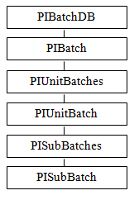
The RDBMSPI Interface currently replicates these objects from the three main collections found in the PI Batch Database. These collections are:
- PIBatchDB stores PIBatch objects
- PIUnitBatches stores PIUnitBatch objects
- PISubBatches stores PISubBatch objects
Each aforementioned object has a different set of properties. Moreover, it can reference its parent object (object from the superior collection) via the GUID (Global Unique Identifier) – 16 byte unique number. This GUID can be used as a key in RDB tables to relate
the PIUnitBatch records to their parent PIBatch(es) and PISubBatches to their parent PIUnitBatch(es). The structure of an RDB table should therefore reflect the available properties on a given object. The following tables enumerate the properties of the batch, unitbatch and subbatch objects, their data types and the corresponding placeholders:

PI Batch Object
Property | RDB Data Type | Placeholder
Batch ID | Character string up to 1024 bytes | BA.ID
Product | Character string up to 1024 bytes | BA.PRODID
Recipe | Character string up to 1024 bytes | BA.RECID
Unique ID | Character string 16 bytes | BA.GUID
Start Time | Timestamp | BA.START
End Time | Timestamp | BA.END
PIUnitBatch Object
Property | RDB Data Type | Placeholder
Batch ID | Character string up to 1024 bytes | UB.ID
Product | Character string up to 1024 bytes | UB.PRODID
Procedure Name | Character string up to 1024 bytes | UB.PROCID
Unique ID | Character string 16 bytes | UB.GUID
PI Unit | Character string up to 1024 bytes | UB.MODID
PI Unit Unique ID | Character string 16 bytes | UB.MODGUID
Start Time | Timestamp | UB.START
End Time | Timestamp | UB.END
PISubBatch Object
Property | RDB Data Type | Placeholder
Name | Character string up to 1024 bytes | SB.ID
PI Heading | Character string up to 1024 bytes | SB.HEADID
Unique ID | Character string 16 bytes | SB.GUID
Start Time | Timestamp | SB.START
End Time | Timestamp | SB.END

PI Batch Database Replication Details
Replication of the “new batches” requires PI SDK connection. PI SDK provides two search functions for filtering the PI Batch Database entries. The search criteria can be defined through keywords, which have the same syntax as the corresponding placeholders, but are prefixed with slashes '/' (the summary of all Batch related keywords can be found in section PI Point Configuration). As mentioned at the beginning of this chapter, the interface scans the PI Batch Database in timely manner. After each scan; that is, after an execution of that many INSERTs as there were newly arrived entries into the PI Batch Database since the last scan, the number of successfully inserted rows is written into the managing tag. The interface thus remembers what was the most recent timestamp (end time) sent to RDB allowing for safe restarts without losing or duplicating batches on the period defined by the keywords /BA_START or /UB_END and now.
Note: Both batches and unit-batches must be closed. This means, they must have the non-empty 'end time' property. The interface will not store the open batches or unit-batches. Exceptions to this rule are sub-batches. Sub-batches are sent to an RDB table when their parent unit-batch closes.

Three tables are required for the data extracted from the PI Batch database.

Example of RDB Tables Needed for PI Batch Database Replication (new batches)
Table Structure for PIBatch objects | Table Structure for PIUnitBatch Objects
BA_START (SQL_TIMESTAMP) | UB_START (SQL_TIMESTAMP)
BA_END (SQL_TIMESTAMP) | UB_END (SQL_TIMESTAMP)
BA_ID (SQL_VARCHAR) | UB_ID (SQL_VARCHAR)
BA_PRODUCT (SQL_VARCHAR) | UB_PRODUCT (SQL_VARCHAR)
BA_RECIPE (SQL_VARCHAR) | UB_PROCEDURE (SQL_VARCHAR)
BA_GUID (SQL_CHAR[37]) | BA_GUID (SQL_CHAR[37])
 | UB_MODULE (SQL_VARCHAR)
 | UB_GUID (SQL_CHAR[37])
Table Structure for PISubBatch Objects
SB_START (SQL_TIMESTAMP) | SB_HEAD (SQL_VARCHAR)
SB_END (SQL_TIMESTAMP) | UB_GUID (SQL_CHAR[37])
SB_ID (SQL_VARCHAR) | SB_GUID (SQL_CHAR[37])
The arrows show the keys that form the relationship between these three tables. Sub-batches can form their own tree structure allowing for a sub-batch object to contain the collection of another sub-batch. To express this hierarchy in one table, the interface constructs the sub-batch name in a way that it contains the above positioned sub-batches divided by a backslashes '\' (an analogy with the file and directory structure). In our case the SB_ID column will contain items like:
…

PIUnitBatch_01\SB_01\SB_101
PIUnitBatch_01\SB_01\SB_102
…

PIUnitBatch_01\SB_01\SB_10n
…
Because sub-batches have different properties than their parent objects – unit-batches, an independent INSERT is needed. Moreover, the unit-batch managing tag needs to know the sub-batch’s managing tag name. A special keyword /SB_TAG ='subbatch_managing_tag' must therefore be defined in the ExtendedDescriptor of the unit-batch’s managing tag.
Refer to these examples that replicate all batches, unit-batches plus their sub-batches over the period of last 10 days:
- Example 5.2a – Batch Export (Module Database required)
- Example 5.2b – UnitBatch Export (Module Database required)
- Example 5.2c – SubBatch Export (Module Database required)

RDBMSPI – Input Recovery Modes
The primary task of the RDBMSPI interface is on-line copying of data from relational databases to the PI archive. For this, users specify SQL queries (mostly SELECTs) and the task of the interface is delivering the newly stored rows to PI tags. On the other hand, history (input) recovery means copying bigger amounts of data (from classic RBDs or other historians) to PI. This task is usually not periodical; that means, it is one-time action only. The interface must thus address different issues; mainly, divide the time interval, for which the data needs to be copied into smaller, configurable chunks. There are many reasons for it, above all, avoid higher memory consumption, improve performance and increase the robustness of the recovery process. In the following paragraphs we will describe the settings, which the interface (since version 3.17) supports.
In the simplest possible scenario, the history recovery is actually covered by the most common query customers have:
SELECT Timestamp,Value,0 FROM Table WHERE Timestamp > ? ORDER BY Timestamp ASC; P1=TS
Provided the amount of data in RDB between the snapshot and the current time is of reasonable size, the query above simply fills in the missing events in PI archive during the first query execution. The interface will then continue executing the SELECT (in on-line mode) and the query will return only the newly inserted rows.
As stated at the beginning of this section, in case the amount of data in RDB is big, it is desirable to divide the time interval into chunks in order to avoid potential high resource utilization (CPU, memory, etc.) on the interface node as well as on the RDB side. For this, the interface offers two switches: /RECOVERY_TIME and the new start-up parameter /RECOVERY_STEP. Both parameters accept various input formats.
Their definitions and short description can be found in the following table:

Input History Recovery startup switches and their definitions
 | RECOVERY_TIME definitions | Example | Description
1 | Absolute start time | /RECOVERY_TIME=  01-Jan-00 /RECOVERY_STEP=30d | Recovery will start at the given time, will process the time interval in 30 days chunks, and, when the current time is reached, the query will continue execution in the standard on-line mode.
2 | Absolute start time,  absolute end time | /RECOVERY_TIME=  01-Jan-00,01-Jan-09  /RECOVERY_STEP=30d | The same as above, but when the end time is reached the query will NOT continue in on-line mode. In fact, after all input tags will be processed, the interface will exit.
3 | Relative start time | /RECOVERY_TIME=  *-365d  /RECOVERY_STEP=1d | The same as #1, start times is expressed in relative times.
4 | Relative start time,  relative end time | /RECOVERY_TIME=  *-365d, *  /RECOVERY_STEP=1d | The same as #3. After processing all tags the interface will exit.
5 | Name of the timestamp tag.  The snapshot value of this tag will be used as the start time. | /RECOVERY_TIME=  RDBMSPI_RecovertTagStart  /RECOVERY_STEP=24h | The start time can be passed through a standard PI tag, (of the type Timestamp).  The interface will read the snapshot value of this referenced tag and, after each execution, it will store the just processed start time to this tag. This allows for starting the recovery from the last successfully executed bulk.
6 | Name of the timestamp tag,  Name of the timestamp tag  The snapshot values of these tags will be used as the start time. | /RECOVERY_TIME=  RDBMSPI_RecoveryTagStart,  RDBMSPI_RecoveryTagEnd  /RECOVERY_STEP=1d | The same as #5.  After processing all tags on the given interval the interface will exit.
Note: Valid start and end time definition syntax used in the /RECOVERY_TIME keyword are strings, which represent:
- absolute times containing some fields of DD-MMM-YY hh:mm:ss
- relative times in +|- n d|h|m|s
- names of the PI tags
In addition, an absolute time can be specified with a word (TODAY, YESTERDAY, SUNDAY, MONDAY,…), an asterisk for the current time, or a combination time using one of the word absolute times and a relative times. See the Data Archive Manual for more information on the time string format.
See also the description of /RECOVERY_TIME and /RECOVERY_STEP in section Command-Line Parameters.
A suitable SQL statement (for the input history recovery) must be of the following pattern:
SELECT Timestamp, Value, 0 FROM Table
WHERE Timestamp > ? AND Timestamp <= ?
ORDER BY Timestamp ASC;
P1=TS P2=TE
That is, a query, which allows binding the start and end times recovery steps, is expected. That does not mean the query must be exactly as stated above. In fact, it can be any query, which delivers suitable result sets, but it must contain at least two timestamp placeholders defined by TS and TE. The query above actually resembles the most often used type of an SQL statement, which delivers ordered time series since the last scan.

Provided the /RECOVERY_TIME and /RECOVERY_STEP are specified, the interface will automatically populate the placeholders with appropriate times and will incrementally process the historical data. When the end time is reached, the interface process will exit. Exiting occurs when the /RECOVERY_TIME contains also end time.

Configuration Example for Input History Recovery
Interface start-up file:

RDBMSPI.exe /PS=RDBMSPI /F=10 /DSN=SQLServer /lb ... /RECOVERY_TIME=”01-Jan-05,*” /RECOVERY_STEP=10d /RECOVERY=TS

SQL Query (using the distributor strategy):

SELECT Timestamp, Name, Value, 0 FROM Table WHERE Timestamp > ? AND Timestamp <= ? ORDER BY Timestamp ASC; P1=TS P2=TE
Explanation:
After the interface starts, all input points’ queries will be executed on the interval beginning 01-Jan-2005 till current time. The recovery step will be 10 days. That is, the placeholders will be populated as follows:
1. Step: TS=01-Jan-2005 00:00:00 TE=10—Jan-2005 00:00:00
2. Step: TS=10-Jan-2005 00:00:00 TE=20—Jan-2005 00:00:00
3. …
When the current time is reached, the interface process will exit. The interface specific log will contain the following printout:
[INFO]: Input recovery on the interval
<01-Sep-2009 00:00:00.000 , 22-Oct-2009 10:27:46.000>
with step 864000 sec started.
[DEB-1]: Point – Recovery_Distributor : SQL statement(s) : SELECT DateTime AS PI_TIMESTAMP, 'Recovery_Target_1' AS PI_NAME, value AS PI_VALUE, 0 AS PI_STATUS FROM History WHERE DateTime > ? AND DateTime <= ? ORDER BY DateTime;
[INFO]: Processing the input recovery interval
<01-Sep-2009 00:00:00.000 , 11-Sep-2009 00:00:00.000>.
[INFO]: Processing the input recovery interval
<11-Sep-2009 00:00:00.000 , 21-Sep-2009 00:00:00.000>.
…
[INFO]: Processing the input recovery interval
<21-Oct-2009 00:00:00.000 , 22-Oct-2009 10:27:46.000>.
Thu Oct 22 10:28:02 2009 [INFO]: Input recovery completed.
Thu Oct 22 10:28:02 2009 [INFO]: Interface exiting.

RDBMSPI – Output Recovery Modes (Only Applicable to Output Points)

Recovery TS
This recovery mode is specified by the /RECOVERY=TS start-up parameter. Whether the recovery handles out-of-order data or not, depends on the Location5 attribute of an output tag:
Location5=0
Recovery starts at snapshot timestamp of the output tag (or at the recovery start-time if that is later) and only in-order data will be recovered.
Location5=1
Recovery begins at the recovery start-time (specified by the /RECOVERY_TIME start-up param.) and the out-of-order events can be covered.
The /OOO_OPTION then determines how the out-of-order events are handled.
Note: During the recovery, the snapshot placeholders are populated with historical (archive) values. In case the placeholder is defined as: Pn=’tagname’/VL , during the recovery, the interpolated archive values are taken.

Out-Of-Order Recovery
For output points that have Location5=1, the interface compares the source with the output tag values and detects the archive events that were added, replaced or deleted. This comparison is done immediately after the interface started on condition the comparison time-window had been specified; e.g. /RECOVERY_TIME='*-10d'.
The following two figures depict the situation before and after the out-of-order recovery.

Two New Values Added to SourceTag (green)
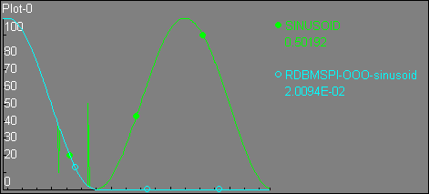
Two values
added when i/f was stopped
/RECOVERY_TIME = *-1d
OutputTag (blue) Synchronized with SourceTag (green).
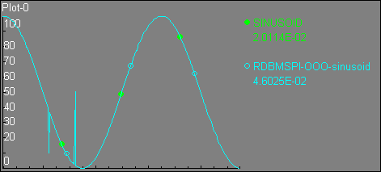
Source tag synchronized
with the output tag
after recovery
The Out-Of-Order recovery can be further parameterized through another start-up parameter /OOO_OPTION. This parameter defines a combination of three keywords: append, replace, and remove.
Keywords are separated by commas: /OOO_OPTION="append,replace".
Depending on these keywords, the interface only takes those actions, for which the corresponding options are set. In this case, even if there were some deletions of the SourceTag events, the interface will not synchronize them with the output tag (in terms of deleting the corresponding output tag entries).
The comparison results are signaled to the user via the following (Boolean) variables: @source_appended, @source_replaced, and @source_removed.
So that they can be used in an 'IF' construct that the interface is able to parse.
For example:
IF @source_appended INSERT INTO table (…);
IF @source_replaced UPDATE table SET column1 = ? …;
IF @source_removed DELETE table WHERE column1 <= ?;
Usually new SourceTag events come in in-order so that only the @source_appended variable is set to true (the others remain false).
Note: If no /OOO_OPTION is specified in the startup file then append is the default.
/ooo_option , Location5 and @* Variables – off line mode
/Recovery=…  /ooo_option=… | Location5 | SQL Execution | @source_appended  @source_replaced  @source_removed | Comment
Source tag / Output tag event comparison matches the /ooo_option | -1 | No | n/a | No Recovery for such tag
 | 0 | Yes | @source_appended=True  @source_replaced=False @source_removed=False | No out-of-order recovery  The recovery starts at snapshot time of the output tag, SQL queries are called for each source tag value after this point
 | 1 | Yes | The option that was matched is setting the correlated parameter to True | Example: /ooo_option=  "replace"  source archive event <> output archive event  @source_appended=False  @source_replaced=True  @source_removed=False
Source tag /  Output tag event comparison matches none of the /ooo_options | -1 | No | n/a | No recovery for such tag
 | 0 | Yes | @source_appended=True  @source_replaced=False @source_removed=False | No out-of-order recovery  The recovery starts at snapshot time of output tag, SQL queries are called for each source tag value after this point
 | 1 | No | n/a | Not specifying a certain ooo_option means no action if the related situation is found
The table above describes the recovery-relevant settings that are valid only when the interface starts (off-line-mode). During the normal operation (on-line-mode), the interface handles the Out-Of-Order events as described in the section below:

Out-Of-Order Handling in On-Line Mode (RDBMSPI Interface Runs)
Location5=1 supports out-of-order recovery also in the on-line-mode; When the Out-Of-Order SourceTag events are detected, either the @source_appended or the @source_replaced is set to true (depending on the addition, or replacement of the SourceTag event).
Note: Deleted values are NOT recognized in on-line-mode.

Note: A new event that has the same timestamp as the current snapshot is considered an out-of-order event too!

Note: If the SourceTag value is edited, but remains the same, then the @source_replaced variable stays False
/ooo_option , Location5 and @* Variables – on line mode
/ooo_option=… | Location5 | SQL Execution | @source_appended  @source_replaced  @source_removed | Comment
Source tag event is out of order and  Source tag/output tag event comparison matches /ooo_option | -1 | No | n/a | out-of-order events ignored
 | 0 | Yes | @source_appended=True  @source_replaced=False  @source_removed=False | Backward compatibility
 | 1 | Yes | The option that was matched is set to True | e.g. /ooo_option=  "replace"  source archive event <>  output archive event  @source_appended=False  @source_replaced=True  @source_removed=False
Source tag event is out of order and  Source tag/output tag event comparison matches none of the /ooo_options | -1 | No | n/a | out-of-order events ignored
 | 0 | Yes | @source_appended=True  @source_replaced=False @source_removed=False | Backward compatibility
 | 1 | No | n/a | e.g. /ooo_option=  "append"  source archive event <> output archive event  no query execution for replaced data
New source tag event (in-order) | -1 | Yes | @source_appended=True  @source_replaced=False @source_removed=False | in-order events trigger query execution
New source tag event (in-order) | 0 | Yes | @source_appended=True  @source_replaced=False @source_removed=False | in-order events trigger query execution
New source tag event (in-order) | 1 | Yes | @source_appended=True  @source_replaced=False @source_removed=False | in-order events trigger query execution

Recovery SHUTDOWN
Shutdown recovery is the same as 'TS', if the output tag's snapshot value is either Shutdown or I/O Timeout. If the output tag snapshot does not contain these digital states, NO recovery takes place.
Note: Shutdown recovery exists for compatibility reasons to earlier interface versions. It is recommended to use TS recovery instead.

Interface in Pure Replication Mode

Input Recovery
When the recovery time-window definition contains both; that is, the start and the end-times (separated by comma); for instance, /RECOVERY_TIME="01-Jan-08,01-Jan-09" all input points will be processed on the defined time interval and then the interface will end (the interface process will exit).

Output Recovery
During recovery, the interface retrieves and reprocesses the compressed data from the PI Archive (as opposed to executing the output points' events coming from the event queue during the interface's normal operation). When the recovery time-window does contain both; that is, the start and the end-times (separated by comma) for example, /RECOVERY_TIME="*-1d,*" all output points will be processed for the defined time interval and then the interface stops (exits).
In the Pure Replication Mode one can schedule the interface execution via the Windows scheduling service (AT) and let the PI Archive (compressed) data replicate in a batch manner.
Note: Due to the different nature of both recovery modes, it is not recomended to run input and output recovery with one interface instance!
For exact specification of all recovery related parameters, see section Startup Command File.

Automatic Reconnection

ODBC Connection Loss
The interface automatically tries to re-connect the RDB in cases when the relational system is not reachable. Because the ODBC API does not provide any direct function to find out whether the communication line is in a healthy and sound state, the interface uses the following mechanism to determine a connection loss:
Any connection related error (ODBC returns error statuses starting with 08xxx) means closing all prepared SQL statements and entering the re-connection loop. Before regarding the situation as a connection loss, an additional verification execution is made. The result of this verification finally decides about the re-connection action. According to the ODBC specification, ODBC drivers have to stamp the errors consistently and communication related problems have to be marked with a proper error state. As different ODBC drivers can return thousands of error codes, it is unlikely that each error code is properly marked. Since version 3.11, the interface implements a new start-up switch /ERC=n. This optional switch activates a mechanism, which counts consecutive occurred runtime errors, and decides for the re-connection action when the number of such errors reaches the specified number (n). This scenario helps to decide about a re-connection action when the interface communicates to an ODBC driver that does not return proper error codes.
Note: The interface tries to re-create the ODBC link every minute. This time interval is hardcoded and cannot be changed.

Note: Since version 3.12, for the output tags, the placeholder values are retained and the query, which discovered the broken ODBC link is executed again when the connection to RDB is re-established.

Note: During the re-connection attempts (1 min intervals) the interface does NOT empty the update-event queue (for output tags). Some events can thus be lost due to the queue overflow. Should such a situation happen, there is currently NO automatic recovery action taken. Only a manual solution is possible – set-up the corresponding /OOO_OPTION recovery parameters, and re-processes the period when the interface was disconnected from the RDBMS by restarting the interface. See section RDBMSPI – Output Recovery Modes (Only Applicable to Output Points). See the PI Server Manual for details how the event queue size can be increased.
When the ODBC link is broken, and the PI System remains available, the interface normally writes the I/O Timeout digital state to all input points. This can be avoided by setting the interface start-up parameter /NO_INPUT_ERROR.

PI Connection Loss
During the PI API or PI SDK connection loss, neither the snapshot placeholders (TS, VL, SS_I,…) nor the attribute placeholders (AT.xxx) can be refreshed. Corresponding error messages are sent to the interface log-file and the interface enters a loop where it tries to re-connect to PI in one minute intervals. The PI Server availability check is made before each scan class processing.
Note: In case the interface runs as a console application (and there are the /user_pi= or/and /pass_pi= startup parameters specified), the login dialog pops up waiting for the user to re-enter the authentication information.

Result Variables

Send Data to PI
The interface sets the following variables according to the result of the write-to-PI action: @write_success and @write_failure.
A failure sets the @write_success to false, the @write_failure to true and vice-versa. Both variables are accessible to users, as indicates the example below:
SELECT Timestamp, Value,0 FROM Table WHERE Timestamp > ? ORDER BY Timestamp;
IF @write_success DELETE FROM Table WHERE Timestamp <= ?;
That means, the rows in the first table can be safely deleted, because they were already copied to PI.
Note: Only if ALL SELECTed rows are successfully sent to the corresponding PI tags then the @write_success variable is true. Data that have no corresponding PI tag (e.g. in the tag distribution strategy, there is a row that references a nonexistent tag and this row thus cannot be sent to PI), do not count as a failures. To achieve this, consider the @rows_dropped variable in section SQL SELECT Statement for Tag Distribution.

Note: @write_success and @write_failure are undefined before the first SELECT or {CALL …} command and they are set to the undefined state always before the query execution. That means that they can only be evaluated when placed after a query. It also only makes sense to place them after SELECT or {CALL …}; that is, after queries that return a result-set.

Note: The implemented IF does NOT support the ELSE part and only covers one statement after the variable.

Result of ODBC Query Execution
The very first SQL statement execution (after the interface start), differs from the other executions so that any error, data-type assignment problem etc. causes the tag gets excluded from any further operations. The information about refusing of such a problematic tag is recorded into the interface specific log. Whereas, the ODBC run-time errors happening during all consequent schedules, are just logged.
To convey the information about a success or failure of the individual SQL commands (during run-time), two boolean variables are available:
@query_success
and
@query_failure.
The @query_success is set to true (and @query_failure to false), when the previous query was successfully executed and data fetched. The variables can be checked by an 'IF' construct; for example:
SELECT Timestamp, Value,0 FROM Table WHERE Timestamp > ? ORDER BY Timestamp;
IF @query_failure INSERT INTO Table2 (Timestamp,Tag, error_message) VALUES (?,?,'Query failed');
Note: The @query_success and @query_failure variables always reflect the result of the last executed command; therefore, it is not possible to add another statement - in this case, the second INSERT; like: 'IF @query_success INSERT table3…' to react on the failure of the SELECT statement. This second INSERT will see the success or failure of the previous INSERT command. If multiple queries shall be executed on failure, then stored procedures are a way to go.

RDBMSPI – Redundancy Considerations
In general, two scenarios can be considered:
- RDBMSPI runs in more than one instances; mostly against the same RDB and collecting data for the same tags
- RDBMSPI runs against HA (High Availability) PI Servers
A few generic considerations re the interface redundancy:
- Data in RDBs can be considered “persisted” - stored on the disk; that means that even if the interface fails/miss to retrieve some rows, in majority of cases data in RDB tables does not immediately disappear, or gets overwritten. As shown in many examples throughout this document, a query can be formulated in a way that after the interface restart, it retrieves all the not-yet-stored-in-PI-data during the first scan:
SELECT Timestamp,Value,0 FROM Table WHERE Timestamp > ? ORDER BY Timestamp;
- The same consideration is true for the output direction (from PI to RDB). The output recovery mode is discussed in RDBMSPI – Output Recovery Modes (Only Applicable to Output Points).
- The RDBMSPI interface can be run in two (redundant) instances against the same relational database, serving the same tags. These instances either:
- Know about each other – utilizing the UniInt Phase II Failover; see the sections in UniInt Failover Configuration for details.
- Or, they run as isolated instances, both having the /RBO start-up parameter set. See the /RBO parameter in section Startup Command File for details.
However, /RBO has a few limitations:
- if the SELECT of an input tag contains the annotation column, then /RBO will NOT apply
- when run with buffering and the PI Server is not available, then /RBO does not help either

RDBMSPI and Server-Level Failover
Note: The interface supports the server level failover only when configured with the Microsoft Native Client ODBC driver against the mirrored SQL Server 2005 or later! See the corresponding ODBC driver description for more.
From the interface perspective, the only requirement is to specify the Mirror server name in the DSN configuration, as shown in the following figure:
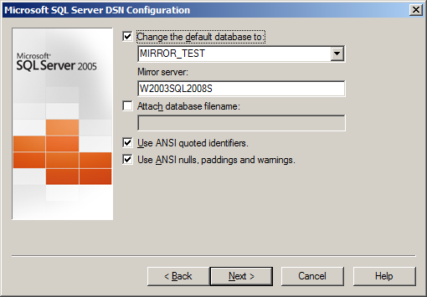
In case the ODBC link gets disconnected, the reconnection attempt will be redirected to the second (mirrored) SQL Server.

Startup Command File
Command-line parameters can begin with a slash ‘/’ or with a hyphen ‘-‘. For example, the
/ps=M
or
-ps=M
command-line parameters are equivalent.
For Windows, command file names have a .bat extension. The Windows continuation character (^) allows for the use of multiple lines for the startup command. The maximum length of each line is 1024 characters (1 kilobyte). The number of parameters is unlimited, and the maximum length of each parameter is 1024 characters.
The PI Interface Configuration Utility (PI ICU) provides a tool for configuring the Interface startup command file.

Configuring the Interface with PI ICU
Note: PI ICU requires PI 3.3 or greater.
The PI Interface Configuration Utility provides a graphical user interface for configuring PI interfaces. If the Interface is configured by the PI ICU, the batch file of the Interface (rdbmspi.bat) will be maintained by the PI ICU and all configuration changes will be kept in that file and the module database. The procedure below describes the necessary steps for using PI ICU to configure the RDBMSPI Interface.
From the PI ICU menu, select Interface, then NewWindows Interface Instance from EXE…, and then Browse to the rdbmspi.exe executable file. Then, enter values for Host PI System, Point Source and Interface ID#. A window such as the following results:
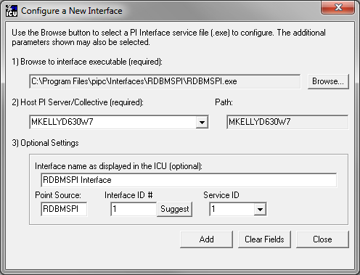
“Interface name as displayed in the ICU (optional)” will have PI- pre-pended to this name and it will be the display name in the services menu.
Click on Add.
The following display should appear:
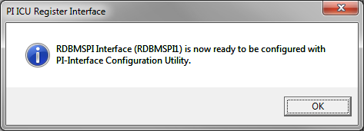
Note that in this example the Host PI System is MKELLYD630W7. To configure the interface to communicate with a remote PI Server, select ‘Interface => Connections…’ item from PI ICU menu and select the default server. If the remote node is not present in the list of servers, it can be added.
Once the interface is added to PI ICU, near the top of the main PI ICU screen, the Interface Type should be rdbodbc. If not, use the drop-down box to change the Interface Type to be rdbodbc.
Click on Apply to enable the PI ICU to manage this copy of the RDBMSPI Interface.
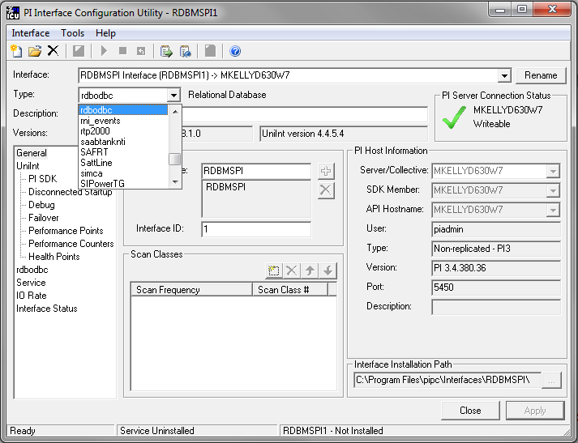
The next step is to make selections in the interface-specific tab (i.e. “RDBODBC”) that allow the user to enter values for the startup parameters that are particular to the RDBMSPI Interface.
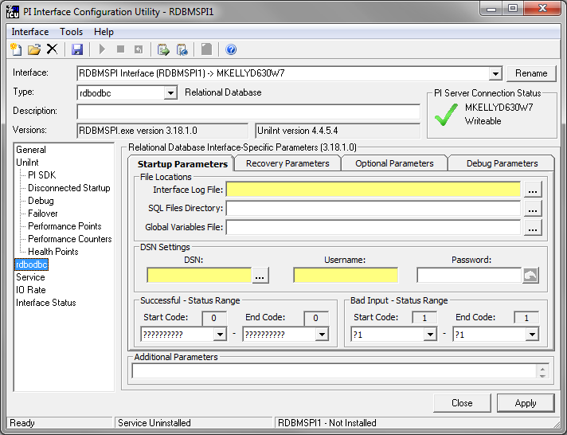
Since the RDBMSPI Interface is a UniInt-based interface, in some cases the user will need to make appropriate selections in the UniInt page. This page allows the user to access UniInt features through the PI ICU and to make changes to the behavior of the interface.
To set up the interface as a Windows Service, use the Service page. This page allows configuration of the interface to run as a service as well as to starting and stopping of the interface. The interface can also be run interactively from the PI ICU. To do that go to menu, select the Interface item and then Start Interactive.
For more detailed information on how to use the above-mentioned and other PI ICU pages and selections, please refer to the PI Interface Configuration Utility User Manual. The next section describes the selections that are available from the RDBODBC page. Once selections have been made on the PI ICU GUI, press the Apply button in order for PI ICU to make these changes to the interface’s startup file.

RDBODBC Interface page
Since the startup file of the RDBMSPI Interface is maintained automatically by the PI ICU, use the RDBODBC page to configure the startup parameters and do not make changes in the file manually. The following is the description of interface configuration parameters used in the PI ICU Control and corresponding manual parameters.
The rebodbc ICU Control for PI ICU has four tabs. A yellow text box indicates that an invalid value has been entered, or that a required value has not been entered.

Startup Parameters

File Locations

Interface Log File:
Full path to the interface specific log file. (/Output=<UNC Path>, Optional)

Sql Files Directory:
Directory of the SQL statement files. (/SQL=<UNC Path>, Optional)

Global Variables Files:
Full path to the global SQL variable file. (/Output=<UNC Path>, Optional)

DSN Settings

DSN:
Data Source Name (/DSN=<DSN name>, Required)

Username:
Username for access to RDB (/USER_ODBC=<username>, Required)

Password:
Password for access to RDB. Once this has been entered and saved the password will be written to an encrypted password file found in the directory pointed to by the /Output=<path> command line parameter. During the save function this field will be changed from asterisks to the string “* Encrypted *” to indicate there is a valid encrypted password file has been saved. The Reset button can be used to delete the encrypted password file and allow a new password to be entered. (/PASS_ODBC=<password>, Optional)

Successful – Status Range
Select the range of Successful status strings from the system digital state table.

Start Code:
Enter the starting location in the system digital state table. (/SUCC1=#, Optional)

End Code:
Enter the ending location in the system digital state table (/SUCC2=#, Optional)

Bad Input – Status Range
Select the range of Bad Input status strings from the system digital state table.

Start Code:
Enter the starting location in the system digital state table. (/BAD1=#, Optional)

End Code:
Enter the ending location in the system digital state table (/BAD2=#, Optional)

Recovery Parameters
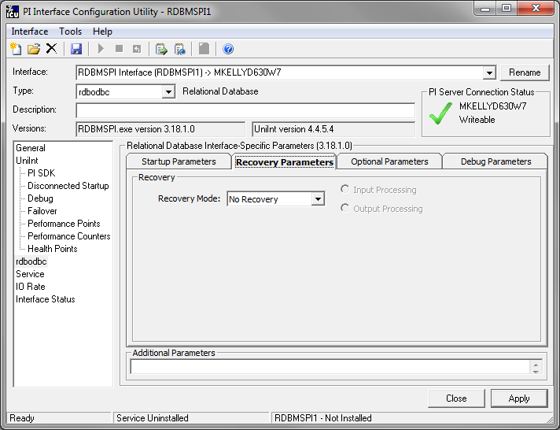

Recovery Mode:
Select the output recovery mode, possible options are: No Recovery and TimeStamp. If TimeStamp is selected then select the type of processing Input or Output. (/RECOVERY=c where:
c = TS (Timestamp) or NO_REC (No Recovery, Default=NO_REC, Optional)

Input Processing
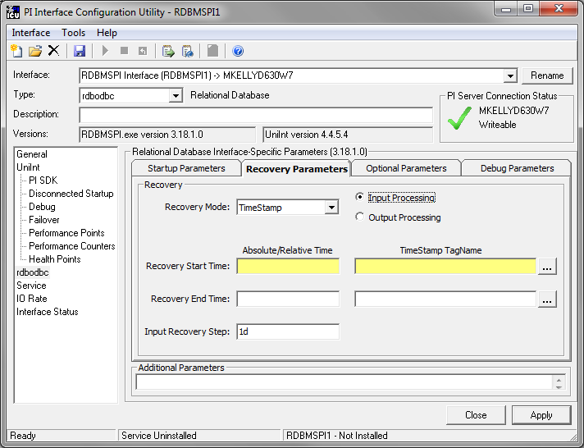

Recovery Start Time:
The /recovery_time=<Start Time, End Time>supports syntax listed in table in chapter RDBMSPI – Input Recovery Modes. A timestamp tag's value could also be used as the Start Time. Only one type of Start Time can be used however, either Absolute/Relative or TimeStamp TagName.

Recovery End Time
The /recovery_time=<Start Time, End Time> supports syntax listed in table in chapter RDBMSPI – Input Recovery Modes. A timestamp tag's value could also be used as the Start Time. Only one type of Start Time can be used however, either Absolute/Relative or TimeStamp TagName.

Input Recovery Step:
Step for input history recovery. (/Recovery_Step=<string>, where <string> = "#dhms", e.g.: 8h, Default: 1d, Optional)

Output Processing
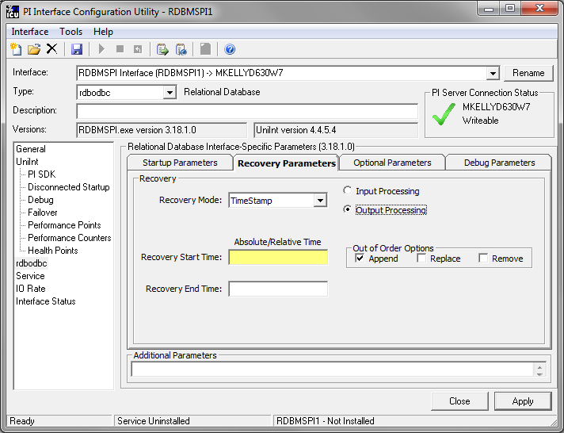

Recovery Start Time:
In conjunction with the recovery parameter (/recovery), the /recovery_time=<Start Time, End Time> parameter determines the oldest timestamp for retrieving data from the archive. The time syntax is in PI time format. (See the Data Archive Manual for more information on the PI time string format.)

Recovery End Time:
In conjunction with the recovery parameter (/recovery), the /recovery_time=<Start Time, End Time> parameter determines the oldest timestamp for retrieving data from the archive. The time syntax is in PI time format. (See the Data Archive Manual for more information on the PI time string format.)

Out of Order Options
In conjunction with Location5=1, the /OOO_OPTION=append,replace specifies situations, for which corresponding SQL queries are executed.
Full details are in the tag configuration section for Location5.
For more detailed description, see sections RDBMSPI – Input Recovery Modes and RDBMSPI – Output Recovery Modes (Only Applicable to Output Points).

Optional Parameters
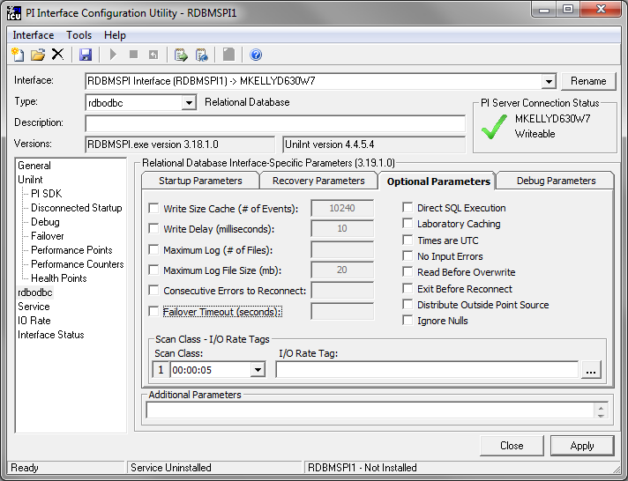

Write Size Cache (# of Events)
In conjunction with the /lb parameter; Write Size. Maximum number of values written in one (bulk) call to the PI Archive; default is 10240 events per bulk. This parameter can be used to tune (throttle) the load on the PI Archive. (/WS=#, Default: 10240, Optional)

Write Delay (milliseconds):
In conjunction with the /lb parameter; Write Delay (in milliseconds) between two bulk writes to the PI archive. Default is 10ms. Used to tune the load on the PI Archive and the network. (/WD=#, Default: 10, Optional)

Maximum Log (# of Files):
Maximum number of log files in the circular buffer. The interface starts overwriting the oldest log files when the MAXLOG has been reached. When not specified, the log files will be indexed indefinitely (/MaxLog=#, Optional)

Maximum Log File Size (mb):
Maximum size of the log file in MB. If this parameter is not specified, the default MAXLOGSIZE is 20 MB. (/MaxLogSize=#, Default: 20, Optional)

Consecutive Errors to Reconnect:
Number of consecutive occurring errors that causes the interface tries to de-allocate all ODBC statements and attempts to re-connect the RDBMS. (/ERC=#, Optional)

Failover Timeout (seconds):
This parameter is used to set a maximum timeout in seconds before the interface will failover if a query takes longer than the specified timeout. (/Failover_Timeout=#, Optional)

Direct SQL Execution
This parameter forces the direct SQL statement execution. All SQL statements are prepared, bound and executed each time they are scheduled for execution. The default is: prepare and bind once, execute many. (/ExecDirect, Optional)

Laboratory Caching
LaBoratory. Events are written directly to PI Archive in bulks.
The event ratio is then significantly faster comparing to the event-by-event sending, which occurs when no /lb is present. The archive mode is ARCREPLACE. (/lb, Optional)

Times are UTC
If this is specified, the interface expects the incoming timestamp values (from RDB) in UTC and outgoing timestamps are converted to UTC – all the timestamp related placeholders (TS, ST, LST, LET, ANN_TS) are transformed.
Since version 3.15, which implemented support for the data type Timestamp, the input as well as output to this data type is also transformed to UTC. To do a correct transformation it is required that Time Zone and DST settings of the interface node are valid. (/UTC, Optional)

No Input Errors
Suppresses writing the BAD_INPUT, IO_TIMEOUT digital states when a runtime error occurs. (/NO_INPUT_ERROR, Optional)

Read Before Overwrite
Forces the interface to check if same value already exists in archive at the given timestamp. Interface will not send duplicate values retrieved from RDB to PI when this is checked. (/RBO, Optional)

Exit Before Reconnect
When this parameter is set and the interface encounters a connection problem with the RDBMS, it does NOT enter the reconnection loop (trying to re-create the ODBC link in one minute intervals), but the interface simply exits. (/EBR, Optional)

Distribute Outside Point Source
Allow Distribute Outside Point Source. If this start-up parameter is set, the interface will distribute events to tags outside the specified point source (based on the TagName or Alias). Otherwise, rows with Tag Names / Aliases pointing outside the point source will be skipped. (/DOPS, Optional)

Ignore Nulls
(/Ignore_Nulls, Optional)

Scan Class – I/O Rate Tags

Scan class:
Select a scan class to assign to a rate tag.

I/O Rate Tag
Select the rate tag for this scan class. (/TF=<tagname>, Optional, This parameter is positional within the Batch File)

Debug Parameters
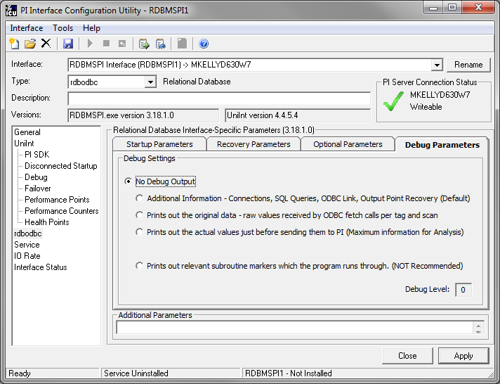

Debug Level
The interface prints additional information into the interface specific log file, depending on the debug level used. The amount of log information increases with the debug number as specified in the table below (see the /DEB=# description)

Additional Parameters
This section is provided for any additional parameters that the current ICU Control does not support.
Note: The UniInt Interface User Manual includes details about other command-line parameters, which may be useful.

Command-line Parameters
Parameter | Description
/BAD1=#  Default: 0  Optional | The /BAD1 parameter is used as an index pointing to the beginning of the range (in the system digital state table) that contains Bad Input status strings.  Strings coming as statuses from RDB are compared with this range. The following example indicates what rule is implemented  Example:  SELECT timestamp, value, 'N/A' FROM table …  In case the interface finds a match for the 'N/A' string in the PI system digital set table (in the range defined through /bad1 and /bad2), the event is archived as 'N/A'; that is, as the digital state selected from RDB.  See section Evaluation of STATUS Field – Data Input.
/BAD2=#  Default: 0  Optional | The /BAD2 parameter is used as an index pointing to the end of the range (in the system digital state table) that contains Bad Input status strings.
/DEB=#  Default: 1  Optional | The interface prints additional information into the interface specific log file, depending on the debug level used. The amount of log information increases with the debug number as follows:  Debug Level Granularity  The message in the file is prefixed with the [DEB-n] marker where n reflects the set debug level.  Note: The interface has an internal limitation on the length of the print out debug information. The limitation is 1400 characters. Use the /DEB=n cautiously!  Once the configuration and query execution are working, go back to /DEB=1.  Note: The error and warning messages are ALWAYS printed.
  Debug Level | Output
  0 | No debug output.
  1  (Default) | Additional information about the interface operation – PI and ODBC connection related info, defined SQL queries, information about actions taken during the ODBC link re-creation, output points recovery, etc.
  2 | Not implemented
  3 | Prints out the original data (raw values received by ODBC fetch calls per tag and scan).This helps to trace a data type conversion or other inconsistencies.
  4 | Prints out the actual values just before sending them to PI.
  5 | Prints out relevant subroutine markers, the program runs through.  Note: Only for onsite test purposes!  Potentially huge print out!
/DOPS  Default: for DISTRIBUTOR and RxC strategies the interface does NOT store events outside specified point source.  Optional | Allow Distribute Outside Point Source. If this start-up parameter is set, the interface will distribute events to tags outside the specified point source (based on the TagName or Alias). Otherwise, rows with Tag Names / Aliases pointing outside the point source will be skipped.  Note: this startup- parameter applies to Tag Distribution and RxC Distribution (combination of Group and Distribution) strategies only.
/DSN=dsn_name  Required | Data Source Name created via the ODBC Administrator utility (found in Windows Control Panel). This interface only supports Machine data-sources and preferably System data-sources!  Note: If the interface is installed as a Windows service, only the System data-sources will work!  For more information on how to setup a DSN, see the ODBC Administrator Help, or consult the ODBC driver documentation.  CAUTION On 64bit operating systems the DSN must be configured using the 32bit ODBC Administrator.  This application is located in:  %systemroot%\syswow64\odbcad32.exe  Because RDBMSPI.exe is 32 bit application!  CAUTION The configuration of using the PI ODBC driver based data source (DSN) is not allowed.  PI API will finally communicate with one server only (the one the PI ODBC is connected to)
/ec=#  Optional | The first instance of the /ec parameter on the command-line is used to specify a counter number, #, for an I/O Rate point. If the # is not specified, then the default event counter is 1. Also, if the /ec parameter is not specified at all, there is still a default event counter of 1 associated with the interface. If there is an I/O Rate point that is associated with an event counter of 1, each copy of the interface that is running without /ec=#explicitly defined will write to the same I/O Rate point. This means either explicitly defining an event counter other than 1 for each copy of the interface or not associating any I/O Rate points with event counter 1. Configuration of I/O Rate points is discussed in the section called I/O Rate Point.  Subsequent instances of the /ec parameter may be used by specific interfaces to keep track of various input or output operations. Subsequent instances of the /ec parameter can be of the form /ec*, where * is any ASCII character sequence. For example, /ecinput=10, /ecoutput=11, and /ec=12 are legitimate choices for the second, third, and fourth event counter strings.
/EBR  Optional | Exit Before Reconnect. When this parameter is set and the interface encounters a connection problem with the RDBMS, it does NOT enter the reconnection loop (trying to re-create the ODBC link in one minute intervals), but the interface simply exits. Then, in case the Windows Services Recovery Option is set, the operating system automatically restarts it. RDBMSPI is then able to go through the output points’ history recovery, which only takes place at the interface start-up.  Such a construct avoids the “event-queue overflow” situation, should the RDBMS be not available for longer time. The downside, however, is that the recovery takes compressed values from PI Archive and not the snapshots, which are in the event queue.
/ERC=#  Default: (not specified)  Optional | Consecutive Errors to Reconnect, the /ERC parameter defines the number (#) of (same) consecutive occurring errors that cause the interface closes all existing ODBC statements and attempts to re-create the whole ODBC link.  Note: This start-up parameter was implemented because of the inconsistent behavior of some ODBC drivers with regard to the returned error codes.
/ExecDirect  Default: (when not specified) prepared execution. See section Prepared Execution  Optional | Direct SQL statement execution (SQLExecDirect())  This parameter forces direct SQL statement execution. All SQL statements are prepared, bound and executed always before the interface schedules them for execution. The default mode (without this start up parameter) is to prepare-and-bind once, execute many.
/f=SS.##  or  /f=SS.##,SS.##  or  /f=HH:MM:SS.##  or  /f=HH:MM:SS.##,  hh:mm:ss.##  Required for reading scan-based inputs | The /f parameter defines the time period between scans in terms of hours (HH), minutes (MM), seconds (SS) and sub-seconds (##). The scans can be scheduled to occur at discrete moments in time with an optional time offset specified in terms of hours (hh), minutes (mm), seconds (ss) and sub-seconds (##). If HH and MM are omitted, then the time period that is specified is assumed to be in seconds.  Each instance of the /f parameter on the command-line defines a scan class for the interface. There is no limit to the number of scan classes that can be defined. The first occurrence of the /f parameter on the command-line defines the first scan class of the interface; the second occurrence defines the second scan class, and so on. PI Points are associated with a particular scan class via the Location4 PI Point attribute. For example, all PI Points that have Location4 set to 1 will receive input values at the frequency defined by the first scan class. Similarly, all points that have Location4 set to 2 will receive input values at the frequency specified by the second scan class, and so on.  Two scan classes are defined in the following example:  /f=00:01:00,00:00:05 /f=00:00:07  or, equivalently:  /f=60,5 /f=7  The first scan class has a scanning frequency of 1 minute with an offset of 5 seconds, and the second scan class has a scanning frequency of 7 seconds. When an offset is specified, the scans occur at discrete moments in time according to the formula:  scan times = (reference time) + n(frequency) + offset  where n is an integer and the reference time is midnight on the day that the interface was started. In the above example, frequency is 60 seconds and offset is 5 seconds for the first scan class. This means that if the interface was started at 05:06:06, the first scan would be at 05:07:05, the second scan would be at 05:08:05, and so on. Since no offset is specified for the second scan class, the absolute scan times are undefined.  The definition of a scan class does not guarantee that the associated points will be scanned at the given frequency. If the interface is under a large load, then some scans may occur late or be skipped entirely. See the section “Performance Summaries” in the UniInt Interface User Manual.doc for more information on skipped or missed scans.  Sub-second Scan Classes  Sub-second scan classes can be defined on the command-line, such as  /f=0.5 /f=00:00:00.1  where the scanning frequency associated with the first scan class is 0.5 seconds and the scanning frequency associated with the second scan class is 0.1 of a second.  Similarly, sub-second scan classes with sub-second offsets can be defined, such as  /f=0.5,0.2 /f=1,0  Wall Clock Scheduling  Scan classes that strictly adhere to wall clock scheduling are now possible. This feature is available for interfaces that run on Windows and/or UNIX. Previously, wall clock scheduling was possible, but not across daylight saving time. For example, /f=24:00:00,08:00:00 corresponds to 1 scan a day starting at 8 AM. However, after a Daylight Saving Time change, the scan would occur either at 7 AM or 9 AM, depending upon the direction of the time shift. To schedule a scan once a day at 8 AM (even across daylight saving time), use /f=24:00:00,00:08:00,L. The ,L at the end of the scan class tells UniInt to use the new wall clock scheduling algorithm.
/Failover_Timeout=#  Default: None  Optional | This parameter is used to set a maximum timeout in seconds before the interface will failover. In other words, the interface will not fail over if a query takes shorter time than the specified timeout.
/Global=FilePath  Default: no global variables file  Optional | The /Global parameter is used to specify the full path to the file that contains definitions of the global variables.
/host=host:port  Required | The /host parameter is used to specify the PI Home node. Host is the IP address of the PI Sever node or the domain name of the PI Server node. Port is the port number for TCP/IP communication. The port is always 5450. It is recommended to explicitly define the host and port on the command-line with the /host parameter. Nevertheless, if either the host or port is not specified, the interface will attempt to use defaults.  Examples:  The interface is running on a PI Interface Node, the domain name of the PI home node is Marvin, and the IP address of Marvin is 206.79.198.30. Valid /host parameters would be:  /host=marvin  /host=marvin:5450  /host=206.79.198.30  /host=206.79.198.30:5450
/id=x  /in=x (included for backwards compatibility with older version of the interface)  Highly Recommended | The /id parameter is used to specify the interface identifier.  The interface identifier is a string that is no longer than 9 characters in length. UniInt concatenates this string to the header that is used to identify error messages as belonging to a particular interface. See the Appendix A Error and Informational Messages for more information.  UniInt always uses the /id parameter in the fashion described above. This interface also uses the /id parameter to identify a particular interface copy number that corresponds to an integer value that is assigned to Location1. For this interface, use only numeric characters in the identifier. For example,  /id=1
/Ignore_Nulls  Default: for GROUP and RxC strategies the interface writes NO_DATA in case the value column is NULL.  Optional | The /Ignore_Nulls start-up parameter will cause the interface will not write the No Data system digital state for tags populated through the Tag Groups and RxC Distribution (combination of Group and Distribution) strategies. (The mandated result-set format for the two above referenced strategies does not allow excluding the NULLs in the WHERE clause.)
/LB  Optional | LaBoratory. Events are written directly to PI Archive in bulks.  The event ratio is then significantly faster comparing to the event-by-event sending, which occurs when no /LB is present. The archive mode is ARCREPLACE.
/MaxLog=#  Default: indefinite  Optional | Maximum number of log files in the circular buffer. The interface starts overwriting the oldest log files when the MAXLOG has been reached. When not specified, the log files will be indexed indefinitely.
/MaxLogSize=#  Default: 20  Optional | Maximum size of the log file in MB. If this parameter is not specified, the default MAXLOGSIZE is 20 MB.
/No_Input_Error  Default: writes BAD_INPUT,  IO_TIMEOUT in case of any runtime error  Optional | The /No_Input_Error parameter suppresses writing IO_TIMEOUT and BAD_INPUT for input tags when any runtime error occurs or ODBC connection is lost.  Example:  SELECT timestamp,value,0 WHERE timestamp > ? ORDER BY timestamp; P1=TS  The ? will be updated (during run-time) with the latest timestamp retrieved. Now, if the interface runs into a communication problem, it will normally write I/O Timeout and use current time to timestamp it. The latest timestamp will thus become the current time, which is potentially a problem, because the next query will miss all values between the last retrieved timestamp and the I/O Timeout timestamp! The /no_input_error will avoid it.
/OOO_Option= "append,replace,  remove"  Default:  /ooo_option="append"  Optional | For output tags (which have Location5=1), this option specifies what kind of out-of-order output-point events will trigger the SQL query execution. In addition, the option will set a variable that can be evaluated in the query file (see section Out-Of-Order Recovery for the description of the related @* variables).  Example:  /OOO_Option="append,replace"  means only additions and modifications of the SourceTag's values cause the defined SQL query(ies) to be executed .  The order of the keywords (append, replace, remove) is arbitrary, they can appear only once and the user can specify any of these.  Note: The remove option will only have an effect during the interface start-up. Value deletions will not be detected when the interface in on-line mode.
/Output=FilePath  Required | The /Output parameter is used to specify the Interface-specific error log file name and location.  If the path contains spaces the parameter has to be surrounded by double quotes:  /Output="c:\program files\...\rdbmspi.log"  The interface generates output messages into the given log-file. In order NOT to overwrite the previous log-file after each restart, the interface renames the previous log-file to log-file.log;n, where n is the consecutive number.  Note: System administrator should regularly delete the old log-files to conserve disk space.
/Pass_ODBC=password_odbc  Default: empty string  Optional | The /Pass_ODBC parameter is used to specify the password for the ODBC connection. The password entered is case sensitive! If this parameter is omitted, the standard ODBC connection dialog prompts the user for his name and password. The password has to be entered only once. On all future startups the interface will take the password from the encrypted file.  Since interface version 3.16.0, this encrypted file has the same name as the interface executable concatenated with pointsource and the id and the file extension is PWD. The file is stored in the same directory as the interface specific output file.  Example of the relevant start-up parameters:  rdbmspi.exe …/id=2 /ps=SQL … /Output=c:\pipc\interfaces\rdbmspi\logs\  rdbmspi.log …  Encrypted password is stored in: c:\pipc\interfaces\rdbmspi\logs\  rdbmspi_SQL_2.PWD  In order to run RDBMSPI as the Windows service, it is necessary to start (at least once) the interface in the interactive mode (to create the encrypted password file) or use the ICU. If this file is deleted, the interface will prompt for a new password during the next interactive startup.  Note: The interface fails to start as a Windows service if it does not find a valid password-file.  Databases like MS Access or dBase may not always have security set up. In this case a dummy username and password can be used, e.g. /Pass_ODBC=dummy.  CAUTION! Since the interface version 3.16.0, the encryption mechanism has been rewritten and the name of the password file changed to executable_ps_id.PWD. In case there is an existing password file, suffixed by .ODBC_PWD the interface will delete it and the new one will be created and used next time.
/Pass_PI=password_pi  Default: empty string  Optional  Obsolete | The /Pass_PI parameter is used to specify the password for the piadmin account (default), or for the account set by the /user_pi parameter. The password entered is Case sensitive. If the interface is started in the console mode, the log-on prompt will request the password. The password is consequently stored in the encrypted form; named as the interface executable and the file extension will be PI_PWD. It is stored in the same directory as the output log-file. The password has to be entered only once. In the course of all future startups, the interface will read the password from this encrypted file.  Example:  rdbmspi.exe … /id=2… /Output=c:\pipc\interfaces\rdbmspi\log\  rdbmspi.log …  The encrypted password is stored in: c:\pipc\interfaces\rdbmspi\log\rdbmspi.PI_PWD  In order to run the interface as a Windows service, one has to start it (at least once) in the interactive mode (to create the encrypted password file). If this file is deleted,  the interface will prompt for a new password during the next startup again.  Note: In order to achieve a connection with the PI Server, the file PILOGIN.INI must contain a reference to that PI Server. The interface automatically adds a new server to the local list of servers (in PILOGIN.INI).  Since this version of the interface is also based on PI SDK, make sure that the requested PI Server is also defined in the PI SDK known server table.  Note Since the RDBMSPI 3.14 (and UniInt 4.1.2), the interface does NOT explicitly login to PI anymore. Users always have to configure the trust entry (PI 3.3 or better) or proxy table (PI 3.2.x) for this interface. For PI Servers earlier than 3.2 this startup parameter works as described.
/perf=#  Default: 8 hours  Optional | The /perf parameter specifies the interval between output of performance summary information in hours. If zero is specified, no performance summaries will be done.  This printout is directed to pipc.log.  UniInt monitors interface performance by keeping track of the number of scans that are hit, missed, and/or skipped for scan-based input points. Scans that occur on time are considered hit. If a scan occurs more than 1 second after its scheduled time, the scan is considered missed. If a scan occurs 1 scan period or more after its scheduled time, then 1 or more scans are considered skipped. Say that a particular scan class has a period of 2 seconds. If a scan for this class occurs 1.1 seconds after its scheduled time, then 1 scan has been missed. However, no scans have been skipped because the next scan still has the opportunity to occur at its scheduled time, which happens to be 0.9 seconds after the last scan in this case. For scans that have periods of 1 second or less, the above definition of a missed scan does not make sense. In these cases, scans are considered either hit or skipped. Since every skipped scan is also considered to be a missed scan, the scan performance summary should indicate the same percentage of skipped and missed scans for scan classes with periods of 1 second or less.  By default, UniInt prints out a performance summary to the message log every 8 hours if the hit ratio (hit ratio = hits / (hits + misses)) drops below 0.95. The performance summary shows the percentage of scans that are missed and skipped for every scan class. The frequency at which performance summaries are printed out can be adjusted using the /perf command-line parameter.  For interfaces that use unsolicited input points, performance summaries should be inactivated by setting /perf=0 because performance summaries are meaningless for unsolicited inputs.
/PISDK=#  Optional | The /pisdk parameter can be used to enable or disable the PI SDK in some situations. Use /pisdk=1 to enable the PI SDK. Use /pisdk=0 to disable the PI SDK. If a particular interface requires the PI SDK, then the PI SDK will always be enabled and the /pisdk parameter will be ignored.  If the interface is running on an interface node with the PI API version 1.6.x or greater and the version of the PI Server is 3.4.370.x or greater, the interface will ignore the /pisdk parameter and the SDK will not be used to retrieve point attributes.  CAUTION! Since the version 3.15, the interface can run with disabled PI SDK, that is, with /pisdk=0. However, the features that require PI SDK will NOT be available! For example, read/write to PI Annotations and PI Batch Database replication.
/ps=x  Required | The /ps parameter specifies the point source for the interface. X is not case sensitive and can be any single or multiple character string. For example, /ps=P and /ps=p are equivalent. The length of X is limited to 100 characters by UniInt. X can contain any character except ‘*’ and ‘?’.  The point source that is assigned with the /ps parameter corresponds to the PointSource attribute of individual PI Points. The interface will attempt to load only those PI points with the appropriate point source.  If the PI API version being used is prior to 1.6.x or the PI Server version is prior to 3.4.370.x, the PointSource is limited to a single character unless the SDK is being used.
/RBO  Default: No comparison with archive values.  Optional | The Read Before Overwrite /RBO parameter tells the interface to check upfront if a new event already exists in the archive. The interface does a value comparison, and if at a given timestamp it finds the SAME value, it will NOT send it to PI. This setting applies only to those input points, which have Location5=1 (see section Input Tags).  This parameter is for instance useful for customers using audit logs. Re-writing the same values can make the audit logs grow too fast, or in cases when the interface is configured in redundant scenarios (queries against the same tables), etc.  Note: Due to the additional read from PI Archive, the /RBO parameter can significantly degrade the interface performace!
/Recovery=TS  Default: no recovery (NO_REC)  Optional | Recovery parameter. Possibilities are SHUTDOWN, TS and NO_REC  The /Recovery parameter determines how to handle output points during the start-up. Based on this setting, the interface goes into the PI archive to process events of the SourceTag since the given time.  Note: A tag edit of an output tag will also trigger recovery, but for this tag only.  The following table summarizes the possible recovery modes:  Note: Remember, an output point contains a copy of all events successfully downloaded from the source point and sent out of the interface. The current snapshot of the output point therefore marks the last downloaded and exported event.
  /recovery= | Behavior
  SHUTDOWN | Only if the Shutdown or I/O Timeout digital states are found in the output point's snapshot, the interface goes back into the PI archive either starting at /Recovery_Time (when Shutdown or I/O Timeout timestamp is older than the /Recovery_Time) or starts the recovery at the snapshot time.
  TS | In-order recovery (Location5=0):  Starts the recovery from /Recovery_Time="stime time" or from the last snapshot of the output point if this is later.  Enhanced out-of-order recovery (Location5=1):  Recovery starts from the time defined by /Recovery_Time and the interface compares the source and output tag values looking for additions, changes and deletions in the SourceTag. In conjunction with Location5=1 the /OOO_Option start-up parameter defines which types of SourceTag data modifications are taken into account (see section Out Of Order Recovery).
  NO_REC | Default settings. No recovery takes place. /Recovery_Time keyword is ignored.
/Recovery_Time=  "*-8 h"  or  /Recovery_Time=  *-1d  or  /Recovery_Time=  *-1h,*  or  /Recovery_Time=  "01-Jan-05 15:00:00,  31-Jan-05 15:00:00"  Default: no recovery  Optional | Output recovery:  In conjunction with the recovery parameter (/Recovery),  the /Recovery_Time parameter determines the oldest timestamp for retrieving data from the archive. The time syntax is in PI time format. (See the Data Archive Manual for more information on the PI time string format.)  Input recovery:  The /Recovery_Time supports syntax listed in table in chapter RDBMSPI – Input Recovery Modes.  Note: for both modes; that is, for input as well as output recovery; when the /Recovery_Time definition contains start as well as end times, the interface will process the specified interval and then it will exit.  CAUTION: since version 3.18.1.x – when the /utc is set - the specified/Recovery_Time is NOT transformed to UTC.
/Recovery_Step  Default: 1d  Optional | For input recovery, it specifies the time used as a recovery step. Valid syntax is:  n d|h|m|s  Examples:  10d  5h  30m
/sio  Optional | The /sio parameter stands for “suppress initial outputs.” The parameter applies only for interfaces that support outputs. If the /sio parameter is not specified, the interface will behave in the following manner.  When the interface is started, the interface determines the current Snapshot value of each output tag. Next, the interface writes this value to each output tag. In addition, whenever an individual output tag is edited while the interface is running, the interface will write the current Snapshot value to the edited output tag.  This behavior is suppressed if the /sio parameter is specified on the command-line. That is, outputs will not be written when the interface starts or when an output tag is edited. In other words, when the /sio parameter is specified, outputs will only be written when they are explicitly triggered.
/sn  Default: the interface uses exception reporting.  Optional | Overrides exception reporting with snapshot reporting. In other words, the interface will send all incoming events to PI snapshot.  This parameter affects only tags whose Location5 attribute is set to 0.
/SQL=Filepath  Optional | The /SQL parameter specifies the location of the SQL statement files.  If this parameter is not specified, the interface searches for the /SQL keyword in ExtendedDescriptor  If there are spaces in the file path structure, the path must be enclosed in double quotes.
/stopstat=digstate  or  /stopstat  /stopstat only is equivalent to  /stopstat="Intf Shut"  Optional  Default = no digital state written at shutdown. | If /stopstat=digstate is present on the command line, then the digital state, digstate, will be written to each PI Point when the interface is stopped. For a PI 3 Server, digstate must be in the system digital state table. . UniInt will use the first occurrence of digstate found in the table.  If the /stopstat parameter is present on the startup command line, then the digital state “Intf Shut” will be written to each PI Point when the interface is stopped.  If neither /stopstat nor /stopstat=digstate is specified on the command line, then no digital states will be written when the interface is shut down.  Note: The /stopstat parameter is disabled If the interface is running in a UniInt failover configuration as defined in the UniInt Failover Configuration section of this manual. Therefore, the digital state, digstate, will not be written to each PI Point when the interface is stopped. This prevents the digital state being written to PI Points while a redundant system is also writing data to the same PI Points. The /stopstat parameter is disabled even if there is only one interface active in the failover configuration.  Examples:  /stopstat=shutdown  /stopstat=”Intf Shut”  The entire digstate value should be enclosed within double quotes when there is a space in digstate.
/SUCC1=#  Default: 0  Optional | The /SUCC1 parameter points to the beginning of the range in the system digital state table that contains the 'OK value area' strings
/SUCC2=#  Default: 0  Optional | The /SUCC2 parameter points to the end of the range in the system digital state table that contains 'OK value area' strings
/TF=tagname  Optional | The /TF parameter specifies the query rate tag per scan and stores the number of successfully executed queries in a scan  Each scan class can get its own query rate tag. The order in the startup line will correlate the tag name to the related scan class (same as the /f=hh:mm:ss /f=hh:mm:ss do)  After each scan, the number of successfully executed queries will be stored into the related /TF=tagname.  Example: Two scan frequencies and corresponding two query rate tags:  . . . /f=00:00:03 /f=00:00:05 /TF=tagname1 /TF=tagname2  Scan class 1 will service the query rate tag tagname1 and scan class 2 will service the tag tagname2. The tags pointed to by the /TF have to be of the same PointSource (/ps=) and Location4 must correspond to a scan class a given 'tf' tag measures.
/UFO_ID=#  Required for UniInt Interface Level Failover Phase 1 or 2 | Failover ID. This value must be different from the Failover ID of the other interface in the failover pair. It can be any positive, non-zero integer.
/UFO_Interval=#  Optional  Default: 1000  Valid values are 50-20000. | Failover Update Interval  Specifies the heartbeat Update Interval in milliseconds and must be the same on both interface computers.  This is the rate at which UniInt updates the Failover Heartbeat tags as well as how often UniInt checks on the status of the other copy of the interface.
/UFO_OtherID=#  Required for UniInt Interface Level Failover Phase 1 or 2 | Other Failover ID. This value must be equal to the Failover ID configured for the other interface in the failover pair.
/UFO_Sync=path/[filename]  Required for UniInt Interface Level Failover Phase 2 synchronization.  Any valid pathname / any valid filename  The default filename is generated as executablename_pointsource_interfaceID.dat | The Failover File Synchronization Filepath and Optional Filename specify the path to the shared file used for failover synchronization and an optional filename used to specify a user defined filename in lieu of the default filename.  The path to the shared file directory can be a fully qualified machine name and directory, a mapped drive letter, or a local path if the shared file is on one of the interface nodes. The path must be terminated by a slash ( / ) or backslash ( \ ) character. If no d terminating slash is found, in the /UFO_Sync parameter, the interface interprets the final character string as an optional filename.  The optional filename can be any valid filename. If the file does not exist, the first interface to start attempts to create the file.  Note: If using the optional filename, do not supply a terminating slash or backslash character.  If there are any spaces in the path or filename, the entire path and filename must be enclosed in quotes.  Note: If you use the backslash and path separators and enclose the path in double quotes, the final backslash must be a double backslash (\\). Otherwise the closing double quote becomes part of the parameter instead of a parameter separator.  Each node in the failover configuration must specify the same path and filename and must have read, write, and file creation rights to the shared directory specified by the path parameter.  The service that the interface runs against must specify a valid logon user account under the “Log On” tab for the service properties.
/UFO_Type=type  Required for UniInt Interface Level Failover Phase 2. | The Failover Type indicates which type of failover configuration the interface will run. The valid types for failover are HOT, WARM, and COLD configurations.  If an interface does not supported the requested type of failover, the interface will shut down and log an error to the pipc.log file stating the requested failover type is not supported.
/updateinterval=#  Default=120 seconds  Optional | Adjusts the minimum interval (in seconds) when the interface checks for point updates  The default interval is 120 seconds, the minimum interval is 1 second, and the maximum interval is 300 seconds  Example:  . . . /updateinterval=60
/User_ODBC=username_odbc  Optional | The /User_ODBC parameter specifies the username for the ODBC connection.  Databases like MS Access or dBase may not always have usernames set up. In this case a dummy username must be used, e.g. /User_ODBC=dummy.
/User_PI=username_pi  Default: piadmin  Optional  Obsolete! | The /User_PI parameter specifies the PI username. PI interfaces usually log in as piadmin and rely on an entry in the PI trust table to get the piadmin credentials. This switch is maintained for legacy reasons and the suggested scenario today (with PI Servers 3.3+) is thus is to always specify a PI trust.  Note: Since RDBMSPI version 3.11.0.0 – when this parameter is NOT present, the interface does not explicitly log in and relies on entries in the PI trust table  CAUTION Users of PI API 1.3.8 should always configure a trust/proxy for the interface. The reason is a bug in the PI API that causes the interface not to regain its user credentials after an automatic re-connect to the PI Server executed by PI API. Without having a trust/proxy configured data may get lost (error -10401).  CAUTION! Since the RDBMSPI 3.14 (and UniInt 4.1.2), the interface does NOT explicitly login to PI anymore. Users always have to configure the trust entry (PI 3.3 or better) or proxy table (PI 3.2.x) for this interface. For PI Servers earlier than 3.2 this startup parameter works as described.
/UTC  Default: no UTC transformation  Optional | If this start-up parameter is specified, the interface expects the incoming timestamp values (from RDB) are in UTC (Universal Time Coordinated) and the interface stores them in PI as UTC timestamps. All the timestamp related placeholders (TS, ST, LST, LET, ANN_TS) are also transformed; that is, the output to RDB is in UTC as well.  Note: Version 3.15 of the interface implemented support for the PI points of the data type PI Timestamp, the input as well as output from PI Timestamp points is transformed to UTC as well!  To do a correct UTC transformation, it is required that the Time Zone/DST settings on the interface node are valid.
/WD=#  Default: 10  Optional | In conjunction with the /LB parameter; Write Delay (in milliseconds) between two bulk writes to the PI archive. Default is 10ms. Used to tune the load on the PI Archive and the network. See also the /LB and /WS=# parameters.
/WS=#  Default: 10240  Optional | In conjunction with the /LB parameter; Write Size. Maximum number of values written in one (bulk) call to the PI Archive; default is 10240 events per bulk.  This parameter can be used to tune (throttle) the load on the PI Archive.  With RDBMSPI in history recovery scenarios, it is possible to load huge amounts of data in a short time; for example, when loading data from tables covering spanning years, the /WS /WD can be used to throttle the load.

Sample RDBMSPI.bat File
The following is an example file:

REM===========================================================================

REM

REM RDBMSPI.BAT

REM

REM Sample startup file for the Relational Database (RDBMS via ODBC) Interface

REM

REM ===========================================================================

REM

REM OSIsoft recommends using PI ICU to modify startup files.

REM

REM Sample command line

REM

RDBMSPI.exe

/ps=RDBMSPI ^

/id=1 ^

/DSN=Oracle8 ^

/User_ODBC=system ^

/Pass_ODBC= ^

/host=XXXXXX:5450 ^

/f=00:00:05 ^

/f=00:00:10 ^

/f=00:00:15 ^

/Output="C:\Program Files\PIPC\Interfaces\RDBMSPI\Log\RDBMSPI.out" ^

/SQL="C:\Program Files\PIPC\Interfaces\RDBMSPI\SQL\" ^

/DEB=1 ^

/PISDK=1 ^

/Recovery=TS ^

/Recovery_Time=*-5m

REM

REM End of RDBMSPI.bat

UniInt Failover Configuration

Introduction
To minimize data loss during a single point of failure within a system, UniInt provides two failover schemas: (1) synchronization through the data source and (2) synchronization through a shared file. Synchronization through the data source is Phase 1, and synchronization through a shared file is Phase 2.
Phase 1 UniInt Failover uses the data source itself to synchronize failover operations and provides a hot failover, no data loss solution when a single point of failure occurs. For this option, the data source must be able to communicate with and provide data for two interfaces simultaneously. Additionally, the failover configuration requires the interface to support outputs.
Note: Phase 1 is appropriate in only two situations: (1) if performance degradation occurs using the shared file or (2) read/write permissions for the shared file cannot be granted to both interfaces.
Phase 2 UniInt Failover uses a shared file to synchronize failover operations and provides for hot, warm, or cold failover. The Phase 2 hot failover configuration provides a no data loss solution for a single point of failure similar to Phase 1. However, in warm and cold failover configurations, you can expect a small period of data loss during a single point of failure transition.
Note: RDBMSPI interface supports UniInt Phase 2 cold failover.
You can also configure the UniInt interface level failover to send data to a High Availability (HA) PI Server collective. The collective provides redundant PI Servers to allow for the uninterrupted collection and presentation of PI time series data. In an HA configuration, PI Servers can be taken down for maintenance or repair. The HA PI Server collective is described in the PI Server Reference Guide.
When configured for UniInt failover, the interface routes all PI data through a state machine. The state machine determines whether to queue data or send it directly to PI depending on the current state of the interface. When the interface is in the active state, data sent through the interface gets routed directly to PI. In the backup state, data from the interface gets queued for a short period. Queued data in the backup interface ensures a no-data loss failover under normal circumstances for Phase 1 and for the hot failover configuration of Phase 2. The same algorithm of queuing events while in backup is used for output data.

Quick Overview
The Quick Overview below may be used to configure this Interface for failover. The failover configuration requires the two copies of the interface participating in failover be installed on different nodes. Users should verify non-failover interface operation as discussed in the Installation Checklist section of this manual prior to configuring the interface for failover operations. If you are not familiar with UniInt failover configuration, return to this section after reading the rest of the UniInt Failover Configuration section in detail. If a failure occurs at any step below, correct the error and start again at the beginning of step 6 Test in the table below. For the discussion below, the first copy of the interface configured and tested will be considered the primary interface and the second copy of the interface configured will be the backup interface.

Configuration
- One Data Source
- Two Interfaces

Prerequisites
- Interface 1 is the Primary interface for collection of PI data from the data source.
- Interface 2 is the Backup interface for collection of PI data from the data source.
- You must set up a shared file if using Phase 2 failover..
- Phase 2: The shared file must store data for five failover tags:
(1) Active ID.
(2) Heartbeat 1.
(3) Heartbeat 2.
(4) Device Status 1.
(5) Device Status 2.
- Each interface must be configured with two required failover command line parameters: (1) its FailoverID number (/UFO_ID); (2) the FailoverID number of its Backup interface (/UFO_OtherID). You must also specify the name of the PI Server host for exceptions and PI tag updates.
- All other configuration parameters for the two interfaces must be identical.

Synchronization through a Shared File (Phase 2)
Figure 1: Synchronization through a Shared File (Phase 2) Failover Architecture
The Phase 2 failover architecture is shown in Figure 1 which depicts a typical network setup including the path to the synchronization file located on a File Server (FileSvr). Other configurations may be supported and this figure is used only as an example for the following discussion.
For a more detailed explanation of this synchronization method, see Detailed Explanation of Synchronization through a Shared File (Phase 2)

Configuring Synchronization through a Shared File (Phase 2)
Step | Description
1. | Verify non-failover interface operation as described in the Installation Checklist section of this manual
2. | Configure the Shared File  Choose a location for the shared file. The file can reside on one of the interface nodes or on a separate node from the Interfaces; however OSIsoft strongly recommends that you put the file on a Windows Server platform that has the “File Server” role configured. .  Setup a file share and make sure to assign the permissions so that both Primary and Backup interfaces have read/write access to the file.
3. | Configure the interface parameters  Use the Failover section of the Interface Configuration Utility (ICU) to enable failover and create two parameters for each interface: (1) a Failover ID number for the interface; and (2) the Failover ID number for its backup interface.  The Failover ID for each interface must be unique and each interface must know the Failover ID of its backup interface.  If the interface can perform using either Phase 1 or Phase 2 pick the Phase 2 radio button in the ICU.  Select the synchronization File Path and File to use for Failover.  Select the type of failover required (Cold, Warm, Hot). The choice depends on what types of failover the interface supports.  Ensure that the user name assigned in the “Log on as:” parameter in the Service section of the ICU is a user that has read/write access to the folder where the shared file will reside.  All other command line parameters for the primary and secondary interfaces must be identical.  If you use a PI Collective, you must point the primary and secondary interfaces to different members of the collective by setting the SDK Member under the PI Host Information section of the ICU.  [Option] Set the update rate for the heartbeat point if you need a value other than the default of 5000 milliseconds.
4. | Configure the PI tags  Configure five PI tags for the interface: the Active ID, Heartbeat 1, Heartbeat2, Device Status 1 and Device Status 2. You can also configure two state tags for monitoring the status of the interfaces.  Do not confuse the failover Device status tags with the UniInt Health Device Status tags. The information in the two tags is similar, but the failover device status tags are integer values and the health device status tags are string values.
  Tag | ExDesc | digitalset | UniInt does not examine the remaining attributes, but the pointsource and location1 must match
  ActiveID | [UFO2_ACTIVEID]
  IF1_Heartbeat  (IF-Node1) | [UFO2_HEARTBEAT:#]
  IF2_Heartbeat  (IF-Node2) | [UFO2_HEARTBEAT:#]
  IF1_DeviceStatus  (IF-Node1) | [UFO2_DEVICESTAT:#]
  IF2_DeviceStatus  (IF-Node2) | [UFO2_DEVICESTAT:#]
  IF1_State  (IF-Node1) | [UFO2_STATE:#] | IF_State
  IF2_State  (IF-Node2) | [UFO2_STATE:#] | IF_State
5. | Test the configuration.  After configuring the shared file and the interface and PI tags, the interface should be ready to run.  See Troubleshooting UniInt Failover for help resolving Failover issues.  - Start the primary interface interactively without buffering.  - Verify a successful interface start by reviewing the pipc.log file. The log file will contain messages that indicate the failover state of the interface. A successful start with only a single interface copy running will be indicated by an informational message stating “UniInt failover: Interface in the “Primary” state and actively sending data to PI. Backup interface not available.” If the interface has failed to start, an error message will appear in the log file. For details relating to informational and error messages, refer to the Messages section below.  - Verify data on the PI Server using available PI tools.  - The Active ID control tag on the PI Server must be set to the value of the running copy of the interface as defined by the /UFO_ID startup command-line parameter.  - The Heartbeat control tag on the PI Server must be changing values at a rate specified by the /UFO_Interval startup command-line parameter.  - Stop the primary interface.  - Start the backup interface interactively without buffering. Notice that this copy will become the primary because the other copy is stopped.  - Repeat steps 2, 3, and 4.  - Stop the backup interface.  - Start buffering.  - Start the primary interface interactively.  - Once the primary interface has successfully started and is collecting data, start the backup interface interactively.  - Verify that both copies of the interface are running in a failover configuration.  - Review the pipc.log file for the copy of the interface that was started first. The log file will contain messages that indicate the failover state of the interface. The state of this interface must have changed as indicated with an informational message stating “UniInt failover: Interface in the “Primary” state and actively sending data to PI. Backup interface available.” If the interface has not changed to this state, browse the log file for error messages. For details relating to informational and error messages, refer to the Messages section below.  - Review the pipc.log file for the copy of the interface that was started last. The log file will contain messages that indicate the failover state of the interface. A successful start of the interface will be indicated by an informational message stating “UniInt failover: Interface in the “Backup” state.” If the interface has failed to start, an error message will appear in the log file. For details relating to informational and error messages, refer to the Messages section below.  - Verify data on the PI Server using available PI tools.  - The Active ID control tag on the PI Server must be set to the value of the running copy of the interface that was started first as defined by the /UFO_ID startup command-line parameter.  - The Heartbeat control tags for both copies of the interface on the PI Server must be changing values at a rate specified by the /UFO_Interval startup command-line parameter or the scan class which the points have been built against.  - Test Failover by stopping the primary interface.  - Verify the backup interface has assumed the role of primary by searching the pipc.log file for a message indicating the backup interface has changed to the “UniInt failover: Interface in the “Primary” state and actively sending data to PI. Backup interface not available.” The backup interface is now considered primary and the previous primary interface is now backup.  - Verify no loss of data in PI. There may be an overlap of data due to the queuing of data. However, there must be no data loss.  - Start the backup interface. Once the primary interface detects a backup interface, the primary interface will now change state indicating “UniInt failover: Interface in the “Primary” state and actively sending data to PI. Backup interface available.” In the pipc.log file.  - Verify the backup interface starts and assumes the role of backup. A successful start of the backup interface will be indicated by an informational message stating “UniInt failover: Interface in “Backup state.” Since this is the initial state of the interface, the informational message will be near the beginning of the start sequence of the pipc.log file.  - Test failover with different failure scenarios (e.g. loss of PI connection for a single interface copy). UniInt failover guarantees no data loss with a single point of failure. Verify no data loss by checking the data in PI and on the data source.  - Stop both copies of the interface, start buffering, start each interface as a service.  - Verify data as stated above.  - To designate a specific interface as primary. Set the Active ID point on the Data Source Server of the desired primary interface as defined by the /UFO_ID startup command-line parameter.

Configuring UniInt Failover through a Shared File (Phase 2)

Start-Up Parameters
Note: The /stopstat parameter is disabled If the interface is running in a UniInt failover configuration. Therefore, the digital state, digstate, will not be written to each PI Point when the interface is stopped. This prevents the digital state being written to PI Points while a redundant system is also writing data to the same PI Points. The /stopstat parameter is disabled even if there is only one interface active in the failover configuration.
The following table lists the start-up parameters used by UniInt Failover Phase 2. All of the parameters are required except the /UFO_Interval startup parameter. See the table below for further explanation.
Parameter | Required/  Optional | Description | Value/Default
/UFO_ID=# | Required | Failover ID for IF-Node1  This value must be different from the failover ID of IF-Node2. | Any positive, non-zero integer / 1
/UFO_ID=# | Required | Failover ID for IF-Node2  This value must be different from the failover ID of IF-Node1. | Any positive, non-zero integer / 2
/UFO_OtherID=# | Required | Other Failover ID for IF-Node1  The value must be equal to the Failover ID configured for the interface on IF-Node2. | Same value as Failover ID for IF-Node2 / 2
/UFO_OtherID=# | Required | Other Failover ID for IF-Node2  The value must be equal to the Failover ID configured for the interface on IF-Node1. | Same value as Failover ID for IF-Node1 / 1
/UFO_Sync=  path/[filename] | Required for Phase 2 synchronization | The Failover File Synchronization Filepath and Optional Filename specify the path to the shared file used for failover synchronization and an optional filename used to specify a user defined filename in lieu of the default filename.  The path to the shared file directory can be a fully qualified machine name and directory, a mapped drive letter, or a local path if the shared file is on one of the interface nodes. The path must be terminated by a slash ( / ) or backslash ( \ ) character. If no terminating slash is found, in the /UFO_Sync parameter, the interface interprets the final character string as an optional filename.  The optional filename can be any valid filename. If the file does not exist, the first interface to start attempts to create the file.  Note: If using the optional filename, do not supply a terminating slash or backslash character.  If there are any spaces in the path or filename, the entire path and filename must be enclosed in quotes.  Note: If you use the backslash and path separators and enclose the path in double quotes, the final backslash must be a double backslash (\\). Otherwise the closing double quote becomes part of the parameter instead of a parameter separator.  Each node in the failover configuration must specify the same path and filename and must have read, write, and file creation rights to the shared directory specified by the path parameter.  The service that the interface runs against must specify a valid logon user account under the “Log On” tab for the service properties. | Any valid pathname / any valid filename  The default filename is generated as executablename_  pointsource_  interfaceID.dat
/UFO_Type=type | Required | The Failover Type indicates which type of failover configuration the interface will run. The valid types for failover are HOT, WARM, and COLD configurations.  If an interface does not supported the requested type of failover, the interface will shutdown and log an error to the pipc.log file stating the requested failover type is not supported. | COLD|WARM|HOT / COLD
/UFO_Interval=# | Optional | Failover Update Interval  Specifies the heartbeat Update Interval in milliseconds and must be the same on both interface computers.  This is the rate at which UniInt updates the Failover Heartbeat tags as well as how often UniInt checks on the status of the other copy of the interface. | 50 – 20000 / 1000
/Host=server | Required | Host PI Server for Exceptions and PI tag updates  The value of the /Host startup parameter depends on the PI Server configuration. If the PI Server is not part of a collective, the value of /Host must be identical on both interface computers.  If the redundant interfaces are being configured to send data to a PI Server collective, the value of the /Host parameters on the different interface nodes should equal to different members of the collective.  This parameter ensures that outputs continue to be sent to the Data Source if one of the PI Servers becomes unavailable for any reason. | For IF-Node1  PrimaryPI / None  For IF-Node2  SecondaryPI / None

Failover Control Points
The following table describes the points that are required to manage failover. In Phase 2 Failover, these points are located in a data file shared by the Primary and Backup interfaces.
OSIsoft recommends that you locate the shared file on a dedicated server that has no other role in data collection. This avoids potential resource contention and processing degradation if your system monitors a large number of data points at a high frequency.
Point | Description | Value / Default
ActiveID | Monitored by the interfaces to determine which interface is currently sending data to PI. ActiveID must be initialized so that when the interfaces read it for the first time, it is not an error.  ActiveID can also be used to force failover. For example, if the current Primary is IF-Node 1 and ActiveID is 1, you can manually change ActiveID to 2. This causes the interface at IF-Node2 to transition to the primary role and the interface at IF-Node1 to transition to the backup role. | From 0 to the highest Interface Failover ID number / None)  Updated by the redundant Interfaces  Can be changed manually to initiate a manual failover
Heartbeat 1 | Updated periodically by the interface on IF-Node1. The interface on IF-Node2 monitors this value to determine if the interface on IF-Node1 has become unresponsive. | Values range between 0 and 31 / None  Updated by the Interface on IF-Node1
Heartbeat 2 | Updated periodically by the interface on IF-Node2. The interface on IF-Node1 monitors this value to determine if the interface on IF-Node2 has become unresponsive. | Values range between 0 and 31 / None  Updated by the Interface on IF-Node2

PI Tags
The following tables list the required UniInt Failover Control PI tags, the values they will receive, and descriptions.

Active_ID Tag Configuration
Attributes | ActiveID
Tag | <Intf>_ActiveID
Compmax | 0
ExDesc | [UFO2_ActiveID]
Location1 | Match # in /id=#
Location5 | Optional, Time in min to wait for backup to collect data before failing over.
Point Source | Match x in /ps=x
Point Type | Int32
Shutdown | 0
Step | 1

Heartbeat and Device Status Tag Configuration
Attribute | Heartbeat 1 | Heartbeat 2 | DeviceStatus 1 | DeviceStatus 2
Tag | <HB1> | <HB2> | <DS1> | <DS2>
ExDesc | [UFO2_Heartbeat:#]  Match # in /UFO_ID=# | [UFO2_Heartbeat:#]  Match # in /UFO_OtherID=# | [UFO2_DeviceStat:#]  Match # in /UFO_ID=# | [UFO2_DeviceStat:#]  Match # in /UFO_OtherID=#
Location1 | Match # in /id=# | Match # in /id=# | Match # in /id=# | Match # in /id=#
Location5 | Optional, Time in min to wait for backup to collect data before failing over. | Optional, Time in min to wait for backup to collect data before failing over. | Optional, Time in min to wait for backup to collect data before failing over. | Optional, Time in min to wait for backup to collect data before failing over.
Point Source | Match x in /ps=x | Match x in /ps=x | Match x in /ps=x | Match x in /ps=x
Point Type | int32 | int32 | int32 | int32
Shutdown | 0 | 0 | 0 | 0
Step | 1 | 1 | 1 | 1

Interface State Tag Configuration
Attribute | Primary | Backup
Tag | <Tagname1> | <Tagname2>
Compmax | 0 | 0
DigitalSet | UFO_State | UFO_State
ExDesc | [UFO2_State:#]  (Match /UFO_ID=# on primary node) | [UFO2_State:#]  (Match /UFO_ID=# on backup node)
Location1 | Match # in /id=# | Same as for Primary node
PointSource | Match x in /ps=x | Same as for Primary node
PointType | digital | digital
Shutdown | 0 | 0
Step | 1 | 1
The following table describes the ExtendedDescriptor for the above PI tags in more detail.
PI Tag ExDesc | Required / Optional | Description | Value
[UFO2_ACTIVEID] | Required | Active ID tag  The ExDesc must start with the case sensitive string: [UFO2_ACTIVEID].  The pointsource must match the interfaces’ point source.  Location1 must match the ID for the interfaces.  Location5 is the COLD failover retry interval in minutes. This can be used to specify how long before an interface retries to connect to the device in a COLD failover configuration. (See the description of COLD failover retry interval for a detailed explanation.) | 0 – highest Interface Failover ID  Updated by the redundant Interfaces
[UFO2_HEARTBEAT:#]  (IF-Node1) | Required | Heartbeat 1 Tag  The ExDesc must start with the case sensitive string: [UFO2_HEARTBEAT:#]  The number following the colon (:) must be the Failover ID for the interface running on IF-Node1.  The pointsource must match the interfaces’ point source.  Location1 must match the ID for the interfaces. | 0 – 31 / None  Updated by the Interface on IF-Node1
[UFO2_HEARTBEAT:#]  (IF-Node2) | Required | Heartbeat 2 Tag  The ExDesc must start with the case sensitive string: [UFO2_HEARTBEAT:#]  The number following the colon (:) must be the Failover ID for the interface running on IF-Node2.  The pointsource must match the interfaces’ point source.  Location1 must match the id for the interfaces. | 0 – 31 / None  Updated by the Interface on IF-Node2
[UFO2_DEVICESTAT :#]  (IF-Node1) | Required | Device Status 1 Tag  The ExDesc must start with the case sensitive string: [UFO2_HEARTBEAT:#]  The value following the colon (:) must be the Failover ID for the interface running on IF-Node1  The pointsource must match the interfaces’ point source.  Location1 must match the id for the interfaces.  A lower value is a better status and the interface with the lower status will attempt to become the primary interface.  The failover 1 device status tag is very similar to the UniInt Health Device Status tag except the data written to this tag are integer values. A value of 0 is good and a value of 99 is OFF. Any value between these two extremes may result in a failover. The interface client code updates these values when the health device status tag is updated. | 0 – 99 / None  Updated by the Interface on IF-Node1
[UFO2_DEVICESTAT :#]  (IF-Node2) | Required | Device Status 2 Tag  The ExDesc must start with the case sensitive string: [UFO2_HEARTBEAT:#]  The number following the colon (:) must be the Failover ID for the interface running on IF-Node2  The pointsource must match the interfaces’ point source.  Location1 must match the ID for the interfaces.  A lower value is a better status and the interface with the lower status will attempt to become the primary interface. | 0 – 99 / None  Updated by the Interface on IF-Node2
[UFO2_STATE:#]  (IF-Node1) | Optional | State 1 Tag  The ExDesc must start with the case sensitive string: [UFO2_STATE:#]  The number following the colon (:) must be the Failover ID for the interface running on IF-Node1  The failover state tag is recommended.  The failover state tags are digital tags assigned to a digital state set with the following values.  0 = Off: The interface has been shut down.  1 = Backup No Data Source: The interface is running but cannot communicate with the data source.  2 = Backup No PI Connection: The interface is running and connected to the data source but has lost its communication to the PI Server.  3 = Backup: The interface is running and collecting data normally and is ready to take over as primary if the primary interface shuts down or experiences problems.  4 = Transition: The interface stays in this state for only a short period of time. The transition period prevents thrashing when more than one interface attempts to assume the role of primary interface.  5 = Primary: The interface is running, collecting data and sending the data to PI. | 0 – 5 / None  Normally updated by the Interface currently in the primary role.
[UFO2_STATE:#]  (IF-Node2) | Optional | State 2 Tag  The ExDesc must start with the case sensitive string: [UFO2_STATE:#]  The number following the colon (:) must be the Failover ID for the interface running on IF-Node2  The failover state tag is recommended. | Normally updated by the Interface currently in the Primary state.  Values range between 0 and 5. See description of State 1 tag.

Detailed Explanation of Synchronization through a Shared File (Phase 2)
In a shared file failover configuration, there is no direct failover control information passed between the data source and the interface. This failover scheme uses five PI tags to control failover operation, and all failover communication between primary and backup interfaces passes through a shared data file.
Once the interface is configured and running, the ability to read or write to the PI tags is not required for the proper operation of failover. This solution does not require a connection to the PI Server after initial startup because the control point data are set and monitored in the shared file. However, the PI tag values are sent to the PI Server so that you can monitor them with standard OSIsoft client tools.
You can force manual failover by changing the ActiveID on the data source to the backup failover ID.
The figure above shows a typical network setup in the normal or steady state. The solid magenta lines show the data path from the interface nodes to the shared file used for failover synchronization. The shared file can be located anywhere in the network as long as both interface nodes can read, write, and create the necessary file on the shared file machine. OSIsoft strongly recommends that you put the file on a dedicated file server that has no other role in the collection of data.
The major difference between synchronizing the interfaces through the data source (Phase 1) and synchronizing the interfaces through the shared file (Phase 2) is where the control data is located. When synchronizing through the data source, the control data is acquired directly from the data source. We assume that if the primary interface cannot read the failover control points, then it cannot read any other data. There is no need for a backup communications path between the control data and the interface.
When synchronizing through a shared file, however, we cannot assume that loss of control information from the shared file implies that the primary interface is down. We must account for the possible loss of the path to the shared file itself and provide an alternate control path to determine the status of the primary interface. For this reason, if the shared file is unreachable for any reason, the interfaces use the PI Server as an alternate path to pass control data.
When the backup interface does not receive updates from the shared file, it cannot tell definitively why the primary is not updating the file, whether the path to the shared file is down, whether the path to the data source is down, or whether the interface itself is having problems. To resolve this uncertainty, the backup interface uses the path to the PI Server to determine the status of the primary interface. If the primary interface is still communicating with the PI Server, than failover to the backup is not required. However, if the primary interface is not posting data to the PI Server, then the backup must initiate failover operations.
The primary interface also monitors the connection with the shared file to maintain the integrity of the failover configuration. If the primary interface can read and write to the shared file with no errors but the backup control information is not changing, then the backup is experiencing some error condition. To determine exactly where the problem exists, the primary interface uses the path to PI to establish the status of the backup interface. For example, if the backup interface controls indicate that it has been shutdown, it may have been restarted and is now experiencing errors reading and writing to the shared file. Both primary and backup interfaces must always check their status through PI to determine if one or the other is not updating the shared file and why.

Steady State Operation
Steady state operation is considered the normal operating condition. In this state, the primary interface is actively collecting data and sending its data to PI. The primary interface is also updating its heartbeat value; monitoring the heartbeat value for the backup interface, checking the active ID value, and checking the device status for the backup interface every failover update interval on the shared file. Likewise, the backup interface is updating its heartbeat value; monitoring the heartbeat value for the primary interface, checking the active ID value, and checking the device status for the primary interface every failover update interval on the shared file. As long as the heartbeat value for the primary interface indicates that it is operating properly, the ActiveID has not changed, and the device status on the primary interface is good, the backup interface will continue in this mode of operation.
An interface configured for hot failover will have the backup interface actively collecting and queuing data but not sending that data to PI. An interface for warm failover in the backup role is not actively collecting data from the data source even though it may be configured with PI tags and may even have a good connection to the data source. An interface configured for cold failover in the backup role is not connected to the data source and upon initial startup will not have configured PI tags.
The interaction between the interface and the shared file is fundamental to failover. The discussion that follows only refers to the data written to the shared file. However, every value written to the shared file is echoed to the tags on the PI Server. Updating of the tags on the PI Server is assumed to take place unless communication with the PI Server is interrupted. The updates to the PI Server will be buffered by bufserv or BufSS in this case.
In a hot failover configuration, each interface participating in the failover solution will queue three failover intervals worth of data to prevent any data loss. When a failover occurs, there may be a period of overlapping data for up to 3 intervals. The exact amount of overlap is determined by the timing and the cause of the failover and may be different every time. Using the default update interval of 5 seconds will result in overlapping data between 0 and 15 seconds. The no data loss claim for hot failover is based on a single point of failure. If both interfaces have trouble collecting data for the same period of time, data will be lost during that time.
As mentioned above, each interface has its own heartbeat value. In normal operation, the Heartbeat value on the shared file is incremented by UniInt from 1 – 15 and then wraps around to a value of 1 again. UniInt increments the heartbeat value on the shared file every failover update interval. The default failover update interval is 5 seconds. UniInt also reads the heartbeat value for the other interface copy participating in failover every failover update interval. If the connection to the PI Server is lost, the value of the heartbeat will be incremented from 17 – 31 and then wrap around to a value of 17 again. Once the connection to the PI Server is restored, the heartbeat values will revert back to the 1 – 15 range. During a normal shutdown process, the heartbeat value will be set to zero.
During steady state, the ActiveID will equal the value of the failover ID of the primary interface. This value is set by UniInt when the interface enters the primary state and is not updated again by the primary interface until it shuts down gracefully. During shutdown, the primary interface will set the ActiveID to zero before shutting down. The backup interface has the ability to assume control as primary even if the current primary is not experiencing problems. This can be accomplished by setting the ActiveID tag on the PI Server to the ActiveID of the desired interface copy.
As previously mentioned, in a hot failover configuration the backup interface actively collects data but does not send its data to PI. To eliminate any data loss during a failover, the backup interface queues data in memory for three failover update intervals. The data in the queue is continuously updated to contain the most recent data. Data older than three update intervals is discarded if the primary interface is in a good status as determined by the backup. If the backup interface transitions to the primary, it will have data in its queue to send to PI. This queued data is sent to PI using the same function calls that would have been used had the interface been in a primary state when the function call was received from UniInt. If UniInt receives data without a timestamp, the primary copy uses the current PI time to timestamp data sent to PI. Likewise, the backup copy timestamps data it receives without a timestamp with the current PI time before queuing its data. This preserves the accuracy of the timestamps.

Failover Configuration Using PI ICU
The use of the PI ICU is the recommended and safest method for configuring the Interface for UniInt failover. With the exception of the notes described in this section, the Interface shall be configured with the PI ICU as described in the “Configuring the Interface with the PI ICU” section of this manual.
Note: With the exception of the /UFO_ID and /UFO_OtherID startup command-line parameters, the UniInt failover scheme requires that both copies of the interface have identical startup command files. This requirement causes the PI ICU to produce a message when creating the second copy of the interface stating that the “PS/ID combo already in use by the interface” as shown in Figure 2 below. Ignore this message and click the Add button.

Create the Interface Instance with PI ICU
If the interface does not already exist in the ICU it must first be created. The procedure for doing this is the same as for non-failover interfaces. When configuring the second instance for UniInt Failover the Point Source and Interface ID will be in yellow and a message will be displayed saying this is already in use. This should be ignored.
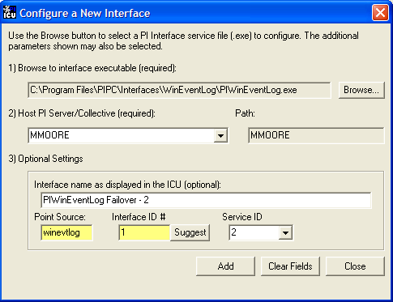
Figure 2: PI ICU configuration screen shows that the “PS/ID combo is already in use by the interface.” The user must ignore the yellow boxes, which indicate errors, and click the Add button to configure the interface for failover.

Configuring the UniInt Failover Startup Parameters with PI ICU
There are three interface startup parameters that control UniInt failover: /UFO_ID, /UFO_OtherID, and /UFO_Interval. The UFO stands for UniInt Failover. The /UFO_ID and /UFO_OtherID parameters are required for the interface to operate in a failover configuration, but the /UFO_Interval is optional. Each of these parameters is described in detail in Configuring UniInt Failover through a Shared File (Phase 2)section and Start-Up Parameters
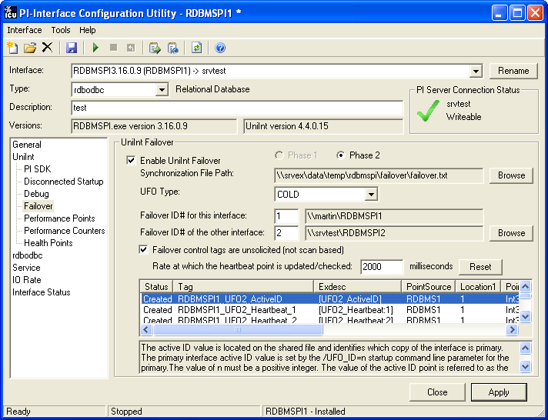
Figure 3: The figure above illustrates the PI ICU failover configuration screen showing the UniInt failover startup parameters (Phase 2). This copy of the interface defines its Failover ID as 2 (/UFO_ID=2) and the other interfaces Failover ID as 1 (/UFO_OtherID=1). The other failover interface copy must define its Failover ID as 1 (/UFO_ID=1) and the other interface Failover ID as 2 (/UFO_OtherID=2) in its ICU failover configuration screen. It also defines the location and name of the synchronization file as well as the type of failover as COLD.

Creating the Failover State Digital State Set
The UFO_State digital state set is used in conjunction with the failover state digital tag. If the UFO_State digital state set has not been created yet, it can be using either the Failover page of the ICU (1.4.1.0 or greater) or the Digital States plug-in in the SMT 3 Utility (3.0.0.7 or greater).

Using the PI ICU Utility to create Digital State Set
To use the UniInt Failover page to create the UFO_State digital state set right click on any of the failover tags in the tag list and then select the “Create UFO_State Digital Set on Server XXXXXX…”, where XXXXXX is the PI Server where the points will be or are create on.
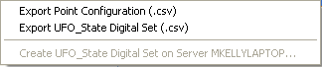
This choice will be grayed out if the UFO_State digital state set is already created on the XXXXXX PI Server.

Using the PI SMT 3 Utility to create Digital State Set
Optionally the “Export UFO_State Digital Set (.csv) can be selected to create a comma separated file to be imported via the System Manangement Tools (SMT3) (version 3.0.0.7 or higher) or use the UniInt_Failover_DigitalSet_UFO_State.csv file included in the installation kit.
The procedure below outlines the steps necessary to create a digital set on a PI Sever using the “Import from File” function found in the SMT3 application. The procedure assumes the user has a basic understanding of the SMT3 application.
- Open the SMT3 application.
- Select the appropriate PI Server from the PI Servers window. If the desired server is not listed, add it using the PI Connection Manager. A view of the SMT application is shown in Figure 4 below.
- From the System Management Plug-Ins window, select Points then Digital States. A list of available digital state sets will be displayed in the main window for the selected PI Server. Refer to Figure 4 below.
- In the main window, right click on the desired server and select the “Import from File” option. Refer to Figure 4 below.
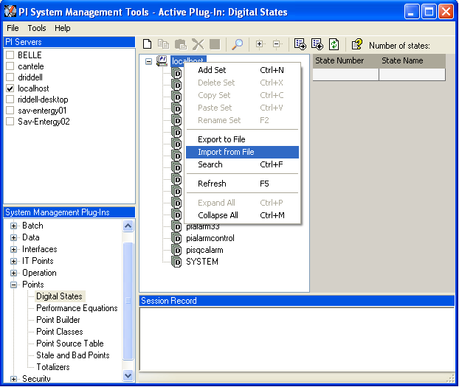
Figure 4: PI SMT application configured to import a digital state set file. The PI Servers window shows the “localhost” PI Server selected along with the System Management Plug-Ins window showing the Digital States Plug-In as being selected. The digital state set file can now be imported by selecting the Import from File option for the localhost.
- Navigate to and select the UniInt_Failover_DigitalSet_UFO_State.csv file for import using the Browse icon on the display. Select the desired Overwrite Options. Click on the OK button. Refer to Figure 5 below.
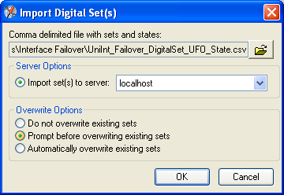
Figure 5: PI SMT application Import Digital Set(s) window. This view shows the UniInt_Failover_DigitalSet_UFO_State.csv file as being selected for import. Select the desired Overwrite Options by choosing the appropriate radio button.
- Navigate to and select the UniInt_Failover_DigitalSet_UFO_State.csv file for import using the Browse icon on the display. Select the desired Overwrite Options. Click on the OK button. Refer to Figure 5 above.
- The UFO_State digital set is created as shown in Figure 6 below.
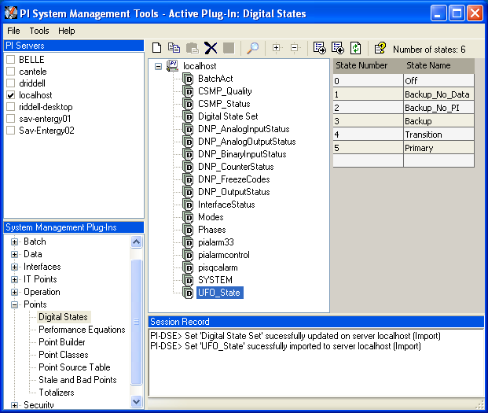
Figure 6: The PI SMT application showing the UFO_State digital set created on the “localhost” PI Server.

Creating the UniInt Failover Control and Failover State Tags (Phase 2)
The ICU can be used to create the UniInt Failover Control and State Tags.
To use the ICU Failover page to create these tags simply right click any of the failover tags in the tag list and select the “Create all points (UFO Phase 2)” menu item.
If this menu choice is grayed out it is because the UFO_State digital state set has not been created on the Server yet. There is a menu choice “Create UFO_State Digitial Set on Server xxxxxxx…” which can be used to create that digital state set. Once this has been done then the “Create all points (UFO Phase2) should be available.
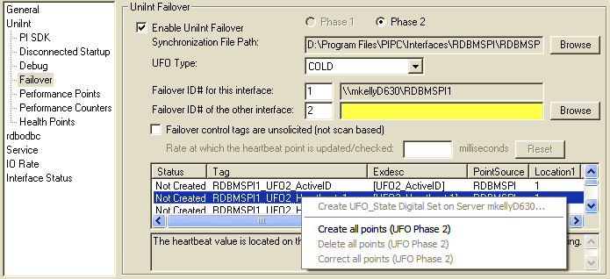
Once the failover control and failover state tags have been created the Failover page of the ICU should look similar to the illustration below.
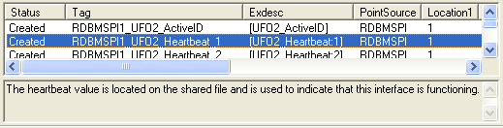

Database Specifics
Although ODBC is the de-facto standard for accessing data stored in relational databases, there are ODBC driver implementation differences. Also the underlying relational databases differ in functionality, supported data-types, SQL syntax and so on. The following section describes some of the interface relevant limits and/or differences; however, users must be aware that this list is by far not complete.

Oracle 7.0; Oracle 8.x, 9i, 10g, 11g; Oracle RDB

Open Statements Limitation
There is a limitation on the number of statements that can be opened concurrently and on some Oracle versions this limitation amounts to just 100 concurrently allocated statements. Since the interface normally uses one SQL statement per tag, not more than the specified number of tags could thus be serviced (per one RDBMSPI instance). Although it is possible to increase this limit via the keyword OPEN_CURSORS configured in the file INIT.ORA (located at the server side of the ORACLE database), this change, because it has the global influence, isn't easily applicable.
Note: The corresponding ODBC Error message, describing the aforementioned situation, is as follows:
[S][HY000]: [Oracle][ODBC][Ora]ORA-01000: maximum open cursors exceeded
One way around this limit is to group tags together (see Data Acquisition Strategies), or run multiple instances of the interface (different Location1), because this limit is per connection. The other approach is to use the interface option /EXECDIRECT that does not use the prepared execution at all. The direct execution (/EXECDIRECT start-up parameter) is the preferred solution.
Note: The described problem also occurs when too many cursors are open from stored procedures. All cursors open within a stored procedure thus have to be properly closed.

TOP 10
If it is required to limit the number of returned rows (e.g. to reduce the CPU load), there is a possibility to formulate the SQL query with the number representing the maximum rows that will be returned. This option is database specific and Oracles' implementation is as follows:
Oracle RDB
SELECT timestamp,value,status FROM Table LIMIT TO 10 ROWS;
SELECT timestamp,value,status FROM Table LIMIT TO 10 ROWS WHERE timestamp > ? ORDER BY timestamp;
Oracle 8.0 (NT) and above
Similar to the example for Oracle RDB, the statement to select a maximum of just 10 records looks as follows:
SELECT timestamp,value,status FROM Table WHERE ROWNUM<11;

How to Construct Stored Procedure that Returns Result-Set:
It is necessary to construct two Oracle objects – a PACKAGE and the actual STORED PROCEDURE:
- Package:
CREATE OR REPLACE PACKAGE myTestPackage IS
TYPE gen_cursor IS REF CURSOR;
END myTestPackage;
- Stored procedure (that takes for example the date argument as the input parameter):
CREATE OR REPLACE PROCEDURE myTestProc
(cur OUT myTestPackage.gen_cursor, ts IN date)
IS res myTestPackage.gen_cursor;
BEGIN
OPEN res FOR SELECT pi_time,pi_value,0 FROM pi_test1 WHERE pi_time > ts;
cur := res;
END myTestProc;
This store procedure can then be executed like:
{CALL myTestProc(?)}; P1=TS
And it delivers a result-set; the same as if the SELECT statement were executed directly.
Note: The above example works only with Oracle's ODBC drivers. It has been tested with Oracle9i.

dBase III, dBase IV

Date and Time Data Type
dBase does not have any native timestamp data type. If sending PI timestamps to dBase, the interface and the ODBC driver will automatically convert the timestamp placeholder from the SQL_TIMESTAMP into SQL_VARCHAR (the dBase target column therefore has to be TEXT(20)).
The other direction RDB->PI is not that simple. Actually, it is not possible to read a timestamp from a TEXT field because the required ODBC function CONVERT does not support the SQL_VARCHAR into SQL_TIMESTAMP conversion either. However, a workaround is possible:
Use the dBase database as a linked table from within MS Access. Now the MS Access ODBC driver is available, which implements a function called CDATE(). The following query works for string columns e.g. TEXT(20) in dBase with the format "DD-MMM-YY hh:mm:ss":
SELECT CDATE(Timestamp), Value, Status FROM Table WHERE CDATE(Timestamp) > ?; P1=TS
ODBC drivers used:
- Microsoft dBase Driver 4.00.4403.02
- Microsoft Access Driver 4.00.4403.02

Login
dBase works without Username and Password. In order to get access from the interface a dummy username and password must be used in the startup line.
/user_odbc=dummy /pass_odbc=dummy

Multi-User Access
The Microsoft dBase ODBC driver seems to lock the dBase tables. That means no other application can access the table at the same time.
There are no known workarounds, other than the Microsoft Access linked table.

Microsoft Access

Login
Access can also be configured without Username and Password. In order to get access from the interface a dummy username and password have to be used in the startup line.
/user_odbc=dummy /pass_odbc=dummy

Slowdown in statement preparation for more than 50 tags
ODBC drivers used:
- Access ODBC driver 4.00.5303.01
The Access ODBC driver shows a decrease in performance that depends on the number of open statements. Using the prepared execution (default setting), this is equivalent to the number of tags that hold a SQL query.
For more than ~50 ODBC statements (concurrently prepared) there is a significant slowdown in speed during the preparation of additional statements. The solution is using the /EXECDIRECT start-up parameter.
An alternative way is to use OLE DB for Jet 4.0 and an ODBC driver for OLE DB (e.g. Attunity Connect) on top.

Microsoft SQL Server 6.5, 7.0, 2000, 2005, 2008

DATETIME Data Type
Only the DATETIME data type represents the date and time implementation. The slightly misleading name TIMESTAMP, another MS SQL Server supported data type, is a database-wide unique number that cannot be bound to the interface time related placeholders (TS, ST,…).

TOP 10
The statement for selecting a maximum of 10 records looks as follows:
SELECT TOP 10 timestamp,value,status FROM Table;

SET NOCOUNT ON
If the stored procedure on MS SQL Server contains more complex T-SQL code, e.g. a combination of INSERT and SELECT statements, the SET NOCOUNT ON setting is preferable. Statements like INSERT, UPDATE, DELETE, {CALL} then do NOT return the number of affected rows (as the default result-set) which, in combination with the result set from a SELECT statement can cause the following errors:
"[S][24000]: [Microsoft][ODBC SQL Server Driver]Invalid cursor state"
or
" [S][HY000]: [Microsoft][ODBC SQL Server Driver]Connection is busy with results for another hstmt "
The following code shows how to avoid the above error:

CREATE PROCEDURE sp_RDBMSPI1

(

@name varchar(30), -- tag name

@TS datetime -- timestamp

)

AS

SET NOCOUNT ON

INSERT Table1 VALUES(@name,@TS)

SELECT Timestamp,Value,0 FROM Table2 WHERE Tagname = @name and Timestamp > @TS

CA Ingres II

Software Development Kit
The ODBC driver which comes with the Ingres II Software Development Kit does not work for this interface. This is due to the fact that the ODBC driver expects the statements being re-prepared before each execution (even if the ODBC driver reports SQL_CB_CLOSE when checking SQL_CURSOR_COMMIT_BEHAVIOR). That means that the ODBC driver is inconsistent with the ODBC specification.
Other ODBC drivers for Ingres II may still work. Alternatively it is possible to set the /EXECDIRECT start-up switch.

IBM DB2 (NT)

Statement Limitation
There is a limitation on the number of statements that can be open concurrently (prepared ODBC execution) for the version 7.1. The limitation only allows 100 concurrently prepared ODBC statements. It is nevertheless possible to increase this value via a corresponding DB2 database parameter (applheapsz via the DB2 Control Center: Configure (right clicking the particular database instance) PerformanceApplication heap size)
ODBC drivers used:
- IBM DB2 (NT) 07.01.0000
- ODBC Driver 06.01.0000
Note: The corresponding ODBC Error message describing the situation is as follows:
[S][57011]: [IBM][CLI Driver][DB2/NT] SQL0954C Not enough storage is available in the application heap to process the statement. SQLSTATE=57011
See the above discussion of the same topic with Oracle database.

Informix (NT)
ODBC drivers used:
- Informix 07.31.0000 TC5 (NT) 02.80.0008 2.20 TC1

Error while ODBC Re-Connection
An access violation in the Informix ODBC driver DLL was experienced when the Informix RDB was shut down during the interface operation.

Paradox
ODBC drivers used:
- Paradox, 5.x ODBC Driver 4.00.5303.01
- BDE (Borland Database Engine) 5.0

Error when ALIASES used in WHERE Clause
Following query returns runtime errors:
SELECT Timestamp AS PI_TIMESTAMP,Value,0 FROM Table WHERE PI_TIMESTAMP > ? ORDER BY PI_TIMESTAMP; P1=TS
[S][07002]: [Microsoft][ODBC Paradox Driver] Too few parameters. Expected 2.
OSIsoft, LLC recommends not using aliases.

Interface Node Clock
Make sure that the time and time zone settings on the computer are correct. To confirm, run the Date/Time applet located in the Windows Control Panel. If the locale where the Interface Node resides observes Daylight Saving Time, check the “Automatically adjust clock for daylight saving changes” box. For example,
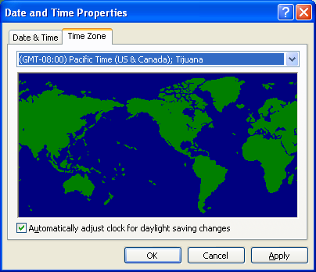
In addition, make sure that the TZ environment variable is not defined. All of the currently defined environment variables can be viewed by opening a Command Prompt window and typing set. That is,
C:> set
Confirm that TZ is not in the resulting list. If it is, run the System applet of the Control Panel, click the “Environment Variables” button under the Advanced Tab, and remove TZ from the list of environment variables. For more information see section Time Zone and Daylight Saving.

Time Synchronization with PI Server
The interface time is automatically synchronized with the PI Server. The interface finds out the time difference (between the PI Server node and the local node) at its start-up and adds this difference to all timestamps it provides. The aforementioned time difference is re-checked each 10 minutes – before each scan class the interface finds out if the difference was refreshed in the last 10 minutes. The time difference is independent of the TZ/DST settings of the PI Server and the interface node.

Time Zone and Daylight Saving
The interface can be connected to a PI Server, which is installed in a different Time Zone or has different DST rules (than the interface node). Nevertheless, the interface operation is usually not influenced by this, because the extended PI API automatically handles all these differences.
As far as the actual RDB timestamps are concerned, it is assumed that they reflect the Time Zone/DST setting as specified in the (Windows) operating system. Because ODBC has no standard way of telling the client about the Time Zone/DST settings of the connected RDB, no timestamp conversion can be applied (should the RDB reside in some other Time Zone/DST than the interface).
Note: The RDB timestamps are thus sent to PI with the Time Zone/DST settings of the interface node!
OSIsoft suggests to set the same (Time Zone/DST) settings on the interface node AS THEY ARE on the RDB machine. For example, many RDB systems are running with DST off; that is – set the DST off also for the interface node and let the PI API to take care of the timestamp conversion between the interface node and the PI Server.
The other scenario assumes the RDB timestamps are UTC timestamps; that is, the interface considers them independent of the local operating system settings. This mode is activated by the /UTC startup switch; see section Command-Line Parameters for more details.
Note: The RDBMSPI Interface uses the extended PI API functions, which do the time zone/DST adjustment automatically. PI API version 1.3.8 or above is therefore required.

Security

Windows
The PI Firewall Database and the PI Proxy Database must be configured so that the interface is allowed to write data to the PI Server. See “Modifying the Firewall Database” and “Modifying the Proxy Database” in the PI Server manuals.
Note that the Trust Database, which is maintained by the Base Subsystem, replaces the Proxy Database used prior to PI version 3.3. The Trust Database maintains all the functionality of the proxy mechanism while being more secure. See “Trust Login Security” in the chapter “Managing Security” of the PI Server System Management Guide.
If the interface cannot write data to the PI Server because it has insufficient privileges, a -10401 error will be reported in the pipc.log file. If the interface cannot send data to a PI2 Serve, it writes a -999 error. See the section Appendix A: Error and Informational Messages for additional information on error messaging.

PI Server v3.3 and Higher

Security configuration using piconfig
For PI Server v3.3 and higher, the following example demonstrates how to edit the PI Trust table:
C:\PI\adm> piconfig
@table pitrust
@mode create
@istr Trust,IPAddr,NetMask,PIUser
a_trust_name,192.168.100.11,255.255.255.255,piadmin

@quit
For the above,
Trust: An arbitrary name for the trust table entry; in the above example,
a_trust_name
IPAddr: the IP Address of the computer running the Interface; in the above example,

192.168.100.11
NetMask: the network mask; 255.255.255.255 specifies an exact match with IPAddr
PIUser: the PI user the Interface to be entrusted as; piadmin is usually an appropriate user

Security Configuring using Trust Editor
The Trust Editor plug-in for PI System Management Tools 3.x may also be used to edit the PI Trust table.
See the PI System Management chapter in the PI Server manual for more details on security configuration.

PI Server v3.2
For PI Server v3.2, the following example demonstrates how to edit the PI Proxy table:
C:\PI\adm> piconfig
@table pi_gen,piproxy
@mode create
@istr host,proxyaccount
piapimachine,piadmin
@quit
In place of piapimachine, put the name of the PI Interface node as it is seen by PI Server.

Starting / Stopping the Interface
This section describes starting and stopping the Interface once it has been installed as a service. See the UniInt Interface User Manual to run the Interface interactively.


Starting Interface as a Service
If the Interface was installed as service, it can be started from PI ICU, the Services control panel or with the command:
rdbmspi.exe –start
To start the interface service with PI ICU, use the button on the PI ICU toolbar.
A message will inform the user of the status of the interface service. Even if the message indicates that the service has started successfully, double check through the Services control panel applet. Services may terminate immediately after startup for a variety of reasons, and one typical reason is that the service is not able to find the command-line parameters in the associated .bat file. Verify that the root name of the .bat file and the .exe file are the same, and that the .bat file and the .exe file are in the same directory. Further troubleshooting of services might require consulting the pipc.log file, Windows Event Viewer, or other sources of log messages. See the section Appendix A: Error and Informational Messages for additional information.

Stopping Interface Running as a Service
If the Interface was installed as service, it can be stopped at any time from PI ICU, the Services control panel or with the command:
rdbmspi.exe –stop
The service can be removed by:
rdbmspi.exe –remove
To stop the interface service with PI ICU, use the button on the PI ICU toolbar.

Buffering
Buffering refers to an Interface Node’s ability to temporarily store the data that interfaces collect and to forward these data to the appropriate PI Servers. OSIsoft strongly recommends that you enable buffering on your Interface Nodes. Otherwise, if the Interface Node stops communicating with the PI Server, you lose the data that your interfaces collect.
The PI SDK installation kit installs two buffering applications: the PI Buffer Subsystem (PIBufss) and the PI API Buffer Server (Bufserv). PIBufss and Bufserv are mutually exclusive; that is, on a particular computer, you can run only one of them at any given time.
If you have PI Servers that are part of a PI Collective, PIBufss supports n-way buffering. N-way buffering refers to the ability of a buffering application to send the same data to each of the PI Servers in a PI Collective. (Bufserv also supports n-way buffering, but OSIsoft recommends that you run PIBufss instead.)
Note: Combining the RDBMSPI interface with buffering can present a couple of issues. Buffering is, in general, very useful concept, especially when run with interfaces that scan the “classic” DCS systems. Such interfaces, however, mostly only keep sending current data to PI and do not need to read anything back from the PI Server. The RDBMSPI interface, on the other hand, needs to refresh its placeholders before each query execution and because buffering supports just one-way communication (from Interface to PI), queries with placeholders will, at times when the PI Server is not accessible, not be executed; while queries without placeholders will run fine. Moreover, queries, which contain the annotation column; that is, queries, which need PI SDK support, will bypass buffering entirely.
Whether buffering should or should not be used depends on the individual installation and data retrieval scenarios.

Which Buffering Application to Use
You should use PIBufss whenever possible because it offers better throughput than Bufserv. In addition, if the interfaces on an Interface Node are sending data to a PI Collective, PIBufss guarantees identical data in the archive records of all the PI Servers that are part of that collective.
You can use PIBufss only under the following conditions:
- the PI Server version is at least 3.4.375.x; and
- all of the interfaces running on the Interface Node send data to the same PI Server or to the same PI Collective.
If any of the following scenarios apply, you must use Bufserv:
- the PI Server version is earlier than 3.4.375.x; or
- the Interface node runs multiple interfaces, and these interfaces send data to multiple PI Servers that are not part of a single PI Collective.
If an Interface Node runs multiple interfaces, and these interfaces send data to two or more PI Collectives, then neither PIBufss nor Bufserv is appropriate. The reason is that PIBufss and Bufserv can buffer data only to a single collective. If you need to buffer to more than one PI Collective, you need to use two or more Interface Nodes to run your interfaces.
It is technically possible to run Bufserv on the PI Server Node. However, OSIsoft does not recommend this configuration.

How Buffering Works
A complete technical description of PIBufss and Bufserv is beyond the scope of this document. However, the following paragraphs provide some insights on how buffering works.
When an Interface Node has Buffering enabled, the buffering application (PIBufss or Bufserv) connects to the PI Server. It also creates shared memory storage.
When an interface program makes a PI API function call that writes data to the PI Server (for example, pisn_sendexceptionqx()), the PI API checks whether buffering is enabled. If it is, these data writing functions do not send the interface data to the PI Server. Instead, they write the data to the shared memory storage that the buffering application created.
The buffering application (either Bufserv or PIBufss) in turn
- reads the data in shared memory, and
- if a connection to the PI Server exists, sends the data to the PI Server; or
- if there is no connection to the PI Server, continues to store the data in shared memory (if shared memory storage is available) or writes the data to disk (if shared memory storage is full).
When the buffering application re-establishes connection to the PI Server, it writes to the PI Server the interface data contained in both shared memory storage and disk.
(Before sending data to the PI Server, PIBufss performs further tasks such data validation and data compression, but the description of these tasks is beyond the scope of this document.)
When PIBufss writes interface data to disk, it writes to multiple files. The names of these buffering files are PIBUFQ_*.DAT.
When Bufserv writes interface data to disk, it writes to a single file. The name of its buffering file is APIBUF.DAT.
As a previous paragraph indicates, PIBufss and Bufserv create shared memory storage at startup. These memory buffers must be large enough to accommodate the data that an interface collects during a single scan. Otherwise, the interface may fail to write all its collected data to the memory buffers, resulting in data loss. The buffering configuration section of this chapter provides guidelines for sizing these memory buffers.
When buffering is enabled, it affects the entire Interface Node. That is, you do not have a scenario whereby the buffering application buffers data for one interface running on an Interface Node but not for another interface running on the same Interface Node.

Buffering and PI Server Security
After you enable buffering, it is the buffering application—and not the interface program—that writes data to the PI Server. If the PI Server’s trust table contains a trust entry that allows all applications on an Interface Node to write data, then the buffering application is able write data to the PI Server.
However, if the PI Server contains an interface-specific PI Trust entry that allows a particular interface program to write data, you must have a PI Trust entry specific to buffering. The following are the appropriate entries for the Application Name field of a PI Trust entry:
Buffering Application | Application Name field for PI Trust
PI Buffer Subsystem | PIBufss.exe
PI API Buffer Server | APIBE (if the PI API is using 4 character process names)  APIBUF (if the PI API is using 8 character process names)
To use a process name greater than 4 characters in length for a trust application name, use the LONGAPPNAME=1 in the PIClient.ini file.

Enabling Buffering on an Interface Node with the ICU
The ICU allows you to select either PIBufss or Bufserv as the buffering application for your Interface Node. Run the ICU and select Tools > Buffering.

Choose Buffer Type
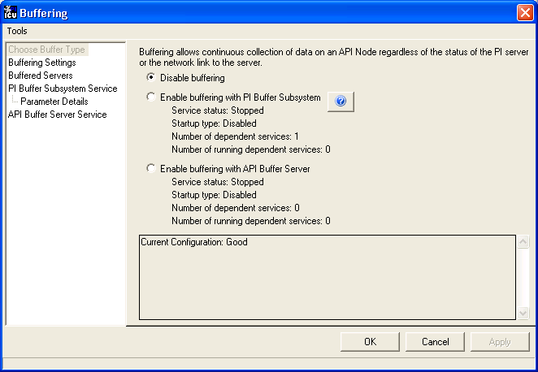
To select PIBufss as the buffering application, choose Enable buffering with PI Buffer Subsystem.
To select Bufserv as the buffering application, choose Enable buffering with API Buffer Server.
If a warning message such as the following appears, click Yes.
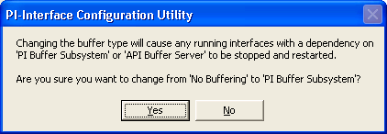

Buffering Settings
There are a number of settings that affect the operation of PIBufss and Bufserv. The Buffering Settings section allows you to set these parameters. If you do not enter values for these parameters, PIBufss and Bufserv use default values.

PIBufss
For PIBufss, the paragraphs below describe the settings that may require user intervention. Please contact OSIsoft Technical Support for assistance in further optimizing these and all remaining settings.
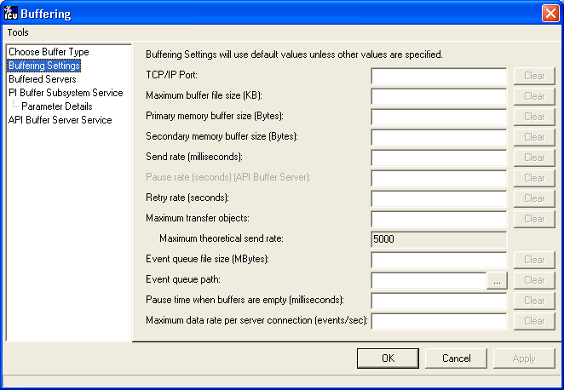

Primary and Secondary Memory Buffer Size (Bytes)
This is a key parameter for buffering performance. The sum of these two memory buffer sizes must be large enough to accommodate the data that an interface collects during a single scan. A typical event with a Float32 point type requires about 25 bytes. If an interface writes data to 5,000 points, it can potentially send 125,000 bytes (25 * 5000) of data in one scan. As a result, the size of each memory buffer should be 62,500 bytes.
The default value of these memory buffers is 32,768 bytes. OSIsoft recommends that these two memory buffer sizes should be increased to the maximum of 2000000 for the best buffering performance.

Send rate (milliseconds)
Send rate is the time in milliseconds that PIBufss waits between sending up to the Maximum transfer objects (described below) to the PI Server. The default value is 100. The valid range is 0 to 2,000,000.

Maximum transfer objects
Maximum transfer objects is the maximum number of events that PIBufss sends between each Send rate pause. The default value is 500. The valid range is 1 to 2,000,000.

Event Queue File Size (Mbytes)
This is the size of the event queue files. PIBufss stores the buffered data to these files. The default value is 32. The range is 8 to 131072 (8 to 128 Gbytes). Please see the section entitled, “Queue File Sizing” in the PIBufss.chm file for details on how to appropriately size the event queue files.

Event Queue Path
This is the location of the event queue file. The default value is [PIHOME]\DAT.
For optimal performance and reliability, OSIsoft recommends that you place the PIBufss event queue files on a different drive/controller from the system drive and the drive with the Windows paging file. (By default, these two drives are the same.)

Bufserv
For Bufserv, the paragraphs below describe the settings that may require user intervention. Please contact OSIsoft Technical Support for assistance in further optimizing these and all remaining settings.
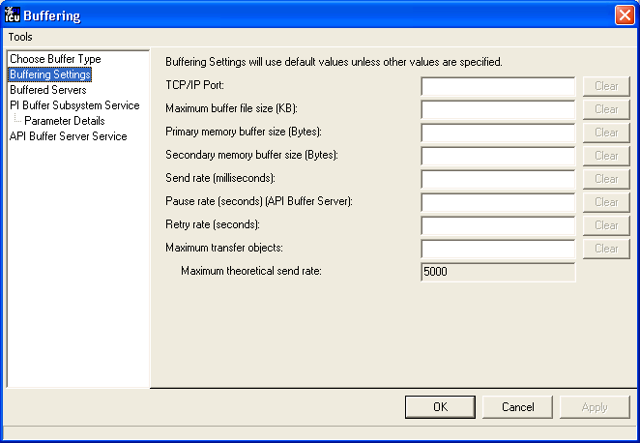

Maximum buffer file size (KB)
This is the maximum size of the buffer file ([PIHOME]\DAT\APIBUF.DAT). When Bufserv cannot communicate with the PI Server, it writes and appends data to this file. When the buffer file reaches this maximum size, Bufserv discards data.
The default value is 2,000,000 KB, which is about 2 GB. The range is from 1 to 2,000,000.

Primary and Secondary Memory Buffer Size (Bytes)
This is a key parameter for buffering performance. The sum of these two memory buffer sizes must be large enough to accommodate the data that an interface collects during a single scan. A typical event with a Float32 point type requires about 25 bytes. If an interface writes data to 5,000 points, it can potentially send 125,000 bytes (25 * 5000) of data in one scan. As a result, the size of each memory buffer should be 62,500 bytes.
The default value of these memory buffers is 32,768 bytes. OSIsoft recommends that these two memory buffer sizes should be increased to the maximum of 2000000 for the best buffering performance.

Send rate (milliseconds)
Send rate is the time in milliseconds that Bufserv waits between sending up to the Maximum transfer objects (described below) to the PI Server. The default value is 100. The valid range is 0 to 2,000,000.

Maximum transfer objects
Max transfer objects is the maximum number of events that Bufserv sends between each Send rate pause. The default value is 500. The valid range is 1 to 2,000,000.

Buffered Servers
The Buffered Servers section allows you to define the PI Servers or PI Collective that the buffering application writes data.

PIBufss
PIBufss buffers data only to a single PI Server or a PI Collective. Select the PI Server or the PI Collective from the Buffering to collective/server drop down list box.
The following screen shows that PIBufss is configured to write data to a standalone PI Server named starlight. Notice that the Replicate data to all collective member nodes check box is disabled because this PI Server is not part of a collective. (PIBufss automatically detects whether a PI Server is part of a collective.)
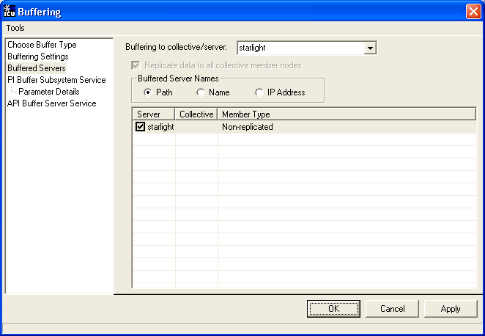
The following screen shows that PIBufss is configured to write data to a PI Collective named admiral. By default, PIBufss replicates data to all collective members. That is, it provides n-way buffering.
You can override this option by not checking the Replicate data to all collective member nodes check box. Then, uncheck (or check) the PI Server collective members as desired.
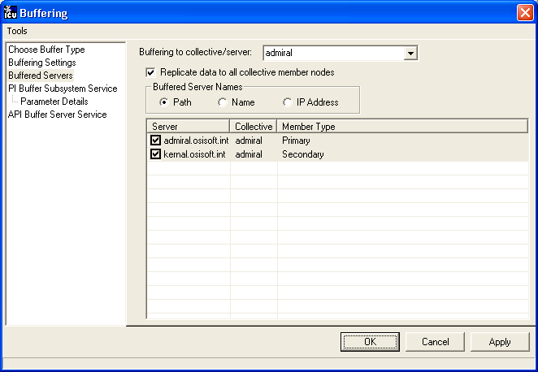

Bufserv
Bufserv buffers data to a standalone PI Server, or to multiple standalone PI Servers. (If you want to buffer to multiple PI Servers that are part of a PI Collective, you should use PIBufss.)
If the PI Server to which you want Bufserv to buffer data is not in the Server list, enter its name in the Add a server box and click the Add Server button. This PI Server name must be identical to the API Hostname entry:
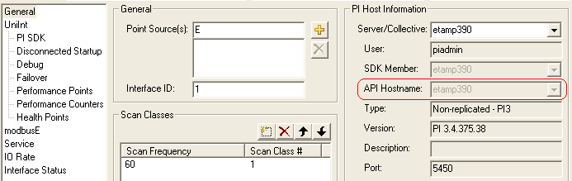
The following screen shows that Bufserv is configured to write to a standalone PI Server named etamp390. You use this configuration when all the interfaces on the Interface Node write data to etamp390.
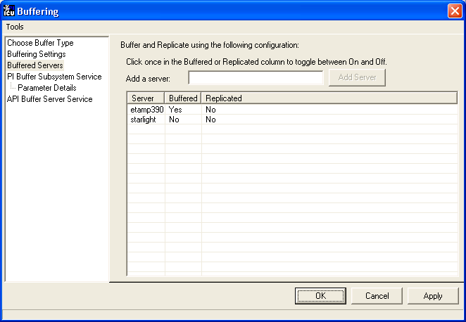
The following screen shows that Bufserv is configured to write to two standalone PI Servers, one named etamp390 and the other one named starlight. You use this configuration when some of the interfaces on the Interface Node write data to etamp390 and some write to starlight.
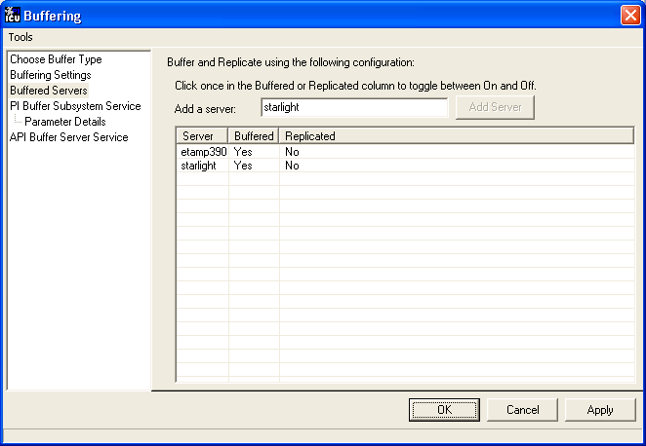

Installing Buffering as a Service
Both the PIBufss and Bufserv applications run as a Service.

PI Buffer Subsystem Service
Use the PI Buffer Subsystem Service page to configure PIBufss as a Service. This page also allows you to start and stop the PIBufss service.
PIBufss does not require the logon rights of the local administrator account. It is sufficient to use the LocalSystem account instead. Although the screen below shows asterisks for the LocalSystem password, this account does not have a password.
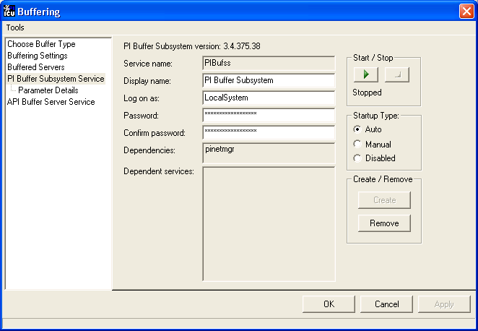
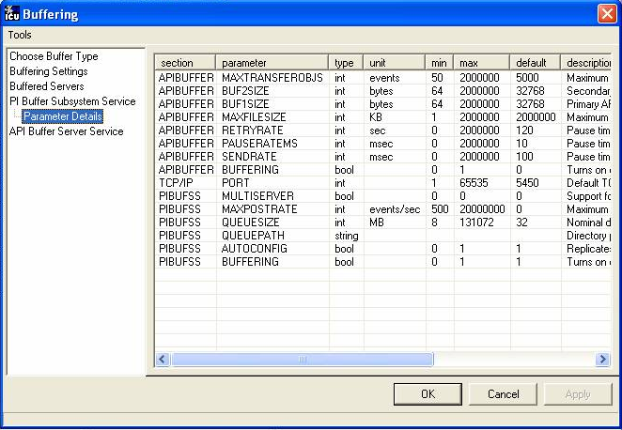

API Buffer Server Service
Use the API Buffer Server Service page to configure Bufserv as a Service. This page also allows you to start and stop the Bufserv Service
Bufserv version 1.6 and later does not require the logon rights of the local administrator account. It is sufficient to use the LocalSystem account instead. Although the screen below shows asterisks for the LocalSystem password, this account does not have a password.
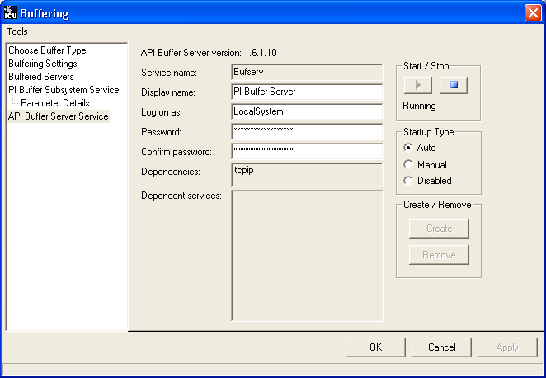

Interface Diagnostics Configuration
The Interface Point Configuration chapter provides information on building PI points for collecting data from the device. This chapter describes the configuration of points related to interface diagnostics.
Note: The procedure for configuring interface diagnostics is not specific to this Interface. Thus, for simplicity, the instructions and screenshots that follow refer to an interface named ModbusE.
Some of the points that follow refer to a “performance summary interval”. This interval is 8 hours by default. You can change this parameter via the Scan performance summary box in the UniInt – Debug parameter category pane:
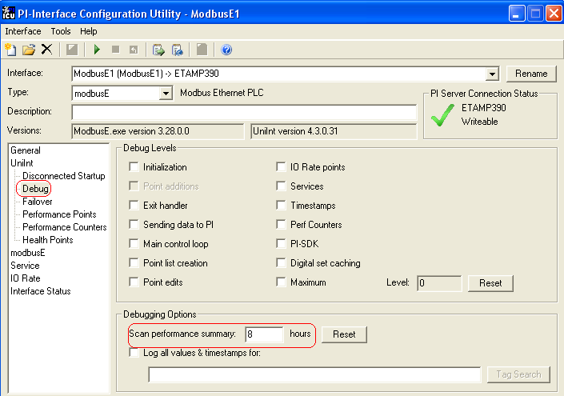

Scan Class Performance Points
A Scan Class Performance Point measures the amount of time (in seconds) that this Interface takes to complete a scan. The Interface writes this scan completion time to millisecond resolution. Scan completion times close to 0 indicate that the Interface is performing optimally. Conversely, long scan completion times indicate an increased risk of missed or skipped scans. To prevent missed or skipped scans, you should distribute the data collection points among several scan classes.
You configure one Scan Class Performance Point for each Scan Class in this Interface. From the ICU, select this Interface from the Interface drop-down list and click UniInt-Performance Points in the parameter category pane:
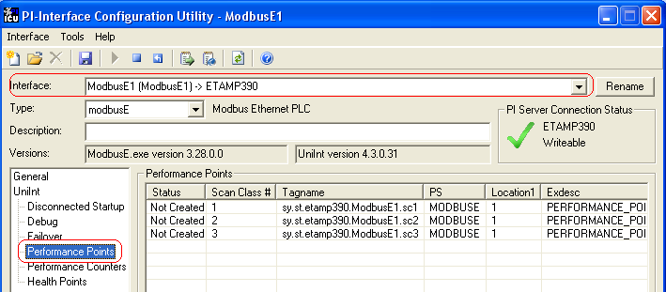
Right click the row for a particular Scan Class # to bring up the context menu:
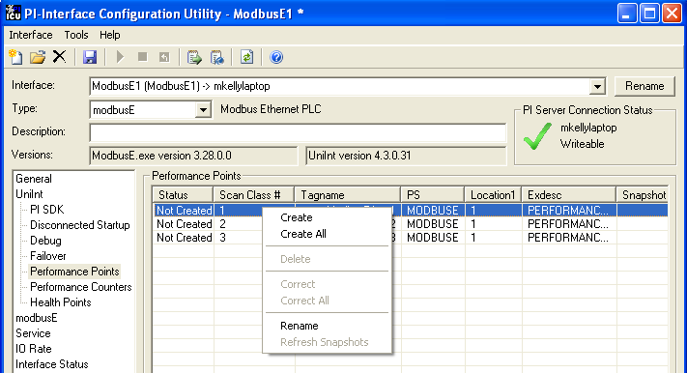
You need not restart the Interface for it to write values to the Scan Class Performance Points.
To see the current values (snapshots) of the Scan Class Performance Points, right click and select Refresh Snapshots.

Create / Create ALL
To create a Performance Point, right-click the line belonging to the tag to be created, and select Create. Click Create All to create all the Scan Class Performance Points.

Delete
To delete a Performance Point, right-click the line belonging to the tag to be deleted, and select Delete.

Correct / Correct All
If the “Status” of a point is marked “Incorrect”, the point configuration can be automatically corrected by ICU by right-clicking on the line belonging to the tag to be corrected, and selecting Correct. The Performance Points are created with the following PI attribute values. If ICU detects that a Performance Point is not defined with the following, it will be marked Incorrect: To correct all points click the Correct All menu item.
The Performance Points are created with the following PI attribute values:
Attribute | Details
Tag | Tag name that appears in the list box
Point Source | Point Source for tags for this interface, as specified on the first tab
Compressing | Off
Excmax | 0
Descriptor | Interface name + “ Scan Class # Performance Point”

Rename
Right-click the line belonging to the tag and select “Rename” to rename the Performance Point.

Column descriptions

Status
The Status column in the Performance Points table indicates whether the Performance Point exists for the scan class in column 2.

Created – Indicates that the Performance Point does exist
Not Created – Indicates that the Performance Point does not exist
Deleted – Indicates that a Performance Point existed, but was just deleted by the user

Scan Class #
The Scan Class column indicates which scan class the Performance Point in the Tagname column belongs to. There will be one scan class in the Scan Class column for each scan class listed in the Scan Classes combo box on the UniInt Parameters tab.

Tagname
The Tagname column holds the Performance Point tag name.

PS
This is the point source used for these performance points and the interface.

Location1
This is the value used by the interface for the /ID=# point attribute.

Exdesc
This is the used to tell the interface that these are performance points and the value is used to corresponds to the /ID=# command line parameter if multiple copies of the same interface are running on the Interface node.

Snapshot
The Snapshot column holds the snapshot value of each Performance Point that exists in PI. The Snapshot column is updated when the Performance Points/Counters tab is clicked, and when the interface is first loaded. You may have to scroll to the right to see the snapshots.

Performance Counters Points
When running as a Service or interactively, this Interface exposes performance data via Windows Performance Counters. Such data include items like:
- the amount of time that the Interface has been running;
- the number of points the Interface has added to its point list;
- the number of tags that are currently updating among others
There are two types or instances of Performance Counters that can be collected and stored in PI Points. The first is (_Total) which is a total for the Performance Counter since the interface instance was started. The other is for individual Scan Classes (Scan Class x) where x is a particular scan class defined for the interface instance that is being monitored.
OSIsoft’s PI Performance Monitor Interface is capable of reading these performance values and writing them to PI points. Please see the Performance Monitor Interface for more information.
If there is no PI Performance Monitor Interface registered with the ICU in the Module Database for the PI Server the interface is sending its data to, you cannot use the ICU to create any Interface instance’s Performance Counters Points:
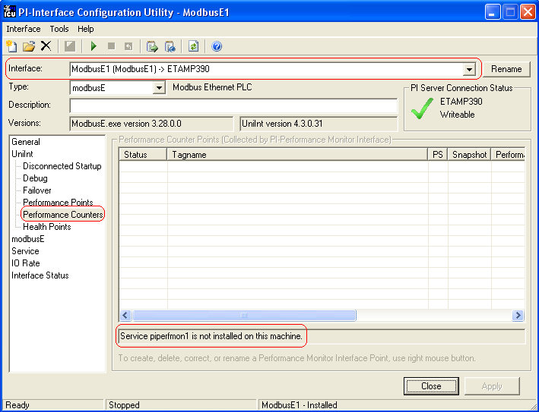
After installing the PI Performance Monitor Interface as a service, select this Interface instance from the Interface drop-down list, then click Performance Counters in the parameter categories pane, and right click on the row containing the Performance Counters Point you wish to create. This will bring up the context menu:
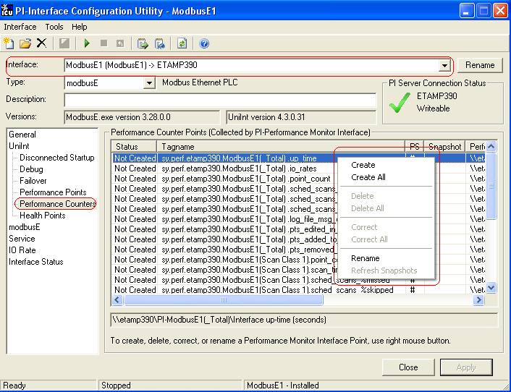
Click Create to create the Performance Counters Point for that particular row. Click Create All to create all the Performance Counters Points listed which have a status of Not Created.
To see the current values (snapshots) of the created Performance Counters Points, right click on any row and select Refresh Snapshots.
Note: The PI Performance Monitor Interface – and not this Interface – is responsible for updating the values for the Performance Counters Points in PI. So, make sure that the PI Performance Monitor Interface is running correctly.

Performance Counters
In the following lists of Performance Counters the naming convention used will be:
“PerformanceCounterName” (.PerformanceCountersPoint Suffix)
The tagname created by the ICU for each Performance Counter point is based on the setting found under the Tools Options Naming Conventions Performance Counter Points. The default for this is “sy.perf.[machine].[if service] followed by the Performance Counter Point suffix.

Performance Counters for both (_Total) and (Scan Class x)

“Point Count” (.point_count)
A .point_count Performance Counters Point is available for each Scan Class of this Interface as well as a Total for the interface instance.
The .point_count Performance Counters Point indicates the number of PI Points per Scan Class or the total number for the interface instance. This point is similar to the Health Point [UI_SCPOINTCOUNT] for scan classes and [UI_POINTCOUNT] for totals.
The ICU uses a naming convention such that the tag containing “(Scan Class 1)” (for example, “sy.perf.etamp390.E1(Scan Class 1).point_count” refers to Scan Class 1, “(Scan Class 2)” refers to Scan Class 2, and so on. The tag containing “(_Total)” refers to the sum of all Scan Classes.

“Scheduled Scans: % Missed” (.sched_scans_%missed)
A .sched_scans_%missed Performance Counters Point is available for each Scan Class of this Interface as well as a Total for the interface instance.
The .sched_scans_%missed Performance Counters Point indicates the percentage of scans the Interface missed per Scan Class or the total number missed for all scan classes since startup. A missed scan occurs if the Interface performs the scan one second later than scheduled.
The ICU uses a naming convention such that the tag containing “(Scan Class 1)” (for example, “sy.perf.etamp390.E1(Scan Class 1).sched_scans_%missed” refers to Scan Class 1, “(Scan Class 2)” refers to Scan Class 2, and so on. The tag containing “(_Total)” refers to the sum of all Scan Classes.

“Scheduled Scans: % Skipped” (.sched_scans_%skipped)
A .sched_scans_%skipped Performance Counters Point is available for each Scan Class of this Interface as well as a Total for the interface instance.
The .sched_scans_%skipped Performance Counters Point indicates the percentage of scans the Interface skipped per Scan Class or the total number skipped for all scan classes since startup. A skipped scan is a scan that occurs at least one scan period after its scheduled time. This point is similar to the [UI_SCSKIPPED] Health Point.
The ICU uses a naming convention such that the tag containing “(Scan Class 1)” (for example, “sy.perf.etamp390.E1(Scan Class 1).sched_scans_%skipped” refers to Scan Class 1, “(Scan Class 2)” refers to Scan Class 2, and so on. The tag containing “(_Total)” refers to the sum of all Scan Classes.

“Scheduled Scans: Scan count this interval” (.sched_scans_this_interval)
A .sched_scans_this_interval Performance Counters Point is available for each Scan Class of this Interface as well as a Total for the interface instance.
The .sched_scans_this_interval Performance Counters Point indicates the number of scans that the Interface performed per performance summary interval for the scan class or the total number of scans performed for all scan classes during the summary interval. This point is similar to the [UI_SCSCANCOUNT] Health Point.
The ICU uses a naming convention such that the tag containing “(Scan Class 1)” (for example, “sy.perf.etamp390.E1(Scan Class 1).sched_scans_this_interval” refers to Scan Class 1, “(Scan Class 2)” refers to Scan Class 2, and so on. The tag containing “(_Total)” refers to the sum of all Scan Classes.

Performance Counters for (_Total) only

“Device Actual Connections” (.Device_Actual_Connections)
The .Device_Actual_Connections Performance Counters Point stores the actual number of foreign devices currently connected and working properly out of the expected number of foreign device connections to the interface. This value will always be less than or equal to the Expected Connections.

“Device Expected Connections” (.Device_Expected_Connections)
The .Device_Expected_Connections Performance Counters Point stores the total number of foreign device connections for the interface. This is the expected number of foreign device connections configured that should be working properly at runtime. If the interface can only communicate with 1 foreign device then the value of this counter will always be one. If the interface can support multiple foreign device connections then this is the total number of expected working connections configured for this Interface.

“Device Status” (.Device_Status)
The .Device_Status Performance Counters Point stores communication information about the interface and the connection to the foreign device(s). The value of this counter is based on the expected connections, actual connections and value of the /PercentUp command line option. If the device status is good then the value is ‘0’. If the device status is bad then the value is ‘1’. If the interface only supports connecting to 1 foreign device then the /PercentUp command line value does not change the results of the calculation. If for example the Interface can connect to 10 devices and 5 are currently working then the value of the /PercentUp command line parameter is applied to determine the Device Status. If the value of the /PercentUp command line parameter is set to 50 and at least 5 devices are working then the DeviceStatus will remain good (i.e. have a value of zero).

“Failover Status” (.Failover_Status)
The .Failover_Status Performance Counters Point stores the failover state of the interface when configured for UniInt interface level failover. The value of the counter will be ‘0’ when the interface is running as the ‘Primary’ interface in the failover configuration. If the interface is running in backup mode then the value of the counter will be ‘1’.

“Interface up-time (seconds)” (.up_time)
The .up_time Performance Counters Point indicates the amount of time (in seconds) that this Interface has been running. At startup the value of the counter is zero. The value will continue to increment until it reaches the maximum value for an unsigned integer. Once it reaches this value then it will start back over at zero.

“IO Rate (events/second)” (.io_rates)
The .io_rates Performance Counters Point indicates the rate (in event per second) at which this Interface writes data to its input tags. (As of UniInt 4.5.0.x and later this performance counters point will no longer be available.)

“Log file message count” (.log_file_msg_count)
The .log_file_msg_count Performance Counters Point indicates the number of messages that the Interface has written to the log file. This point is similar to the [UI_MSGCOUNT] Health Point.

“PI Status” (PI_Status)
The .PI_Status Performance Counters Point stores communication information about the interface and the connection to the PI Server. If the interface is properly communicating with the PI server then the value of the counter is ‘0’. If the communication to the PI Server goes down for any reason then the value of the counter will be ‘1’. Once the interface is properly communicating with the PI server again then the value will change back to ‘0’.

“Points added to the interface” (.pts_added_to_interface)
The .pts_added_to_interface Performance Counter Point indicates the number of points the Interface has added to its point list. This does not include the number of points configured at startup. This is the number of points added to the interface after the interface has finished a successful startup.

“Points edited in the interface”(.pts_edited_in_interface)
The .pts_edited_in_interface Performance Counters Point indicates the number of point edits the Interface has detected. The Interface detects edits for those points whose PointSource attribute matches the Point Source parameter and whose Location1 attribute matches the Interface ID parameter of the Interface.

“Points Good” (.Points_Good)
The .Points_Good Performance Counters Point is the number of points that have sent a good current value to PI. A good value is defined as any value that is not a system digital state value. A point can either be Good, In Error or Stale. The total of Points Good, Points In Error and Points State will equal the Point Count. There is one exception to this rule. At startup of an interface, the Stale timeout must elapse before the point will be added to the Stale Counter. Therefore the interface must be up and running for at least 10 minutes for all tags to belong to a particular Counter.

“Points In Error” (.Points_In_Error)
The .Points_In_Error Performance Counters Point indicates the number of points that have sent a current value to PI that is a system digital state value. Once a point is in the In Error count it will remain in the In Error count until the point receives a new, good value. Points in Error do not transition to the Stale Counter. Only good points become stale.

“Points removed from the interface” (.pts_removed_from_interface)
The .pts_removed_from_interface Performance Counters Point indicates the number of points that have been removed from the Interface configuration. A point can be removed from the interface when one of the tag properties for the interface is updated and the point is no longer a part of the interface configuration. For example, changing the point source, location 1, or scan property can cause the tag to no longer be a part of the interface configuration.

“Points Stale 10(min)” (.Points_Stale_10min)
The .Points_Stale_10min Performance Counters Point indicates the number of good points that have not received a new value in the last 10 min. If a point is Good, then it will remain in the good list until the Stale timeout elapses. At this time if the point has not received a new value within the Stale Period then the point will move from the Good count to the Stale count. Only points that are Good can become Stale. If the point is in the In Error count then it will remain in the In Error count until the error clears. As stated above, the total count of Points Good, Points In Error and Points Stale will match the Point Count for the Interface.

“Points Stale 30(min)” (.Points_Stale_30min)
The .Points_Stale_30min Performance Counters Point indicates the number of points that have not received a new value in the last 30 min. For a point to be in the Stale 30 minute count it must also be a part of the Stale 10 minute count.

“Points Stale 60(min)” (.Points_Stale_60min)
The .Points_Stale_60min Performance Counters Point indicates the number of points that have not received a new value in the last 60 min. For a point to be in the Stale 60 minute count it must also be a part of the Stale 10 minute and 30 minute count.

“Points Stale 240(min)” (.Points_Stale_240min)
The .Points_Stale_240min Performance Counters Point indicates the number of points that have not received a new value in the last 240 min. For a point to be in the Stale 240 minute count it must also be a part of the Stale 10 minute, 30 minute and 60 minute count.

Performance Counters for (Scan Class x) only

“Device Scan Time (milliseconds)” (.Device_Scan_Time)
A .Device_Scan_Time Performance Counter Point is available for each Scan Class of this Interface.
The .Device_Scan_Time Performance Counters Point indicates the number of milliseconds the Interface takes to read the data from the foreign device and package the data to send to PI. This counter does not include the amount of time to send the data to PI. This point is similar to the [UI_SCINDEVSCANTIME] Health Point.
The ICU uses a naming convention such that the tag containing “(Scan Class 1)” (for example, “sy.perf.etamp390.E1 (Scan Class 1).device_scan _time” refers to Scan Class 1, “(Scan Class 2) refers to Scan Class 2, and so on.

“Scan Time (milliseconds)” (.scan_time)
A .scan_time Performance Counter Point is available for each Scan Class of this Interface.
The .scan_time Performance Counter Point indicates the number of milliseconds the Interface takes to both read the data from the device and send the data to PI. This point is similar to the [UI_SCINSCANTIME] Health Point.
The ICU uses a naming convention such that the tag containing “(Scan Class 1)” (for example, “sy.perf.etamp390.E1(Scan Class 1).scan_time” refers to Scan Class 1, “(Scan Class 2)” refers to Scan Class 2, and so on.

Interface Health Monitoring Points
Interface Health Monitoring Points provide information about the health of this Interface. To use the ICU to configure these points, select this Interface from the Interface drop-down list and click Health Points from the parameter category pane:
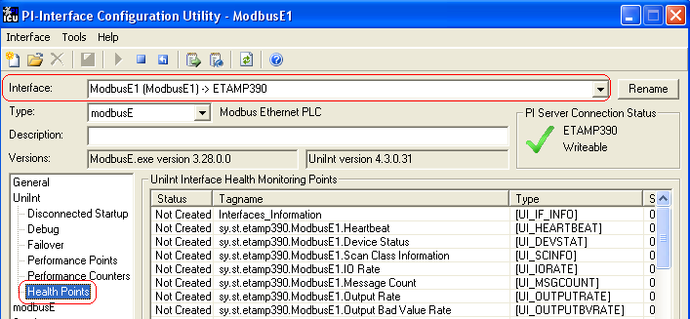
Right click the row for a particular Health Point to display the context menu:
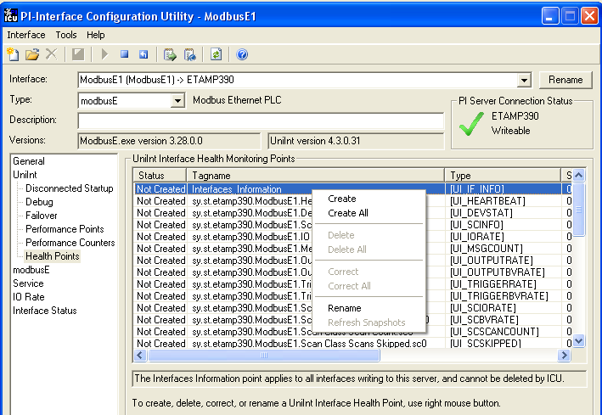
Click Create to create the Health Point for that particular row. Click Create All to create all the Health Points.
To see the current values (snapshots) of the Health Points, right click and select Refresh Snapshots.
For some of the Health Points described subsequently, the Interface updates their values at each performance summary interval (typically, 8 hours).

[UI_HEARTBEAT]
The [UI_HEARTBEAT] Health Point indicates whether the Interface is currently running. The value of this point is an integer that increments continuously from 1 to 15. After reaching 15, the value resets to 1.
The fastest scan class frequency determines the frequency at which the Interface updates this point:
Fastest Scan Frequency | Update frequency
Less than 1 second | 1 second
Between 1 and 60 seconds, inclusive | Scan frequency
More than 60 seconds | 60 seconds
If the value of the [UI_HEARTBEAT] Health Point is not changing, then this Interface is in an unresponsive state.

[UI_DEVSTAT]
The RDBMSPI Interface is built with UniInt 4.3+, where the new functionality has been added to support health tags – the health tag with the point attribute
Exdesc = [UI_DEVSTAT] is used to represent the status of the source device.
The following events will be written into the tag:
- "0 | Good | " the interface is properly communicating and gets data from/to the RDBMS system via the given ODBC driver
- "3 | 1 device(s) in error | " ODBC data source communication failure
- "4 | Intf Shutdown | " the interface was shut down
Please refer to the UniInt Interface User Manual.doc file for more information on how to configure health points.

[UI_SCINFO]
The [UI_SCINFO] Health Point provides scan class information. The value of this point is a string that indicates
- the number of scan classes;
- the update frequency of the [UI_HEARTBEAT] Health Point; and
- the scan class frequencies
An example value for the [UI_SCINFO] Health Point is:

3 | 5 | 5 | 60 | 120
The Interface updates the value of this point at startup and at each performance summary interval.

[UI_IORATE]

The [UI_IORATE] Health Point indicates the sum of
- the number of scan-based input values the Interface collects before it performs exception reporting; and
- the number of event-based input values the Interface collects before it performs exception reporting; and
- the number of values that the Interface writes to output tags that have a SourceTag.
The Interface updates this point at the same frequency as the [UI_HEARTBEAT] point. The value of this [UI_IORATE] Health Point may be zero. A stale timestamp for this point indicates that this Interface has stopped collecting data.

[UI_MSGCOUNT]
The [UI_MSGCOUNT] Health Point tracks the number of messages that the Interface has written to the pipc.log file since start-up. In general, a large number for this point indicates that the Interface is encountering problems. You should investigate the cause of these problems by looking in pipc.log.
The Interface updates the value of this point every 60 seconds. While the Interface is running, the value of this point never decreases.

[UI_POINTCOUNT]
The [UI_POINTCOUNT] Health Point counts number of PI tags loaded by the interface. This count includes all input, output and triggered input tags. This count does NOT include any Interface Health tags or performance points.
The interface updates the value of this point at startup, on change and at shutdown.

[UI_OUTPUTRATE]
After performing an output to the device, this Interface writes the output value to the output tag if the tag has a SourceTag. The [UI_OUTPUTRATE] Health Point tracks the number of these values. If there are no output tags for this Interface, it writes the System Digital State No Result to this Health Point.
The Interface updates this point at the same frequency as the [UI_HEARTBEAT] point’s. The Interface resets the value of this point to zero at each performance summary interval.

[UI_OUTPUTBVRATE]
The [UI_OUTPUTBVRATE] Health Point tracks the number of System Digital State values that the Interface writes to output tags that have a SourceTag. If there are no output tags for this Interface, it writes the System Digital State No Result to this Health Point.
The Interface updates this point at the same frequency as the [UI_HEARTBEAT] point’s. The Interface resets the value of this point to zero at each performance summary interval.

[UI_TRIGGERRATE]
The [UI_TRIGGERRATE] Health Point tracks the number of values that the Interface writes to event-based input tags. If there are no event-based input tags for this Interface, it writes the System Digital State No Result to this Health Point.
The Interface updates this point at the same frequency as the [UI_HEARTBEAT] point’s. The Interface resets the value of this point to zero at each performance summary interval.

[UI_TRIGGERBVRATE]
The [UI_TRIGGERRATE] Health Point tracks the number of System Digital State values that the Interface writes to event-based input tags. If there are no event-based input tags for this Interface, it writes the System Digital State No Result to this Health Point.
The Interface updates this point at the same frequency as the [UI_HEARTBEAT] point’s. The Interface resets the value of this point to zero at each performance summary interval.

[UI_SCIORATE]
You can create a [UI_SCIORATE] Health Point for each Scan Class in this Interface. The ICU uses a tag naming convention such that the suffix “.sc1” (for example, sy.st.etamp390.E1.Scan Class IO Rate.sc1) refers to Scan Class 1, “.sc2” refers to Scan Class 2, and so on.
A particular Scan Class’s [UI_SCIORATE] point indicates the number of values that the Interface has collected. If the current value of this point is between zero and the corresponding [UI_SCPOINTCOUNT] point, inclusive, then the Interface executed the scan successfully. If a [UI_SCIORATE] point stops updating, then this condition indicates that an error has occurred and the tags for the scan class are no longer receiving new data.
The Interface updates the value of a [UI_SCIORATE] point after the completion of the associated scan.
Although the ICU allows you to create the point with the suffix “.sc0”, this point is not applicable to this Interface.

[UI_SCBVRATE]
You can create a [UI_SCBVRATE] Health Point for each Scan Class in this Interface. The ICU uses a tag naming convention such that the suffix “.sc1” (for example, sy.st.etamp390.E1.Scan Class Bad Value Rate.sc1) refers to Scan Class 1, “.sc2” refers to Scan Class 2, and so on.
A particular Scan Class’s [UI_SCBVRATE] point indicates the number System Digital State values that the Interface has collected.
The Interface updates the value of a [UI_SCBVRATE] point after the completion of the associated scan.
Although the ICU allows you to create the point with the suffix “.sc0”, this point is not applicable to this Interface.

[UI_SCSCANCOUNT]
You can create a [UI_SCSCANCOUNT] Health Point for each Scan Class in this Interface. The ICU uses a tag naming convention such that the suffix “.sc1” (for example, sy.st.etamp390.E1.Scan Class Scan Count.sc1) refers to Scan Class 1, “.sc2” refers to Scan Class 2, and so on.
A particular Scan Class’s [UI_ SCSCANCOUNT] point tracks the number of scans that the Interface has performed.
The Interface updates the value of this point at the completion of the associated scan. The Interface resets the value to zero at each performance summary interval.
Although there is no “Scan Class 0”, the ICU allows you to create the point with the suffix “.sc0”. This point indicates the total number of scans the Interface has performed for all of its Scan Classes.

[UI_SCSKIPPED]
You can create a [UI_SCSKIPPED] Health Point for each Scan Class in this Interface. The ICU uses a tag naming convention such that the suffix “.sc1” (for example, sy.st.etamp390.E1.Scan Class Scans Skipped.sc1) refers to Scan Class 1, “.sc2” refers to Scan Class 2, and so on.
A particular Scan Class’s [UI_SCSKIPPED] point tracks the number of scans that the Interface was not able to perform before the scan time elapsed and before the Interface performed the next scheduled scan.
The Interface updates the value of this point each time it skips a scan. The value represents the total number of skipped scans since the previous performance summary interval. The Interface resets the value of this point to zero at each performance summary interval.
Although there is no “Scan Class 0”, the ICU allows you to create the point with the suffix “.sc0”. This point monitors the total skipped scans for all of the Interface’s Scan Classes.

[UI_SCPOINTCOUNT]
You can create a [UI_SCPOINTCOUNT] Health Point for each Scan Class in this Interface. The ICU uses a tag naming convention such that the suffix “.sc1” (for example, sy.st.etamp390.E1.Scan Class Point Count.sc1) refers to Scan Class 1, “.sc2” refers to Scan Class 2, and so on.
This Health Point monitors the number of tags in a Scan Class.
The Interface updates a [UI_SCPOINTCOUNT] Health Point when it performs the associated scan.
Although the ICU allows you to create the point with the suffix “.sc0”, this point is not applicable to this Interface.

[UI_SCINSCANTIME]
You can create a [UI_SCINSCANTIME] Health Point for each Scan Class in this Interface. The ICU uses a tag naming convention such that the suffix “.sc1” (for example, sy.st.etamp390.E1.Scan Class Scan Time.sc1) refers to Scan Class 1, “.sc2” refers to Scan Class 2, and so on.
A particular Scan Class’s [UI_ SCINSCANTIME] point represents the amount of time (in milliseconds) the Interface takes to read data from the device, fill in the values for the tags, and send the values to the PI Server.
The Interface updates the value of this point at the completion of the associated scan.

[UI_SCINDEVSCANTIME]
You can create a [UI_SCINDEVSCANTIME] Health Point for each Scan Class in this Interface. The ICU uses a tag naming convention such that the suffix “.sc1” (for example, sy.st.etamp390.E1.Scan Class Device Scan Time.sc1) refers to Scan Class 1, “.sc2” refers to Scan Class 2, and so on.
A particular Scan Class’s [UI_ SCINDEVSCANTIME] point represents the amount of time (in milliseconds) the Interface takes to read data from the device and fill in the values for the tags.
The value of a [UI_ SCINDEVSCANTIME] point is a fraction of the corresponding [UI_SCINSCANTIME] point value. You can use these numbers to determine the percentage of time the Interface spends communicating with the device compared with the percentage of time communicating with the PI Server.
If the [UI_SCSKIPPED] value is increasing, the [UI_SCINDEVSCANTIME] points along with the [UI_SCINSCANTIME] points can help identify where the delay is occurring: whether the reason is communication with the device, communication with the PI Server, or elsewhere.
The Interface updates the value of this point at the completion of the associated scan.

I/O Rate Point
An I/O Rate point measures the rate at which the Interface writes data to its input tags. The value of an I/O Rate point represents a 10-minute average of the total number of values per minute that the Interface sends to the PI Server.
When the Interface starts, it writes 0 to the I/O Rate point. After running for ten minutes, the Interface writes the I/O Rate value. The Interface continues to write a value every 10 minutes. When the Interface stops, it writes 0.
The ICU allows you to create one I/O Rate point for each copy of this Interface. Select this Interface from the Interface drop-down list, click IO Rate in the parameter category pane, and check Enable IORates for this Interface.
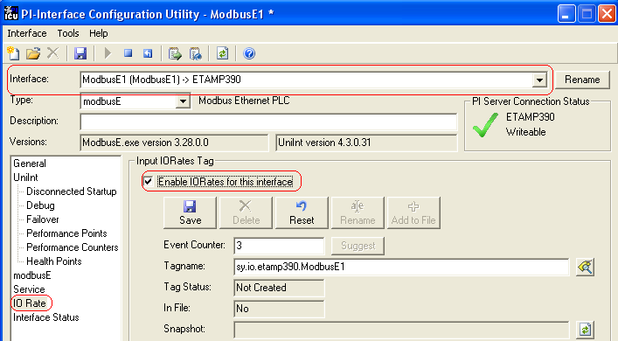
As the preceding picture shows, the ICU suggests an Event Counter number and a Tagname for the I/O Rate Point. Click the Save button to save the settings and create the I/O Rate point. Click the Apply button to apply the changes to this copy of the Interface.
You need to restart the Interface in order for it to write a value to the newly created I/O Rate point. Restart the Interface by clicking the Restart button:
(The reason you need to restart the Interface is that the PointSource attribute of an I/O Rate point is Lab.)
To confirm that the Interface recognizes the I/O Rate Point, look in the pipc.log for a message such as:
PI-ModBus 1> IORATE: tag sy.io.etamp390.ModbusE1 configured.
To see the I/O Rate point’s current value (snapshot), click the Refresh snapshot button:
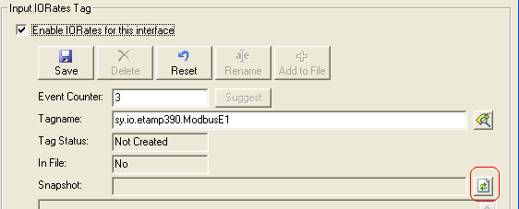

Enable IORates for this Interface
The Enable IORates for this interface check box enables or disables I/O Rates for the current interface. To disable I/O Rates for the selected interface, uncheck this box. To enable I/O Rates for the selected interface, check this box.

Event Counter
The Event Counter correlates a tag specified in the iorates.dat file with this copy of the interface. The command-line equivalent is /ec=x, where x is the same number that is assigned to a tag name in the iorates.dat file.

Tagname
The tag name listed under the Tagname column is the name of the I/O Rate tag.

Tag Status
The Tag Status column indicates whether the I/O Rate tag exists in PI. The possible states are:
- Created – This status indicates that the tag exist in PI
- Not Created – This status indicates that the tag does not yet exist in PI
- Deleted – This status indicates that the tag has just been deleted
- Unknown – This status indicates that the PI ICU is not able to access the PI Server

In File
The In File column indicates whether the I/O Rate tag listed in the tag name and the event counter is in the IORates.dat file. The possible states are:
- Yes – This status indicates that the tag name and event counter are in the IORates.dat file
- No – This status indicates that the tag name and event counter are not in the IORates.dat file

Snapshot
The Snapshot column holds the snapshot value of the I/O Rate tag, if the I/O Rate tag exists in PI. The Snapshot column is updated when the IORates/Status Tags tab is clicked, and when the Interface is first loaded.

Right Mouse Button Menu Options

Create
Create the suggested I/O Rate tag with the tag name indicated in the Tagname column.

Delete
Delete the I/O Rate tag listed in the Tagname column.

Rename
Allow the user to specify a new name for the I/O Rate tag listed in the Tagname column.

Add to File
Add the tag to the IORates.dat file with the event counter listed in the Event Counter Column.

Search
Allow the user to search the PI Server for a previously defined I/O Rate tag.

Interface Status Point
The PI Interface Status Utility (ISU) alerts you when an interface is not currently writing data to the PI Server. This situation commonly occurs if
- the monitored interface is running on an Interface Node, but the Interface Node cannot communicate with the PI Server; or
- the monitored interface is not running, but it failed to write at shutdown a System state such as Intf Shut.
The ISU works by periodically looking at the timestamp of a Watchdog Tag. The Watchdog Tag is a tag whose value a monitored interface (such as this Interface) frequently updates. The Watchdog Tag has its excdev, excmin, and excmax point attributes set to 0. So, a non-changing timestamp for the Watchdog Tag indicates that the monitored interface is not writing data.
Please see the Interface Status Interface for complete information on using the ISU. PI Interface Status runs only on a PI Server Node.
If you have used the ICU to configure the PI Interface Status Utility on the PI Server Node, the ICU allows you to create the appropriate ISU point. Select this Interface from the Interface drop-down list and click Interface Status in the parameter category pane. Right click on the ISU tag definition window to bring up the context menu:
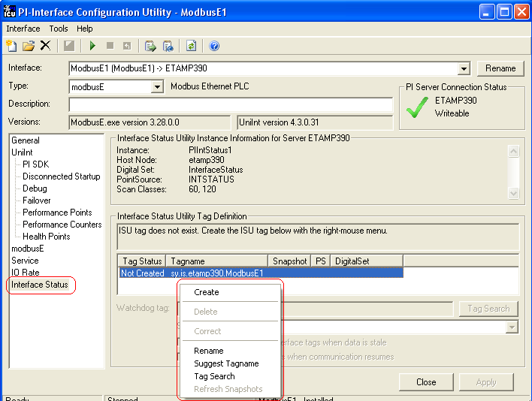
Click Create to create the ISU tag.
Use the Tag Search button to select a Watchdog Tag. (Recall that the Watchdog Tag is one of the points for which this Interface collects data.)
Select a Scan frequency from the drop-down list box. This Scan frequency is the interval at which the ISU monitors the Watchdog Tag. For optimal performance, choose a Scan frequency that is less frequent than the majority of the scan rates for this Interface’s points. For example, if this Interface scans most of its points every 30 seconds, choose a Scan frequency of 60 seconds. If this Interface scans most of its points every second, choose a Scan frequency of 10 seconds.
If the Tag Status indicates that the ISU tag is Incorrect, right click to enable the context menu and select Correct.
Note: The PI Interface Status Utility – and not this Interface – is responsible for updating the ISU tag. So, make sure that the PI Interface Status Utility is running correctly.

- Error and Informational Messages
A string RDBMSPI'ID' is prefixed to error messages written to the message log. RDBMSPI is a non-configurable identifier. ID is a configurable identifier that is no longer than 9 characters and is specified using the /id parameter on the startup command line.
General information messages are written to the pipc.log file; in addition, all PI API and buffering related errors are also directed there. The location of the pipc.log file is determined by the PIHOME entry in the pipc.ini file. The pipc.ini file should always be in the WinNT directory. For example, if the PIHOME entry is
C:\PIPC
then the pipc.log file will be located in the c:\PIPC\dat directory.
Messages are written to PIHOME\dat\pipc.log at the following times.
- When the Interface starts many informational messages are written to the log. These include the version of the interface, the version of UniInt, the command-line parameters used, and the number of points.
- As the Interface loads points, messages are sent to the log if there are any problems with the configuration of the points.
- If the /db is used on the command line, then various messages are written to the log file. The /db the UniInt start-up switch. For more about it, see the relevant documentation. However, with this interface it is recommended using the /deb parameter instead.
Note: For PI API version 1.3 and greater, a process called pilogsrv can be installed to run as a service. After the pipc.log file exceeds a user-defined maximum size, the pilogsrv process renames the pipc.log file to pipcxxxx.log , where xxxx ranges from 0000 to the maximum number of allowed log files. Both the maximum file size and the maximum number of allowed log files are configured in the pipc.ini file. Configuration of the pilogsrv process is discussed in detail in the PI API Installation Instructions manual.

Interface-specific Output File
The file pointed to by the start-up parameter /OUTPUT= stores relevant operational information. During normal operation (/deb=1) error logging is sufficient just to detect problems. A problem can then be drilled down with modified debug level. The amount of extra information depends on the debug level: /deb=1-5.
Note: Errors related to tag values will also be reported in giving the tag a Bad Input or Bad Output state. This happens if the status of a RDBMS value is BAD or the output operation failed. Points can also get a status of I/O Timeout if the interface detects connection problems.

Messages

System Errors and PI Errors
System errors are associated with positive error numbers. Errors related to PI are associated with negative error numbers.

Error Descriptions on Windows
On Windows, descriptions of system and PI errors can be obtained with the pidiag utility:
Windows: \PI\adm\pidiag – e error_number

UniInt Failover Specific Error Messages

Informational
Message | 16-May-06 10:38:00  RDBMSPI 1> UniInt failover: Interface in the “Backup” state.
Meaning | Upon system startup, the initial transition is made to this state. While in this state the interface monitors the status of the other interface participating in failover. When configured for Hot failover, data received from the data source is queued and not sent to the PI Server while in this state. The amount of data queued while in this state is determined by the failover update interval. In any case, there will be typically no more than two update intervals of data in the queue at any given time. Some transition chains may cause the queue to hold up to five failover update intervals worth of data.
Message | 16-May-06 10:38:05  RDBMSPI 1> UniInt failover: Interface in the “Primary” state and actively sending data to PI. Backup interface not available.
Meaning | While in this state, the interface is in its primary role and sends data to the PI Server as it is received. This message also states that there is not a backup interface participating in failover.
Message | 16-May-06 16:37:21  RDBMSPI 1> UniInt failover: Interface in the “Primary” state and actively sending data to PI. Backup interface available.
Meaning | While in this state, the interface sends data to the PI Server as it is received. This message also states that the other copy of the interface appears to be ready to take over the role of primary.

Errors (Phase 1 & 2)
Message | 16-May-06 17:29:06  RDBMSPI 1> One of the required Failover Synchronization points was not loaded.  Error = 0: The Active ID synchronization point was not loaded.  The input PI tag was not loaded
Cause | The Active ID tag is not configured properly.
Resolution | Check validity of point attributes. For example, make sure Location1 attribute is valid for the interface. All failover tags must have the same PointSource and Location1 attributes. Modify point attributes as necessary and restart the interface.
Message | 16-May-06 17:38:06  RDBMSPI 1> One of the required Failover Synchronization points was not loaded.  Error = 0: The Heartbeat point for this copy of the interface was not loaded.  The input PI tag was not loaded
Cause | The Heartbeat tag is not configured properly.
Resolution | Check validity of point attributes. For example, make sure Location1 attribute is valid for the interface. All failover tags must have the same PointSource and Location1 attributes. Modify point attributes as necessary and restart the interface.
Message | 17-May-06 09:06:03  RDBMSPI 1 > The Uniint FailOver ID (/UFO_ID) must be a positive integer.
Cause | The UFO_ID parameter has not been assigned a positive integer value.
Resolution | Change and verify the parameter to a positive integer and restart the interface.
Message | 17-May-06 09:06:03  RDBMSPI 1> The Failover ID parameter (/UFO_ID) was found but the ID for the redundant copy was not found
Cause | The /UFO_OtherID parameter is not defined or has not been assigned a positive integer value.
Resolution | Change and verify the /UFO_OtherID parameter to a positive integer and restart the interface.

Errors (Phase 2)

Unable to open synchronization file
Message | 27-Jun-08 17:27:17  PI Eight Track 1 1> Error 5: Unable to create file ‘\\georgiaking\GeorgiaKingStorage\UnIntFailover\\PIEightTrack_eight_1.dat’  Verify that interface has read/write/create access on file server machine.  Initializing UniInt library failed  Stopping Interface
Cause | This message will be seen when the interface is unable to create a new failover synchronization file at startup. The creation of the file only takes place the first time either copy of the interface is started and the file does not exist. The error number most commonly seen is error number 5. Error number 5 is an “access denied” error and is likely the result of a permissions problem.
Resolution | Ensure the account the interface is running under has read and write permissions for the folder. The “log on as” property of the Windows service may need to be set to an account that has permissions for the folder.

Error Opening Synchronization File
Message | Sun Jun 29 17:18:51 2008  PI Eight Track 1 2> WARNING> Failover Warning: Error = 64  Unable to open Failover Control File ‘\\georgiaking\GeorgiaKingStorage\Eight\PIEightTrack_eight_1.dat’  The interface will not be able to change state if PI is not available
Cause | This message will be seen when the interface is unable to open the failover synchronization file. The interface failover will continue to operate correctly as long as communication to the PI Server is not interrupted. If communication to PI is interrupted while one or both interfaces cannot access the synchronization file, the interfaces will remain in the state they were in at the time of the second failure, so the primary interface will remain primary and the backup interface will remain backup.
Resolution | Ensure the account the interface is running under has read and write permissions for the folder and file. The “log on as” property of the Windows service may need to be set to an account that has permissions for the folder and file.

- PI SDK Options
To access the PI SDK settings for this Interface, select this Interface from the Interface drop-down list and click UniInt – PI SDK in the parameter category pane.
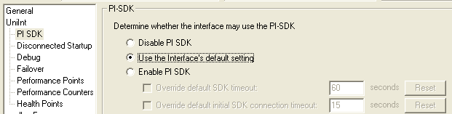

Disable PI SDK
Select Disable PI SDK to tell the Interface not to use the PI SDK. If you want to run the Interface in Disconnected Startup mode, you must choose this option.
The command line equivalent for this option is /pisdk=0.

Use the Interface’s default setting
This selection has no effect on whether the Interface uses the PI SDK. However, you must not choose this option if you want to run the Interface in Disconnected Startup mode.

Enable PI SDK
Select Enable PI SDK to tell the Interface to use the PI SDK. Choose this option if the PI Server version is earlier than 3.4.370.x or the PI API is earlier than 1.6.0.2, and you want to use extended lengths for the Tag, Descriptor, ExDesc, InstrumentTag, or PointSource point attributes. The maximum lengths for these attributes are:
Attribute | Enable the Interface to use the PI SDK | PI Server earlier than 3.4.370.x or PI API earlier than 1.6.0.2, without the use of the PI SDK
Tag | 1023 | 255
Descriptor | 1023 | 26
ExDesc | 1023 | 80
InstrumentTag | 1023 | 32
PointSource | 1023 | 1
However, if you want to run the Interface in Disconnected Startup mode, you must not choose this option.
The command line equivalent for this option is /pisdk=1.

- Examples

Example 1.1 – single tag query
SQL Statement
(defined in file PI_REAL1.SQL)
SELECT PI_TIMESTAMP, PI_VALUE, PI_STATUS FROM T1_1 WHERE PI_KEY_VALUE = ?;
Relevant PI Point Attributes
Extended Descriptor | Location1 |  | Location2 |  | Location3 | Location4 |  | Location5
P1="Key_1234" | 1 |  | 0 |  | 0 | 1 |  | 0
InstrumentTag | Point Type |  | Point Source
PI_REAL1.SQL | Float32 |  | S
RDBMS Table Design
Table T1_1
PI_TIMESTAMP |  | PI_VALUE |  | PI_STATUS |  |  | PI_KEY_VALUE
Datetime  (MS SQL Server)  Date/Time  (MS Access) |  | Real  (MS SQL Server)  Number-Single Precision  (MS Access) |  | Smallint  (MS SQL Server)  Number-Whole Number  (MS Access) |  |  | Varchar(50)  (MS SQL Server)  Text(50)  (MS Access)
Note: Location2 is set to zero. This setting makes sure the interface takes just one row from the SELECTed result-set. See Location2 for more details.

Example 1.2 – query data array for a single tag
SQL Statement
(defined in file PI_STRING1.SQL)
SELECT PI_TIMESTAMP, PI_VALUE, 0 FROM T1_2 WHERE PI_TIMESTAMP > ?
ORDER BY PI_TIMESTAMP ASC;
Relevant PI Point Attributes
Extended Descriptor | Location1 | Location2 |  | Location3 | Location4 | Location5
P1=TS | 1 | 1 |  | 0 | 1 | 0
Instrumenttag | Point Type | Point Source
PI_STRING1.SQL | String | S
RDBMS Table Design
Table T1_2
PI_TIMESTAMP |  |  | PI_VALUE
Datetime  (MS SQL Server)  Date/Time  (MS Access) |  |  | Varchar(1000)  (MS SQL Server)  Text(255)  (MS Access)
Note: The status column, which is mandatory, is represented by the constant expression 0.

Example 1.3 – three PI points forming a GROUP
SQL Statement
(defined in file PI_INT_GROUP1.SQL)
SELECT PI_TIMESTAMP, PI_VALUE1, 0 ,PI_VALUE2, 0, PI_VALUE3, 0 FROM T1_3 WHERE PI_TIMESTAMP > ? ORDER BY PI_TIMESTAMP ASC;
Relevant PI Point Attributes
Extended Descriptor  (Master Tag) | Location1  (All points) | Location2  (All points) |  | Location3 | Location4  (All points) | Location5  (All points)
P1=TS | 1 | 1 |  | Target_Point1 2  Target_Point2 4  Target_Point3 6 | 1 | 0
Instrumenttag  (All Points) | Point Type | Point Source  (All Points)
PI_INT_  GROUP1.SQL | Int32 | S
RDBMS Table Design
Table T1_3
PI_TIMESTAMP |  |  | PI_VALUEn
Datetime  (MS SQL Server)  Date/Time  (MS Access) |  |  | Smallint  (MS SQL Server)  Number (Whole Number)  (MS Access)
Example of an appropriate result-set:

PI_TIMESTAMP PI_VALUE1 PI_VALUE2 PI_VALUE3

20-Oct-2000 08:10:00 10 20 30

20-Oct-2000 08:20:00 11 21 31

20-Oct-2000 08:30:00 12 22 32

…

Target_Point1 gets 10, 11, 12

Target_Point2 gets 20, 21, 22

Target_Point3 gets 30, 31, 32

Example 1.4 – Tag Distribution
SQL Statement
(defined in file PI_REAL_DISTR1.SQL)
SELECT PI_TIMESTAMP, PI_TAGNAME, PI_VALUE, PI_STATUS FROM T1_4 WHERE PI_TAGNAME LIKE 'Tag%' ORDER BY PI_TMESTAMP, PI_TAGNAME;
Relevant PI Point Attributes
Extended Descriptor  (Distributor) | Location1  (All points) |  | Location2  (All points) |  | Location3 | Location4  All points |  | Location5  All points
 | 1 |  | 0 |  | 'Distributor'  -1  'Target_Point(n)'  0 | 1 |  | 0
Instrumenttag  (Distributor) | Point Type  (Distributor) |  | Point Source  (All Points)
PI_REAL_DISTR1.SQL | Float32 |  | S
RDBMS Table Design
Table T1_4
PI_TIMESTAMP |  | PI_VALUE |  | PI_STATUS |  |  | PI_TAGNAME
Datetime  (MS SQL Server)  Date/Time  (MS Access) |  | Real  MS SQL Server)  Number (Single) Prec.(MS Access) |  | Varchar(12)  (MS SQL Server)  Text(12)  (MS Access) |  |  | Varchar(80)  (MS SQL Server)  Text(80)  MS Access)
Example of an appropriate result-set:

PI_TIMESTAMP PI_TAGNAME PI_VALUE PI_STATUS

20-Oct-2000 08:10:00 Target_Point1 10 NULL

20-Oct-2000 08:10:00 Target_Point2 20 NULL

20-Oct-2000 08:10:00 Target_Point3 30

10 goes to Target_Point1; 20 to Target_Point1; 30 to Target_Point3 …
Note: See also section: Detailed Description of Information the Distributor Tags Store.

Example 1.5 – RxC Distribution
SQL Statement
(defined in file PI_REAL_DISTR1.SQL)
SELECT sampletime AS PI_TIMESTAMP1, 'Tag1' AS PI_TAGNAME1, [level] AS PI_VALUE1, sampletime AS PI_TIMESTAMP2, 'Tag2' AS PI_TAGNAME2, temperature AS PI_VALUE2, temperature_status AS PI_STATUS2, sampletime AS PI_TIMESTAMP3,'Tag3' AS PI_TAGNAME3, density AS PI_VALUE3, density_status AS PI_STATUS3 FROM T1_5 WHERE sampletime > ? AND tank = 'Tank1'
Relevant PI Point Attributes
Extended Descriptor  (RxC Distributor) | Location1  (All points) |  | Location2  (All points) |  | Location3 | Location4  (All points) |  | Location5  (All points)
P1=TS | 1 |  | 0 |  | 'RxC Distributor'  -2  'Target points'  0 | 1 |  | 0
Instrumenttag  (Distributor) | Point Type  (All points) |  | Point Source  (All Points)
PI_REAL_DISTR_RxC.SQL | Float32 |  | S
RDBMS Table Design
Table T1_5
SAMPLETIME |  | LEVEL,  TEMPERATURE,  DENSITY |  | LEVEL_STATUS,  TEMPERAURE_  STATUS,  DENSITY_STATUS |  |  | TANK
Datetime  (MS SQL Server)  Date/Time  (MS Access) |  | Real  MS SQL Server)  Number (Single) Prec.(MS Access) |  | Varchar(12)  (MS SQL Server)  Text(12)  (MS Access) |  |  | Varchar(80)  (MS SQL Server)  Text(80)  (MS Access)
Example of an appropriate result-set:

PI_TIMESTAMP1 PI_TAGNAME1 PI_VALUE1

20-Jul-2002 08:10:00 Target_Point1 1

PI_TIMESTAMP2 PI_TAGNAME2 PI_VALUE2 PI_STATUS2

20-Jul-2002 08:10:00 Target_Point2 10 NULL

PI_TIMESTAMP3 PI_TAGNAME3 PI_VALUE3 PI_STATUS3

20-Jul-2002 08:10:00 Target_Point3 100 NULL

1 goes to Target_Point1; 10 to Target_Point2;

100 to Target_Point3
Note: See also section: Detailed Description of Information the Distributor Tags Store.

Example 1.6 – Single Input with PI Annotations
SQL Statement
(file PI_ANNO1.SQL)
SELECT time AS PI_TIMESTAMP, value AS PI_VALUE, annotation AS PI_ANNOTATION FROM T1_6 WHERE time > ? ORDER BY time;
Relevant PI Point Attributes
Extended Descriptor | Location1 |  | Location2 | Location3 |  | Location4 | Location5
P1=TS | 1 |  | 1 | 0 |  | 1 | 1
Instrumenttag | Point Type |  | Point Source
PI_ANNO1.SQL | Float32 |  | S
RDBMS Table Design
T1_6
TIME |  | VALUE |  |  | ANNOTATION
Datetime  MS SQL Server)  Date/Time  (MS Access) |  | Real  (MS SQL Server)  Number-Single Precision  (MS Access) |  |  | Varchar(255)  (MS SQL Server)  Text(50)  (MS Access)

Example 2.1a – insert sinusoid values into table (event based)
SQL Statement
(defined in file PI_SINUSOID_OUT.SQL)
INSERT INTO T2_1a (PI_TIMESTAMP1, PI_VALUE, PI_STATUS) VALUES (?,?,?);
Relevant PI Point Attributes
Extended Descriptor | Location1 |  | Location2 | Location3 |  | Location4 | Location5
P1=TS P2=VL P3=SS_I | 1 |  | 0 | 0 |  | 0 | 0
Instrumenttag | Point Type |  | Source Tag | Point Source
PI_SINUSOID_OUT.SQL | Float32 |  | SINUSOID | S
RDBMS Table Design
Table T2_1a
PI_TIMESTAMPn |  | PI_VALUE |  |  | PI_STATUS
Datetime  (MS SQL Server)  Date/Time  (MS Access) |  | Real  (MS SQL Server)  Single Precision  (MS Access) |  |  | Smallint  (MS SQL Server)  Whole Number  (MS Access)

Example 2.1b – insert sinusoid values into table (scan based)
SQL Statement
(defined in file PI_SIN_OUT_SCAN.SQL)
INSERT INTO T2_1b (PI_TIMESTAMP1, PI_VALUE, PI_STATUS) VALUES (?,?,?);
Relevant PI Point Attributes
Extended Descriptor | Location1 |  | Location2 | Location3 |  | Location4 | Location5
P1='SINUSOID'/TS P2='SINUSOID'/VL P3='SINUSOID'/SS_I | 1 |  | 0 | 0 |  | 1 | 0
Instrumenttag | Point Type |  | Source Tag | Point Source
PI_SIN_OUT_SCAN.SQL | Float32 |  |  | S
RDBMS Table Design
Table T2_1b
PI_TIMESTAMPn |  | PI_VALUE |  |  | PI_STATUS
Datetime  (MS SQL Server)  Date/Time  (MS Access) |  | Real  (MS SQL Server)  Single Precision  (MS Access) |  |  | Smallint  (MS SQL Server)  Whole Number  (MS Access)

Example 2.1c – insert 2 different sinusoid values into table (event based)
SQL Statement
(defined in file PI_SIN_VALUES_OUT.SQL)
INSERT INTO T2_1c (PI_TAGNAME1, PI_TIMESTAMP1, PI_VALUE1, PI_STATUS1, PI_TAGNAME2, PI_VALUE2, PI_STATUS2) VALUES (?,?,?,?,?,?,?);
Relevant PI Point Attributes
Extended Descriptor |  | Location1 | Location2 |  | Location3 | Location4 |  | Location5
/EXD=…path…\ pi_sin_values_out.plh  Content of the above-stated file:  P1=AT.TAG  P2=TS  P3=VL  P4=SS_I P5='SINUSOIDU'/AT.TAG  P6='SINUSOIDU'/VL P7='SINUSOIDU'/SS_I |  | 1 | 0 |  | 0 | 0 |  | 0
Instrumenttag |  | Point Type | Source Tag |  | Point Source
PI_SIN_VALUES_  OUT.SQL |  | Float16 | SINUSOID |  | S
RDBMS Table Design
Table T2_1c
PI_TIMESTAMPn | PI_VALUEn |  |  | PI_STATUSn |  |  | PI_TAGNAMEn
Datetime (MS SQL Server)  Date/Time (MS Access) | Real (MS SQL Server)  Single Precision  (MS Access) |  |  | Smallint (MS SQL Server)  Whole Number  (MS Access) |  |  | Varchar(80) (MS SQL Server)  Text(80)  (MS Access)
Note: The /EXD= keyword is used when the overall length of placeholders is greater than 1024 bytes. Normally, the placeholder definitions can be stated in the Extended Descriptor directly

Example 2.1d – insert sinusoid values with (string) annotations into RDB table (event based)
SQL Statement
(file PI_ANNO2.SQL)
INSERT INTO T2_1d (time, value, annotation) VALUES (?,?,?);
Relevant PI Point Attributes
Extended Descriptor | Location1 |  | Location2 | Location3 |  | Location4 | Location5
P1=TS  P2=VL P3=ANN_C | 1 |  | 0 | 0 |  | 0 | 0
Instrumenttag | Point Type |  | Source Tag | Point Source
PI_ANNO2.SQL | Float32 |  | SINUSOID | S
RDBMS Table Design
Table T2_1d
TIME |  | VALUE |  |  | ANNOTATION
Datetime (MS SQL Server)  Date/Time  (MS Access) |  | Real  (MS SQL Server)  Number-Single Precision  (MS Access) |  |  | Varchar(255)  (MS SQL Server)  Text(50)  (MS Access)

Example 3.1 – Field Name Aliases
SQL Statement
(defined in file PI_STRING2.SQL)
SELECT VALIDITY AS PI_STATUS, SCAN_TIME AS PI_TIMESTAMP, VOLUME AS PI_VALUE FROM T3_1 WHERE KEY_VALUE = ?;
Relevant PI Point Attributes
Extended Descriptor | Location1 |  | Location2 |  | Location3 | Location4 |  | Location5
P1="Key_1234" | 1 |  | 0 |  | 0 | 1 |  | 0
Instrumenttag | Point Type |  | Point Source
PI_STRING2.SQL | String |  | S
RDBMS Table Design
Table T3_1
SCAN_TIME |  | VOLUME |  | VALIDITY |  |  | KEY_VALUE
Datetime  (MS SQL Server)  Date/Time  (MS Access) |  | Varchar(1000) (MS SQL Server)  Text(255) (MS Access) |  | Smallint (MS SQL Server)  Whole Number  (MS Access) |  |  | Varchar(50) (MS SQL Server)  Text(50) (MS Access)

Example 3.2 – Tag Group, Fixed Column Positions
SQL Statement
(file PI_GR1.SQL)
SELECT Time0, VALUE1, 0, VALUE2, 0 FROM T3_2 WHERE Time0 > ?;
Relevant PI Point Attributes
Tag | Instrument  Tag | Extended Desc. |  | Location1 | Location2 |  | Location3 | Location4
Target_Point1 | PI_GR1.SQL | P1=TS |  | 1 | 1 |  | 2 | 1
Target_Point2 | PI_GR1.SQL |  |  | 1 | 1 |  | 4 | 1
RDBMS Table Data
Table T3_2
Time0 |  |  | Value1 |  |  | Value2
20-Oct-2000 08:10:00 |  |  | 1.123 |  |  | "String1"
20-Oct-2000 08:10:10 |  |  | 2.124 |  |  | "String2"
20-Oct-2000 08:10:20 |  |  | 3.125 |  |  | "String3"
20-Oct-2000 08:10:30 |  |  | 4.126 |  |  | "String4"
Values selected in column Value1 go to Target_Point1
Values selected in column Value2 go to Target_Point2

Example 3.3 – Tag Group, Arbitrary Column Position – Aliases
SQL Statement
(file PI_GR2.SQL)
SELECT PI_TIMESTAMP, PI_VALUE1, PI_VALUE2, PI_STATUS1=0, PI_STATUS2=0 FROM T3_3 WHERE PI_TIMESTAMP > ? ORDER BY PI_TIMESTAMP ASC;
or
SELECT PI_TIMESTAMP, VALUE1 AS PI_VALUE1, VALUE2 AS PI_VALUE2, 0 AS PI_STATUS1, 0 AS PI_STATUS2 FROM T3_3 WHERE PI_TIMESTAMP > ? ORDER BY PI_TIMESTAMP ASC;
Relevant PI Point Attributes
Tag | Instrument  tag | Extended Descriptor |  | Location1 | Location2 |  | Location3 | Location4
Target_Point1 | PI_GR2.SQL | P1=TS |  | 1 | 1 |  | 1 | 1
Target_Point2 | PI_GR2.SQL |  |  | 1 | 1 |  | 2 | 1
RDBMS Table Data
Table T3_3
PI_TIMESTAMP |  |  | PI_VALUE1 |  |  | PI_VALUE2
20-Oct-2000 08:10:00 |  |  | 1.123 |  |  | 4.567
20-Oct-2000 08:10:10 |  |  | 2.124 |  |  | 5.568
20-Oct-2000 08:10:20 |  |  | 3.125 |  |  | 6.569
20-Oct-2000 08:10:30 |  |  | 4.126 |  |  | 7.570
Values selected in column PI_VALUE1 go to Target_Point1
Values selected in column PI_VALUE2 go to Target_Point2

Example 3.4a – Tag Distribution, Search According to Real Tag Name
SQL Statement
(file PI_DIST1.SQL)
SELECT PI_TIME, PI_TAGNAME, PI_VALUE, 0 FROM T3_4a WHERE PI_TIME > ? ORDER BY PI_TIME;
Relevant PI Point Attributes
Tag | Instrument  tag | Ext. Desc. |  | Location1 | Location2 |  | Location3 | Location4
Tag1 | PI_DIST1.SQL | P1=LST |  | 1 |  |  | -1 | 1
Tag2 |  |  |  | 1 |  |  |  | 1
Tag3 |  |  |  | 1 |  |  |  | 1
Tag4 |  |  |  | 1 |  |  |  | 1
RDBMS Table Data
Table T3_4a
PI_TIME |  |  | PI_TAGNAME |  |  | PI_VALUE
20-Oct-2000 08:10:00 |  |  | Tag1 |  |  | 4.567
20-Oct-2000 08:10:10 |  |  | Tag2 |  |  | 5.568
20-Oct-2000 08:10:20 |  |  | Tag3 |  |  | 6.569

Example 3.4b – Tag Distribution, Search According to Tag's ALIAS Name
SQL Statement
(file PI_DIST2.SQL)
SELECT TIME, PI_ALIAS, VALUE,0 FROM T3_4b WHERE TIME > ?;
Relevant PI Point Attributes
Tag | Instrument  tag | Extended Descriptor | Location1 | Location3 |  | Location4
Tag1 | PI_DIST2.SQL | P1=TS | 1 | -1 |  | 1
Tag2 |  | /ALIAS=Valve1 | 1 |  |  | 1
Tag3 |  | /ALIAS=Valve2 | 1 |  |  | 1
Tag4 |  | /ALIAS=Valve3 | 1 |  |  | 1
RDBMS Table Data
Table T3_4b
Time |  |  | PI_Alias |  | Value
20-Oct-2000 08:10:00 |  |  | Valve1 |  | "Open"
20-Oct-2000 08:10:00 |  |  | Valve2 |  | "Closed"
20-Oct-2000 08:10:00 |  |  | Valve3 |  | "N/A"

Example 3.4c – Tag Distribution with Auxiliary Column – rowRead
SQL Statement
(file PI_DIST3.SQL)
SELECT time, tag, value, 0 AS status FROM T3_4c WHERE rowRead=0;
UPDATE Tdata SET rowRead=1 WHERE rowRead=0;
Relevant PI Point Attributes
Tag | Instrument  tag |  | Extended Descriptor | Location1 |  | Location3 |  | Location4
Tag1 | PI_DIST3.SQL |  |  | 1 |  | -1 |  | 1
Tag2 |  |  |  | 1 |  |  |  | 1
RDBMS Table Design
Table T3_4c
tag |  | time |  |  | value |  | rowRead
Varchar(255)  (MS SQL Server) |  | DateTime  (MS SQL Server) |  |  | Real  (MS SQL Server) |  | Integer (MS SQL Server)

Example 3.4d – Tag Distribution with Auxiliary Table Keeping Latest Snapshot
SQL Statement
(file PI_DIST4.SQL)
SELECT T3_4data.time, T3_4data.tag, T3_4data.value, 0 AS status FROM T3_4data INNER JOIN T3_4snapshot ON T3_4data.tag=T3_4snapshot.tag WHERE T3_4data.time > T3_4snapshot.time;
UPDATE T3_4snapshot SET time=(SELECT MaxTimeTag.maxTime FROM
(SELECT DISTINCT (SELECT MAX(time) FROM T3_4data WHERE tag=TdataTmp.tag) As MaxTime, tag FROM T3_4data TdataTmp) MaxTimeTag
INNER JOIN T3_4snapshot TsnapshotTmp ON MaxTimeTag.tag=TsnapshotTmp.tag WHERE T3_4snapshot.tag=MaxTimeTag.tag)
Relevant PI Point Attributes
Tag | Instrument  tag |  | Extended Descriptor | Location1 |  | Location3 |  | Location4
Tag1 | PI_DIST4.SQL |  |  | 1 |  | -1 |  | 1
Tag2 |  |  |  | 1 |  |  |  | 1
RDBMS Table Design
Table T3_4data
tag |  | time |  |  | value |  | status
Varchar(255)  (MS SQL Server) |  | DateTime  (MS SQL Server) |  |  | Real  (MS SQL Server) |  | Integer (MS SQL Server)
Table T3_4snapshot
tag |  |  |  |  | time
Varchar(255)  (MS SQL Server) |  |  |  |  | DateTime  (MS SQL Server)
Explanation:
The T3_4snapshot table has to contain a list of all 'Target Points', and, at the very beginning, also the initial timestamps (the time column in T3_4snapshot cannot be NULL). The first statement (the SELECT) will thus deliver all the rows (from the T3_4data) theirs time is bigger than the time column of the T3_4snapshot. The UPDATE statement will then retrieve the most recent timestamps – MAX (time) from the T3_4data and will update the T3_4snapshot. During the next scan, the JOIN makes sure only the new entries (from the T3_4data) will be SELECTed.

Example 3.4e – Tag Distribution in Combination with /RBO and 'Time-Window'
SQL Statement
(file PI_DIST5.SQL)
SELECT time, tag, value, 0 AS status FROM T3_4e WHERE time > GETDATE()-(1./24.);
Relevant PI Point Attributes
Tag | Instrument  tag |  | Extended Descriptor | Location1 |  | Location3 |  | Location4
Tag1 | PI_DIST5.SQL |  |  | 1 |  | -1 |  | 1
Tag2 |  |  |  | 1 |  |  |  | 1
RDBMS Table Design
Table T3_4e
tag |  | time |  |  | value |  | status
Varchar(255)  (MS SQL Server) |  | DateTime  (MS SQL Server) |  |  | Real  (MS SQL Server) |  | Integer (MS SQL Server)
Explanation:
The time-window is created by the MS SQL function GETDATE() (returning the current time). The (1./24.) means one hour. The interface will thus have to have the /RBO start-up parameter specified to avoid duplicates in the PI Archive.

Example 3.5 – Tag Distribution with Aliases in Column Names
SQL Statement
(file PI_DIST3.SQL)
SELECT NAME AS PI_TAGNAME, VALUE AS PI_VALUE , STATUS AS PI_STATUS, DATE_TIME AS PI_TIMESTAMP FROM T3_5 WHERE NAME LIKE ?;
Relevant PI Point Attributes
Extended Descriptor | Location1  All points |  | Location2  All points |  | Location3 | Location4  All points |  | Location5  All points
Distributor – P1="Key_123%"  Target points - /ALIAS='value retrieved from NAME column' | 1 |  | Not evaluated |  | -1  Not evaluated | 1 |  | 0
Instrumenttag | Point Type  (Distributor) |  | Point Source  S
PI_DIST3.SQL | Float32
RDBMS Table Design
Table T3_5
DATE_TIME |  | NAME |  | VALUE |  |  | STATUS
Datetime (MS SQL Server)  Date/Time (MS Access) |  | Char(80) (MS SQL Server)  Text(80) (MS Access) |  | Real (MS SQL Server)  Text(255) (MS Access) |  |  | Real (MS SQL Server)  Text(12) (MS Access)

Example 3.6 – RxC Distribution
SQL Statement
(file PI_DIST4.SQL)
SELECT sampletime AS PI_TIMESTAMP1, name1 AS PI_TAGNAME1, value1 AS PI_VALUE1, sampletime AS PI_TIMESTAMP2, name2 AS PI_TAGNAME2, value2 AS PI_VALUE2, status2 AS PI_STATUS2, sampletime AS PI_TIMESTAMP3,name3 AS PI_TAGNAME3, value3 AS PI_VALUE3, status3 AS PI_STATUS3 FROM T3_6 WHERE sampletime > ?;
Relevant PI Point Attributes
Extended Descriptor | Location1  All points |  | Location2  All points |  | Location3 | Location4  All points |  | Location5  All points
RxC Distributor: P1=TS  Targets: | 1 |  | Not evaluated |  | -2  Not evaluated | 1 |  | 0
InstrumentTag | Point Type  (Distributor) |  | Point Source  S
PI_DIST4.  SQL | Float32
RDBMS Table Design
Table T3_6
SAMPLETIME |  | NAMEn |  | VALUEn |  |  | STATUSn
Datetime (MS SQL Server)  Date/Time (MS Access) |  | Char(80) (MS SQL Server)  Text(80) (MS Access) |  | Real (MS SQL Server)  Number (MS Access) |  |  | Real (MS SQL Server)  Number (MS Access)

Example 3.6b – RxC Distribution Using PI_TIMESTAMP Keyword
SQL Statement
(file PI_DIST4.SQL)
SELECT sampletime AS PI_TIMESTAMP, name1 AS PI_TAGNAME1, value1 AS PI_VALUE1, name2 AS PI_TAGNAME2, value2 AS PI_VALUE2, status2 AS PI_STATUS2, name3 AS PI_TAGNAME3, value3 AS PI_VALUE3, status3 AS PI_STATUS3 FROM T3_6b WHERE sampletime > ?;

Example 3.7 – Event Based Input
SQL Statement
(file PI_EVENT.SQL)
SELECT PI_TIMESTAMP, PI_VALUE, PI_STATUS FROM T3_7;
Relevant PI Point Attributes
Extended  Descriptor | Location1 |  | Location2 | Location3 | Location4 | Location5
/EVENT=sinusoid | 1 |  | 0 | 0 | Not evaluated | 0
InstrumentTag | Point Type |  | Point Source
PI_EVENT.SQL | String |  | S
RDBMS Table Design
Table T3_7
PI_TIMESTAMP |  | PI_VALUE |  |  | PI_STATUS
Datetime  (MS SQL Server)  Date/Time  (MS Access) |  | Varchar(1000)  (MS SQL Server)  Text(255)  (MS Access) |  |  | Smallint  (MS SQL Server)  Byte  (MS Access)

Example 3.8 – Multi Statement Query
SQL Statement
(file PI_MULTI.SQL)
INSERT INTO T3_8 (PI_TIMESTAMP, PI_VALUE, PI_STATUS) VALUES (?, ?, ?);
DELETE FROM T3_8 WHERE PI_TIMESTAMP < ?;
Relevant PI Point Attributes
Extended Descriptor | Location1 |  | Location2 | Location3 |  | Location4 | Location5
P1=TS  P2=VL  P3=SS_I  P4=TS | 1 |  | 0 | 0 |  | 0 | 0
InstrumentTag | Point Type |  | Source Tag | Point Source
PI_MULTI.SQL | Float32 |  | SINUSOID | S
RDBMS Table Design
Table T3_8
PI_TIMESTAMP |  | PI_VALUE |  |  | PI_STATUS
Datetime (MS SQL Server)  Date/Time (MS Access) |  | SmallInt (MS SQL Server)  Number-Whole Number (MS Access) |  |  | Smallint (MS SQL Server)  Number Single Precision (MS Access)

Example 3.9 – Stored Procedure Call
SQL Statement
{CALL SP_T3_9(?,?)};
Stored procedure definition
CREATE PROCEDURE SP3_9 @Start_Time DateTime, @End_Time DateTime AS
SELECT PI_TIMESTAMP,PI_VALUE,PI_STATUS FROM T3_9 WHERE PI_TIMESTAMP BETWEEN @Start_Time AND @End_Time
Relevant PI Point Attributes
Extended Descriptor | Location1 | Location2 | Location3 |  | Location4 | Location5
/SQL=  "{CALL SP3_9(?,?)};"  P1=LST P2=ST | 1 | 1 | 0 |  | 1 | 0
InstrumentTag | Point Type | Point Source
 | Float16 | S
RDBMS Table Design
Table T3_9
PI_TIMESTAMP | PI_VALUE |  |  | PI_STATUS
Datetime  (MS SQL Server) | Real  (MS SQL Server) |  |  | Smallint  (MS SQL Server)

Example 3.10 – Event Based Output
SQL Statement
(file PI_EVOUT1.SQL)
UPDATE T3_10 SET PI_TIMESTAMP=?, PI_VALUE=?, PI_STATUS=? WHERE PI_KEY LIKE 'Key123';
Relevant PI Point Attributes
Extended Descriptor | Location1 |  | Location2 | Location3 |  | Location4 | Location5
P1=TS P2=VL P3=SS_I | 1 |  | 0 | 0 |  | 0 | 0
InstrumentTag | Point Type |  | Source Tag | Point Source
PI_EVOUT1.SQL | Float16 |  | SINUSOID | S
RDBMS Table Design
Table T3_10
PI_TIMESTAMP |  | PI_VALUE |  |  | PI_STATUS
Datetime  (MS SQL Server)  Date/Time (MS Access) |  | Real (MS SQL Server)  Byte (MS Access) |  |  | Smallint (MS SQL Server)  Number Whole Number (MS Access)

Example 3.11 – Output Triggered by 'Sinusoid', Values Taken from 'TagDig'
SQL Statement
(file PI_EVOUT2.SQL)
UPDATE T3_11 SET PI_TIMESTAMP=?, PI_VALUE=?, PI_STATUS_I=?, PI_STATUS_STR=?;
Relevant PI Point Attributes
Extended Descriptor |  | Location1 | Location2 |  | Location3 |  | Location4 | Location5
P1='TagDig'/TS P2='TagDig'/VL P3='TagDig'/SS_I P4='TagDig'/SS_C |  | 1 | 0 |  | 0 |  | 0 | 0
InstrumentTag |  | Point Type | Source Tag |  | Point Source
PI_EVOUT2.SQL |  | Float16 | SINUSOID |  | S
RDBMS Table Design
Table T3_11
PI_TIMESTAMP | PI_VALUE |  |  | PI_STATUS_I |  | PI_STATUS_STR
Datetime (MS SQL Server)  Date/Time (MS Access) | Char(12) (MS SQL Server)  Text(12) (MS Access) |  |  | Smallint (MS SQL Server)  Number Single Precision  (MS Access) |  | Varchar(20)  (MS SQL Server)  Text(12) (MS Access)

Example 3.12 – Global Variables
SQL Statement
(file PI_G1.SQL)
UPDATE T3_12 SET PI_TIMESTAMP=?, PI_TAGNAME=?, PI_VALUE=?, PI_STATUS=?;
Relevant PI Point Attributes
Extended Descriptor | Location1 |  | Location2 |  | Location3 | Location4 | Location5
P1=G1 P2=G4 P3=G5 P4=G6 | 1 |  | 0 |  | 0 | 1 | 0
InstrumentTag | Point Type |  | Point Source
PI_G1.SQL | Int16 |  | S
RDBMS Table Design
Table T3_12
PI_TIMESTAMP |  | PI_TAGNAME |  | PI_VALUE |  | PI_STATUS
Datetime (MS SQL Server)  Date/Time (MS Access) |  | Char(50) (MS SQL Server)  Text(50) (MS Access) |  | Real (MS SQL Server)  Number  Single Precision (MS Access) |  | Char(12)  (MS SQL Server)  Text(12)  (MS Access)
Content of the global variables file
G1='sinusoid'/TS G2="any_string1" G3="any_string2" G4='sinusoid'/AT.TAG G5='sinusoid'/VL G6='sinusoid'/SS_C …

Example 4.1 – PI Point Database Changes – Short Form Configuration
SQL Statement
(file PI_TAGCHG1.SQL)
INSERT INTO T4_1 (TAG_NAME, ATTRIBUTE_NAME, CHANGE_DATETIME, CHANGER, NEW_VALUE, OLD_VALUE) VALUES (?, ?, ?, ?, ?, ?);
Relevant PI Point Attributes
Extended Descriptor |  | Location1 | Location2 |  | Location3 | Location4 |  | Location5
P1= AT.TAG  P2= AT.ATTRIBUTE  P3= AT.CHANGEDATE  P4=AT.CHANGER  P5=AT.NEWVALUE  P6=AT.OLDVALUE |  | 1 | 0 |  | 0 | -1  (Marks the tag as managing point for point changes) |  | 0
InstrumentTag |  | Point Type |  |  | Point Source
PI_TAGCHG1.SQL |  | Int32 |  |  | S
RDBMS Table Design
Table T4_1
TAG_NAME | ATTRIBUTE_NAME |  |  | CHANGE_DATETIME |  |  | CHANGER
Varchar(80) (MS SQL Server)  Text(80) (MS Access) | Varchar(80) (MS SQL Server)  Text(80) (MS Access) |  |  | Datetime (MS SQL Server)  Date/Time (MS Access) |  |  | Varchar(80) (MS SQL Server)  Text(80) (MS Access)
NEW_VALUE | OLD_VALUE
Varchar(80) (MS SQL Server)  Text(80)  (MS Access) | Varchar(80) (MS SQL Server)  Text(80)  (MS Access)

Example 4.2 – PI Point Database Changes – Long Form Configuration (only changedate and tag name recorded)
SQL Statement
(file PI_TAGCHG2.SQL)
INSERT INTO T4_2 (TSTAMP_EXEC, TSTAMP_CHANGEDATE, TAG) VALUES
({Fn NOW()}, ?, ?);
Relevant PI Point Attributes
Extended Descriptor | Location1 | Location2 | Location3 |  | Location4 | Location4
P1= AT.CHANGEDATE  P2= AT.TAG | 1 | 0 | 0 |  | -2  (Marks the tag as managing point for point changes) | 0
InstrumentTag | Point Type |  | Point Source
PI_TAGCHG2.SQL | Int32 |  | S
RDBMS Table Design
Table T4_2
TSTAMP_EXEC | TSTAMP_CHANGEDATE |  |  | TAG
Datetime  (MS SQL Server)  Date/Time  (MS Access) | Datetime  (MS SQL Server)  Date/Time  (MS Access) |  |  | Varchar(1024)  (MS SQL Server)  Text(255)  (MS Access)

Example 5.1 – Batch Export (not requiring Module Database)
SQL Statement
(file PI_BA1.SQL)
INSERT INTO T5_1 (BA_ID,BA_UNITID,BA_PRODUCT,BA_START,BA_END) VALUES (?,?,?,?,?);
Relevant PI Point Attributes
Extended  Descriptor | Location1 | Location2 | Location3 |  | Location4 | Location5
P1=BA.BAID P2=BA.UNIT P3=BA.PRID P4=BA.START P5=BA.END | 1 | 0 | 0 |  | 1 | 0
Point Type | InstrumentTag |  | Point Source
Float32 | PI_BA1.SQL |  | S
RDBMS Table Design
Table T5_1
BA_ID  BA_UNITID  BA_PRODUCT |  |  |  | BA_START  BA_END
Varchar(1024)  (MS SQL Server)  Text(255)  (MS Access) |  |  |  | Datetime  (MS SQL Server)  Date/Time  (MS Access)

Example 5.2a – Batch Export (Module Database required)
SQL Statement
(file PI_BA2a.SQL)
INSERT INTO T5_2a (BA_START, BA_END, BA_ID, BA_PRODUCT, BA_RECIPE, BA_GUID)
VALUES (?, ?, ?, ?, ?, ?);
Relevant PI Point Attributes
Extended  Descriptor | Location1 | Location2 |  | Location3 | Location4 | Location5
/BA.START="*-10d" P1=BA.START P2=BA.END P3=BA.ID P4=BA.PRODID P5=BA.RECID P6=BA.GUID | 1 | 0 |  | 0 | 1 | 0
Point Type | InstrumentTag | Point Source
Float32 | PI_BA2a.SQL | S
RDBMS Table Design
Table T5_2a
BA_ID  BA_PRODUCT  BA_RECIPE  BA_GUID |  |  | BA_START  BA_END
Varchar(1024)  (MS SQL Server)  Text(255)  (MS Access) |  |  | Datetime  (MS SQL Server)  Date/Time  (MS Access)

Example 5.2b – UnitBatch Export (Module Database required)
SQL Statement
(file PI_BA2b.SQL)
INSERT INTO T5_2b (UB_START,UB_END, UB_ID, UB_PRODUCT,UB_PROCEDURE,BA_GUID,UB_GUID) VALUES (?,?,?,?,?,?,?);
Relevant PI Point Attributes
Extended Descriptor | Location1 | Location3 |  | Location4 | Location5
/UB.START="*-10d" /SB_TAG="SBTag" P1=UB.START P2=UB.END P3=UB.ID P4=UB.PRODID P5=UB.PROCID P6=BA.GUID P7=UB.GUID | 1 | 0 |  | 1 | 0
Point Type | InstrumentTag | Point Source
Float32 | PI_BA2b.SQL | S
RDBMS Table Design
Table T5_2b
UB_ID  UB_PRODUCT  UB_PROCEDURE  UB_GUID  BA_GUID |  |  | UB_START  UB_END
Varchar(1024)  (MS SQL Server)  Text(255)  (MS Access) |  |  | Datetime  (MS SQL Server)  Date/Time  (MS Access)

Example 5.2c – SubBatch Export (Module Database required)
SQL Statement
(file PI_BA2c.SQL)
INSERT INTO T5_2c (SB_START, SB_END, SB_ID, SB_HEAD, SB_GUID, UB_GUID) VALUES (?, ?, ?, ?, ?, ?);
Relevant PI Point Attributes
Extended Descriptor | Location1 | Location3 |  | Location4 | Location5
P1=SB.START P2=SB.END P3=SB.ID P4=SB.HEADID P5=SB.GUID P6=UB.GUID | 1 | 0 |  | 1 | 0
Point Type | InstrumentTag | Point Source
Float32 | PI_BA2c.SQL | S
RDBMS Table Design
Table T5_2c
SB_ID  SB_HEAD  SB_GUID UB_GUID |  |  | SB_START  SB_END
Varchar(1024)  (MS SQL Server)  Text(255)  (MS Access) |  |  | Datetime  (MS SQL Server)  Date/Time  (MS Access)

Example 6.1 – Last One Hour of 'Sinusoid'
SQL Statement
(file PI_IU1.SQL)
UPDATE PI_INSERT_UPDATE_1ROW SET PI_TSTAMP=?, PI_VALUE=?, PI_STATUS=?;
UPDATE PI_INSERT_UPDATE RIGHT JOIN PI_INSERT_UPDATE_1ROW ON {Fn MINUTE(PI_INSERT_UPDATE_1ROW.PI_TSTAMP)}={Fn MINUTE(PI_INSERT_UPDATE.PI_TSTAMP)}
SET PI_INSERT_UPDATE.PI_TSTAMP = PI_INSERT_UPDATE_1ROW.PI_TSTAMP, PI_INSERT_UPDATE.PI_VALUE = PI_INSERT_UPDATE_1ROW.PI_VALUE, PI_INSERT_UPDATE.PI_STATUS = PI_INSERT_UPDATE_1ROW.PI_STATUS;
Relevant PI Point Attributes
Extended Descriptor | Location1 |  | Location2 | Location3 |  | Location4 | Location5
P1=TS  P2=VL  P3=SS_I | 1 |  | 0 | 0 |  | 0 | 0
InstrumentTag | Point Type |  | Source Tag | Point Source
PI_IU1.SQL | Float16 |  | SINUSOID | S
RDBMS Table Design
Table PI_INSERT_UPDATE_1ROW and PI_INSERT_UPDATE
PI_TSTAMP (PK) |  | PI_VALUE |  |  | PI_STATUS
Date/Time (MS Access) |  | Number Single Precision (MS Access) |  |  | Number Whole Number (MS Access)

- Hints and Checklist

Hints for the PI System Manager

ORDER BY TIMESTAMP
Timestamp/value pairs must arrive ordered by timestamp. Otherwise, the interface cannot perform exception reporting and the PI Server cannot do compression. The ORDER BY part of the WHERE clause is therefore recommended to use.

Suppress I/O Timeout
Consider using the /NO_INPUT_ERROR start-up parameter when the relational database gets shutdown periodically, for instance, for maintenance purposes.

Checklist and Trouble-Shooting
From experience supporting this interface, OSIsoft has assembled a number of check points that should help beginners with getting to the right configuration:

No Data (Input)
- The status column is mandatory when the “not aliased” column names are used
- The timestamp column must be of data type: SQL_TIMESTAMP
- The timestamp placeholders are internally bound to the type: SQL_TIMESTAMP. Therefore, there is no need to care about the right timestamp format.
- If the query is directly specified in the ExtendedDescriptor, the query string must be preceded by /SQL= keyword. The statement must be in double quotes and ended by the semicolon
- Distribution target tags must be (mostly) in the same scan class as the distributor tag
- /ALIAS comparison is case sensitive

- For Users of Previous Interface Versions

Read Before Update
Version 3.0 of the RDBMSPI Interface is a major revision (as the version 2.0 was for version 1.x) and many enhancements have been made that did not fit into the design of the previous version. Be aware that version 3.x of the RDBMSPI interface:
- Is not available for Windows NT
- For some tasks, the interface requires PI SDK.
- The /sr parameter to set the Sign-Up-For-Updates scan period has been removed.
Note: Since 3.11.0.0, there is the /UPDATEINTERVAL parameter that allows for setting the sign-up-for-update rate.
- The /skip_time switch has been removed. See the /perf start up parameter description in the Startup Command File chapter.
- The following minor changes may affect compatibility to a previous configuration:
Location5=1 for String input tags – behavior has changed.. In previous versions (2.x) this setting caused the interface to only send changes to these tags. Now, the behavior is aligned with all other data types, which means no exception reporting is done for tags with Location5=1.

Upgrading the Interface from a Previous Version
For an upgrade of the RDBMS to PI Interface:
- Make a backup of all interface files at PIPC/interfaces/RDBMSPI directory.
For example:
c:> md /PIPC/interfaces/RDBMSPI/RDBMSPI_old
c:> copy /PIPC/interfaces/RDBMSPI/*.* /PIPC/interfaces/RDBMSPI/RDBMSPI_old/*.*
- If the interface was installed as a Windows service, remove the service using
c:> rdbmspi.exe remove.
- Remove the interface with "Add/Remove Programs" on the Control Panel or just delete the interface files if the interface was not installed with a Setup Kit.
- If not already installed, update the PI API to the current release of PI SDK (includes latest PI API as well).
CAUTION! Users of PI API 1.3.8 should configure a trust/proxy for the interface. The reason is an issue in the PI API that causes the interface not to regain its user credentials after an automatic reconnection to the PI Server executed by PI API. Without having a trust/proxy configured data may get lost. A -10401 error may occur in the PI Server log.

CAUTION! Since RDBMSPI version 3.14 (and UniInt 4.1.2), the interface does NOT explicitly log in to PI anymore. Users always have to configure the trust entry for this interface (in the trust table on the PI Server). Delete the *.PI_PWD file (if there is one in the directory where the /output= parameter points) and remove the /user_pi= and /pass_pi= from the interface start-up file.

CAUTION! RDBMSPI version 3.15 must explicitly set the start-up parameter /pisdk=1 in case the interface is supposed to read and write to (or read from) PI Annotations or will replicate the PI Batch Database. The default value for the /pisdk parameter is 0.

CAUTION! RDBMSPI version 3.16 re-implemented the crypt algorithm for storing the password for the ODBC database. The new password file (a file which stores the password for the database) is still placed in the same directory where the interface specific log-file resides, but its name is different. The new name is composed of the following: interface_name_ps_id.PWD
Where the interface_name is the name of the executable file, ps is the specified PointSource and id is the # of the interface instance.

CAUTION! RDBMSPI version 3.16 stores events with annotations will be forwarded to PI with pure PI SDK call. This has two important side-effects:
- annotated events will not support exception reporting
- when the interface runs against High Availability PI Servers, the annotated events will only be sent to the primary server.

CAUTION! RDBMSPI version 3.18.1 changed the implementation of the /recovery_time start-up parameter when combined with another start-up - /utc. If the /utc is set, the specified recovery time is NOT transformed to UTC and is interpreted as local time.
Now proceed with running the set-up program as described in section Interface Installation.
Perform all configuration steps and, optionally, use existing configuration files from the backup.

- Interface Test Environment

Interface Version 1.28
The interface version 1 was tested using the following software versions:
Intel Platform Only
Operating System | Windows NT 4.0 Workstation and Server, SP1 and SP3
C-Compiler | MS Visual C/C++ 5.0
PI | PI 3.1 on NT (Intel), Build 2.71 and 2.81  PI API 1.2.3.4  UniInt 2.23, 2.25, 2.31

RDBMS | ODBC driver
RDB Oracle 6.1 (Open VMS) 2.10.1100 | 2.10.1100
MS SQL Server 6.5 | 2.65.0240
Oracle 7.2 (Open VMS) | 2.00.00.6325
dBase III, dBase IV | 3.50.360200 (MS Access)
MS Access 95, MS Access 97 | 3.50.360200

Interface Version 2.x
The interface version 2 was tested using the following software versions:
Intel Platform Only
Operating System | Windows NT 4.0 Workstation SP4
C-Compiler | MS Visual C/C++ 6.0 SP2
PI | 3.2 – SR1 Build 357.8  PI API 1.2.3.4 and PI API 1.3.0.0

RDBMS | ODBC Driver
MS SQL 6.50.201  (ROBUSTNESS tests only) | 3.60.03.19
MS SQL 7.00.623 | 3.70.06.23
ORACLE 8.0.5.0.0 (NT) | 8.00.06.00

Interface Version 3.x
The interface version 3.x was compiled and tested using the following software versions:
Intel Platform Only
Operating System | See section Supported Features
C-Compiler | MS Visual C/C++ 6.0 SP5  MS VC++ 2003  MS VC++ 2005, SP1  MS VC++ 2008, SP1
PI Server | – SR1 Build 357.8  3.3 – Build 361.43  3.3 – Build 361.96  3.3 – Build 362.47  3.4 – Build 363.12  3.4 - Build 370.52  3.4 - Build 370.76  3.4 - Build 375.38  3.4 - Build 375.80  3.4 - Build 375.99  3.4 - Build 380.36  3.4 - Build 385.59
PI API | 1.3.4  1.3.8  1.6.0.2  1.6.1.10  1.6.1.17  1.6.8.12
PI SDK | 1.1.0.142  1.2.0.168  1.2.0.171  1.3.1.227  1.3.3.304  1.3.4.333  1.3.5.343  1.3.6.361  1.3.8.388  1.4.0.416
UniInt | 3.4.8  3.5.0  3.5.5  4.1.2  4.3.0.36  4.4.2.0  4.4.5.2  4.4.5.4  4.5.1.4  4.5.2.22

Tested RDBMSs
RDBMS | ODBC Driver
Oracle (NT) | Oracle ODBC Driver  (http://www.oracle.com/technology/software/tech/windows/odbc/index.html)  8.0.5.0.0.0  8.01.73.00  9.00.11.00  9.00.15.00  11.01.00.06  Microsoft ODBC Driver for Oracle  (http://msdn.microsoft.com/data  see the latest MDAC)  2.573.6526.00  2.573.9030.00  2.575.1117.00  DataDirect  (www.datadirect-technologies.com)  4.10.00.4
8.0.5 (Oracle 8)
9.0.1 (Oracle 9i)
10.1 (Oracle 10g)
11.1 (Oracle 11g)

Microsoft SQL Server | (http://msdn.microsoft.com/data  see the latest MDAC)  03.70.0820  2000.80.194.00  2000.81.9031.14  2005.90.1399.00  6.01.7601  2009.100.2500.00  2011.110.2100.60
7.00 (SQL Server 7.0)
8.00 (SQL Server 2000)
9.00 (SQL Server 2005)
10.00 (SQL Server 2008, 2008R2)
11.00 (SQL Server 2012)

DB2 (NT platform) | 06.01.0000
07.01.0000 | 06.01.0000
Informix (NT platform) | 02.80.0008 2.20 TC1
07.31.0000 TC5 | 02.80.0008 2.20 TC1
Ingres II (NT platform) | 3.50.00.11 (Some tests FAILED!)
Advantage Ingres  Version 2.6 | 3.50.00.11 (Some tests FAILED!)
Sybase (NT platform) | 3.50.00.10
12 ASE | 3.50.00.10
Microsoft Access | 4.00.5303.01  4.00.6200.00  6.01.7601.17632
2000  2002  2003  2007  2010 | 4.00.5303.01  4.00.6200.00  6.01.7601.17632
Paradox | Microsoft ODBC driver for Paradox  4.00.5303.01  (BDE 5.0 was installed)
Microsoft Visual FoxPro | 6.0.1.8630.01
6.0 | 6.0.1.8630.01
PostgreSQL Database Server  (NT platform) | PostgreSQL Ansi  08.02.04.00
8.0 | PostgreSQL Ansi  08.02.04.00
MySQL Server  (NT platform) | MySQL ODBC 5.1 driver (5.01.04.00)
5.0.67 | MySQL ODBC 5.1 driver (5.01.04.00)

- Technical Support and Resources
You can read complete information about technical support options, and access all of the following resources at the OSIsoft Technical Support Web site:
http://techsupport.osisoft.com (http://techsupport.osisoft.com)

Before You Call or Write for Help
When you contact OSIsoft Technical Support, please provide:
- Product name, version, and/or build numbers
- Computer platform (CPU type, operating system, and version number)
- The time that the difficulty started
- The log file(s) at that time

Help Desk and Telephone Support
You can contact OSIsoft Technical Support 24 hours a day. Use the numbers in the table below to find the most appropriate number for your area. Dialing any of these numbers will route your call into our global support queue to be answered by engineers stationed around the world.
Office Location | Access Number | Local Language Options
San Leandro, CA, USA | 1 510 297 5828 | English
Philadelphia, PA, USA | 1 215 606 0705 | English
Johnson City, TN, USA | 1 423 610 3800 | English
Montreal, QC, Canada | 1 514 493 0663 | English, French
Sao Paulo, Brazil | 55 11 3053 5040 | English, Portuguese
Frankfurt, Germany | 49 6047 989 333 | English, German
Manama, Bahrain | 973 1758 4429 | English, Arabic
Singapore | 65 6391 1811  86 021 2327 8686 | English, Mandarin  Mandarin
Perth, WA, Australia | 61 8 9282 9220 | English

Support may be provided in languages other than English in certain centers (listed above) based on availability of attendants. If you select a local language option, we will make best efforts to connect you with an available Technical Support Engineer (TSE) with that language skill. If no local language TSE is available to assist you, you will be routed to the first available attendant.
If all available TSEs are busy assisting other customers when you call, you will be prompted to remain on the line to wait for the next available TSE or else leave a voicemail message. If you choose to leave a message, you will not lose your place in the queue. Your voicemail will be treated as a regular phone call and will be directed to the first TSE who becomes available.
If you are calling about an ongoing case, be sure to reference your case number when you call so we can connect you to the engineer currently assigned to your case. If that engineer is not available, another engineer will attempt to assist you.

Search Support
From the OSIsoft Technical Support Web site, click Search Support.
Quickly and easily search the OSIsoft Technical Support Web site’s Support Solutions, Documentation, and Support Bulletins using the advanced MS SharePoint search engine.

Email-based Technical Support
techsupport@osisoft.com
When contacting OSIsoft Technical Support by email, it is helpful to send the following information:
- Description of issue: Short description of issue, symptoms, informational or error messages, history of issue
- Log files: See the product documentation for information on obtaining logs pertinent to the situation.

Online Technical Support
From the OSIsoft Technical Support Web site, click Contact us > My Support > My Calls.
Using OSIsoft’s Online Technical Support, you can:
- Enter a new call directly into OSIsoft’s database (monitored 24 hours a day)
- View or edit existing OSIsoft calls that you entered
- View any of the calls entered by your organization or site, if enabled
- See your licensed software and dates of your Service Reliance Program agreements

Remote Access
From the OSIsoft Technical Support Web site, click Contact Us > Remote Support Options.
OSIsoft Support Engineers may remotely access your server in order to provide hands-on troubleshooting and assistance. See the Remote Access page for details on the various methods you can use.

On-site Service
From the OSIsoft Technical Support Web site, click Contact Us > On-site Field Service Visit.
OSIsoft provides on-site service for a fee. Visit our On-site Field Service Visit page for more information.

Knowledge Center
From the OSIsoft Technical Support Web site, click Knowledge Center.
The Knowledge Center provides a searchable library of documentation and technical data, as well as a special collection of resources for system managers. For these options, click Knowledge Center on the Technical Support Web site.
- The Search feature allows you to search Support Solutions, Bulletins, Support Pages, Known Issues, Enhancements, and Documentation (including user manuals, release notes, and white papers).
- System Manager Resources include tools and instructions that help you manage: Archive sizing, backup scripts, daily health checks, daylight savings time configuration, PI Server security, PI System sizing and configuration, PI trusts for Interface Nodes, and more.

Upgrades
From the OSIsoft Technical Support Web site, click Contact Us > Obtaining Upgrades.
You are eligible to download or order any available version of a product for which you have an active Service Reliance Program (SRP), formerly known as Tech Support Agreement (TSA). To verify or change your SRP status, contact your Sales Representative or Technical Support (http://techsupport.osisoft.com/) for assistance.

OSIsoft Virtual Campus (vCampus)
The OSIsoft Virtual Campus (vCampus) Web site offers a community-oriented program that focuses on PI System development and integration. The Web site's annual online subscriptions provide customers with software downloads, resources that include a personal development PI System, online library, technical webinars, online training, and community-oriented features such as blogs and discussion forums.
OSIsoft vCampus is intended to facilitate and encourage communication around PI programming and integration between OSIsoft partners, customers and employees. See the OSIsoft vCampus Web site, http://vCampus.osisoft.com (http://vCampus.osisoft.com) or contact the OSIsoft vCampus team at vCampus@osisoft.com for more information.

- Revision History
Date | Author | Comments
24-Jan-1997 | BBachmannMFreitag | 50 % draft
20-Mar-1997 | BBachmannMFreitag | Preliminary Manual
10-Dec-1997 | Bbachmann | Release Manual Version 1.21
18-Sep-1998 | Bbachmann | More details added  related to RDBMS Interface Version 1.27
06-Nov-1998 | Bbachmann | Release Manual Version 1.28
29-Nov-1998 | Mfreitag | 50 % draft of Version 2
25-Feb-1999 | Mhesselb.  Mfreitag | Examples tested and corrected
04-Jun-1999 | Bbachmann | Release Version 2.08
24-Mar-2000 | Mfreitag | Testplan 2.14 (SQL Server 7.0,Oracle8, DB2 Ver.5)
16-May-2000 | Bbachmann | Manual Update for Release 2.14
15-Sep-2000 | Bbachmann | Manual Update for Release 2.15
10-Jan-2001 | Bbachmann | Manual Update for Release 2.16
16-May-2001 | Bbachmann | Manual Update for Release 2.17
28-Oct-2000 | Mfreitag | Version3 Draft
17-Jul-2001 | Mfreitag | Version3.0.6; Skeleton Version 1.09
05-Oct-2001 | Bbachmann | Review for Release
30-Oct-2001 | DAR | Added ICU information
02-Nov-2001 | Bbachmann | /id is equivalent to /in
09-Nov-2001 | Mfreitag, Bbachmann | Location5 evaluation against PI3.3+
27-May-2002 | Bbachmann | Edit /UTC text for better understanding
04-Jun-2002 | Bbachmann | MMC correction
26-Jun-2002 | Mfreitag | CPPI chapter reviewed
01-Jul-2002 | Mfreitag | Added a Note to Tag Distribution chapter and Oracle9i tests.
11-Jul-2002 | Mfreitag | Added Chapter Output Points Replication
02-Sep-2002 | Cgoodell | Changed title; fixed headers & footers
30-Sep-2002 | Bbachmann | Removed section break in note on first page chapter 1
15-Nov-2002 | Mfreitag | Added Chapters about the RxC reading strategy; added comments into section Multistatement SQL Clause; minor text modifications related to version 3.1 and UniInt 3.5.1.
27-Feb-2003 | Bbachmann | manual review, examples moved to appendix,  several text changes
04-Apr-2003 | Bbachmann | PI API node changed to PI interface node,  interface supported on Windows NT 4/2000/XP
03-Mar-2004 | Bbachmann Mfreitag | Added chapter Recovery Modes; changes related to interface version 3.12.
18-Jun-2004 | Bbachmann | version 3.12 review, added query checklist
25-Aug-2004 | DAR | Updated ICU section, noted default debug level is 1
14-Sep-2004 | Bbachmann | Reapplied CG changes of 02-Sep-2002
23-Nov-2004 | Mkelly | Fixed headers and footers. Added new supported features from the skeleton manual. Save as Final.
09-Dec-2004 | Bbachmann | Fixed recovery option description and placeholder sizes.
16-Dec-2004 | Bbachman | Increased version to 3.12.0.26
17-Dec-2004 | Mkelly | Fixed headers and footers. Added section on configuring buffering with PI ICU. Removed section on Microsoft DLL. Modified screen shots for PI ICU.
24-May-2005 | Mfreitag | Changes related to version 3.13.0.06
20-Feb-2006 | Mfreitag | Changes related to version 3.14.0.06, overall revision of the manual.
8-Mar-2006 | Jloe | Version 3.14.0.06 Rev B: updated manual to reflect current interface documentation standards. Fixed headers and footers, removed first person references, moved the section “For Users of Previous Interface Versions” to Appendix D.
15-Mar-2006 | Mfreitag | Version 3.14.0.07
27-Mar-2006 | Jloe | Version 3.14.0.07 Rev A: updated hyperlinks within document
30-Mar-2006 | Mkelly | Version 3.14.0.07 Rev B: Fixed headers and Footer, rebuild TOC to include hyperlinks, fixed bookmarks. Change sample batch file to command line only no descriptions or parameters.
24-Apr-2006 | Mfreitag | Version 3.14.0.07 Rev C: made corrections to references in the document; updated the Table of Contents
25-May-2007 | Mfreitag | Version 3.15.0.10
08-Jun-2007 | Mfreitag | Version 3.15.0.11 SetDeviceStatus
11-Dec-2008 | Mfreitag | Version 3.16.0.10  Applied the new Interface Skeleton (3.0.7)  Changes made in several sections: Phase II Failover, RxC, Group and Distributor strategies, ODBC password encryption.
04-Feb-2009 | Mkelly | Version 3.16.0.10, Revision A, Updated screenshots, changed all references to hyperlinks within the manual, fixed tables, updated TOC. Fixed headers and footer and added section break where necessary. Saved as Final.
15-May-2009 | Mfreitag | Version 3.16.1.4  Applied the new Interface Skeleton (3.0.9)
24-Jun-2009 | Mkelly | Version 3.16.1.4, Revision A; Fixed headers, footers, section breaks. Fixed miscellaneous formatting problems. Added clarification for /id and /in to indicate /in is for backwards compatilibity with older versions of the interface. /id is the preferred command line parameter to use.
04-Nov-2009 | Mfreitag | Version 3.17.0.8
16-Jun-2010 | Mfreitag | Version 3.18.1.10 added description for /ignore_nulls and /dops new start-up parameters; removed the Connected/No Data  device status.
11-Jan-2011 | Sbranscomb | Version 3.18.1.0, Revision A; Updated to Skeleton Version 3.0.31
03-Feb-2011 | Mkelly | Version 3.19.1.x, Updated ICU Control section of the manual and added new command line parameter /Failover_Timeout=#.
12-Feb-2011 | Mfreitag | Version 3.19.1.x, Revision A. Removed the CPPI references, added the /Failover_Timeout=# description.
19-Jul-2011 | MKelly | Version 3.19.1.x – 3.19.2.x; Updated the version number for a rebuild with new UniInt 4.5.2.0.
03-Apr-2012 | MFreitag | Version 3.20.6.x, added a note about using the necessity to use the 32-bit ODBC Administrator on the 64-bit platforms.
05-Jun-2012 | MFreitag | Version 3.20.6.x, Rev. A. Reformulated several paragraphs in chapter 2 and in chapters 8 till 17.

